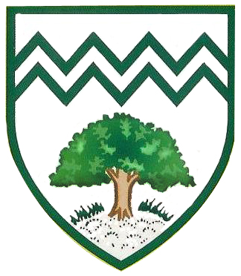

**As Readers** we will be studying:

-*The Troll* by Julia Donaldson

- *The Three Billy Goats Gruff* by Kate Pankhurst

- *Above and Below* by Hanako Clulow

**As Writers**, our work will be inspired by:

-*The Troll Swap* by Lee Hodgkinson

-*The Owl who was Afraid of the Dark* – Jill Tomlinson

**As Spellers,** we will learn new sounds and spelling rules through the RWI Phonics or Spelling Programme.

PSHE

Geography

Plantation Primary School

Curriculum Map

Year 2 Autumn Term

PE

Music

As Citizens we will learn about **‘Families and relationships’.** We will recognise how others show feelings in different ways and how to respond.

We will develop our understanding of **self-image** and **identity** online with an emphasis on keeping ourselves safe. We will be investigating **computing** **systems** and IT around us.

As Geographers, we ask the question, ‘**Why Does it Matter Where Our Food Comes From?’** We will compare our local climate to others and learn about importing and exporting food.

**As Scientists, we will learn about:**

Our lessons will be very practical and ‘hands-on’. We will follow the Snap Science scheme. We will plan and carry out our own investigations, drawing our own conclusions based on the results.

1. What is in your habitat? This will involve exploring different habitats and looking for living and non-living things within.
2. Materials: Good choices What are things made from and why?

Art

DT

French

RE

Computing

History

Maths

English

As artists we will learn about the colours, materials and shapes that **Andy Goldsworthy** uses in his artwork. We will examine his sculptures and use them as inspiration for our own creations.

As designers we will explore, cut, sew, design, make and evaluate our own **Christmas tree decorations.**

As linguists we will be developing our listening, speaking and reading skills in French. We will be learning basic conversational language and numbers 1-20.

As Musicians we will learn African **call and response** songs based on animals. We will also explore different **instruments** through musical storytelling.

As Theologians we will learn all about the key principles of **Buddhism** as well as the meaning of some Buddhist symbols. We will also learn about why **Christmas** is special for Christians all over the world.

As Sportspeople we will learn the skills required to run, jump and throw, as well as attack, defend and shoot. We will also create our own dances using a variety of movements.

As Historians, we will learn about what it means when people are referred to as ‘**History Makers’**. We will compare and contrast the achievements of eightsignificant people from the past.

**As Mathematicians, we will learn:**

**Place Value-** Place Value of digits in Tens and Ones;partitioning numbers into T and O including other combinations**;** estimate and recognise numbers on a number line; compare and order numbers up to 100 using > < and =.

**Measure** - Capacity

**Addition and Subtraction-** 2 digit not crossing the boundaries; 2 digit both numbers are tens; 2 digit + tens e.g. 43 + 30 (not crossing 100). Money.

**Multiplication and Division-** Arrays**;** commutativity; problem solving; division problems.

**Geometry-** Properties of shape 2D and 3D**;** describing and comparing.

Science