

Bexton Primary Residential Visit for Year 4
Wednesday 29th April to Friday 1st May 2026

Canolfan Conway Centre
Llanfairpwll
Anglesey
LL61 6DJ

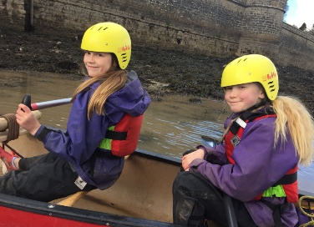
Dear Parents and Carers,
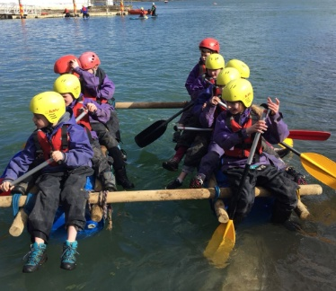
We’re very excited to be able to take the children on their first residential visit. The memories they make are for a lifetime and it’s wonderful to see the children grow in confidence throughout their stay. Usually, by the end of the visit they’re begging to stay extra nights! We hope this booklet answers all the questions you or your child may have.

Aims and Objectives
The value of educational visits is widely acknowledged. Often these experiences will be remembered as a high point in a child’s school life.
We have carefully planned this residential course in collaboration with the staff of the Canolfan Conway Centre and we aim to provide the children with exciting and rewarding experiences that will:

- Promote children’s personal and social skills.
- Enhance the study of relevant curriculum areas.
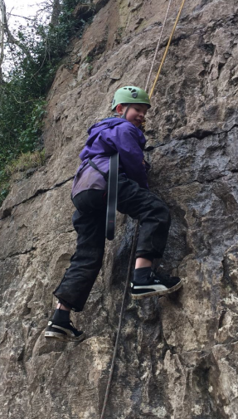
Dates and Times of Departure and Return
We will leave school at around 9.15 am on Wednesday 29th April and return in time for end of school on Friday 1st May.

Accompanying Staff
Mr Waters and Miss Whiteley will be leading the visit this year. There will also be lots of other members of Bexton staff accompanying the children. The Conway Centre provides 24-hour cover by duty staff for emergencies. They also provide a first - aider on site at all times.

During the day, the children work in groups according to the activities under taken, with a ratio of 1 adult to every ten children. In addition to a member of the Centre staff, a member of the Bexton Primary School Team will always be present to help supervise the activities being undertaken. Any child who has additional support in school will be supported by a familiar adult during the activities.

Activities Planned (all times are estimates)

Wednesday | 9.15 am: Leave Bexton Primary School,  11:30 arrive at Conway centre for Introduction and orientation by Centre staff including Fire Safety routines.  12.00 Lunch (own packed lunch eaten in the grounds of the centre).  1.30pm Indoor and outdoor activities at the centre  5.45pm: Evening meal  6pm: Visit to beach for Scavenger hunt  8pm: Campfire  9pm: Bedtime  10pm: Lights out
Thursday | 8.30am: Breakfast  9am: Indoor and outdoor activities at the centre  12.30: Lunch provided by Conway  1.30: Indoor and outdoor activities at the centre  5.45pm: Evening meal  7pm: Evening activities including disco  9pm: Bedtime  10pm: Lights out
Friday | 8.30am: Breakfast  9.30am: Indoor and outdoor activities at the centre  12pm: Lunch provided by Conway  1.30pm: Return to Bexton Primary School

All children need to bring a packed lunch on Wednesday 29th April, packed so that it can all be easily disposed of afterwards. The children do not need to wear Bexton Uniform on any part of this visit. They will need to be suitably dressed for the weather (see kit list at the end of the booklet).

Indoor and Outdoor Activities
The children will have access to sporting activities and team building experiences we cannot offer at school, such as:

- Canoeing
- Raft Building
- Low ropes and zip wire
- Bush craft
- Climbing

Due to the short duration of the stay, the children will only be able to do two of the above activities. Children should choose a land choice and a water choice. Please complete the form on the attached link to choose four (in priority order) they would like to do. We will aim to ensure children do two activities from their choices.

All of the children will also be taking part in an art workshop, campfire and disco.

Name of Travel Company and Method of Travel
Walkers Coaches, who are used regularly by the school, will transport the party to and from the Conway Centre.

Conway Centre Accommodation
We will have our own social area allocated to us and additionally a wet room/drying area.
All sleeping and accommodation areas have an alert system to let adults know if the children leave the bedroom area in the night. After the bedtime routine has been completed the adults will sit near the bedroom until the children are settled. If anyone is upset, there is always an adult near to comfort them and help them get back to sleep. All external doors to the centre have restricted entry via keypads. Boys and girls will sleep in separate rooms, supervised by staff.

Food and drink

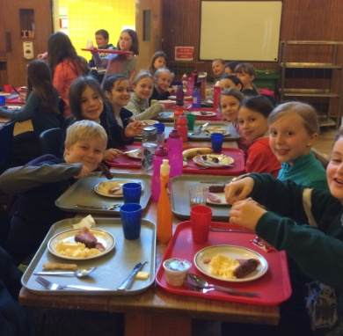
The food at the centre is always excellent- no-one will go hungry! There are four options available during the evening meal, including one vegetarian option and the Conway Centre cater for all dietary requirements. In addition to this there is a salad bar with plenty of choice. Choices of puddings are also provided. We take water bottles and plenty of juice and encourage the children to drink often.
Breakfast will consist of toast and cereal every morning and in addition to that either a cooked breakfast (sausages, baked beans, hash browns, eggs etc.) or a continental breakfast. Orange juice and water will be on all the tables.

For any children with dietary requirements, please ensure this is brought to our attention in the consent forms. The Conway Centre are excellent at meeting these requirements.

Advice on Pocket Money and Allocation.
Your child will not need any money during the visit.

Health and Safety
The Centre has carried out risk assessments for all the available activities outlined above. Copies can be viewed on the Centre’s website. We complete detailed risk assessments for the whole visit and the beach and these are also checked by an external auditor at Cheshire East. If parents wish to view these risk assessments please contact the school who are happy to provide them.
An Adventurous Activities License is held by the Conway Centres. This is awarded by H & S Executive through Adventure RMS services. Their license can be viewed on their website. The Conway Centre Anglesey has been inspected and met standards demonstrating their educational focus, planning, aims/objectives and H&S is paramount receiving the Learning Outside the Classroom Quality Badge.
The Conway Centres hold the Adventure Mark accreditation. They have been inspected by the Adventure Activities Industry Advisory Committee and their operating procedures meet all accrediting standards.
All Conway Centre staff hold either the relevant NGB (National Governing Body) qualifications for their roles or are assessed as competent by a technical expert, or both.
The Conway Centres Anglesey catering team follow all HSE, DFE and food safety requirements for groups on educational visits and trips with them, and they are particularly diligent when it comes to supporting pupils with medical and dietary conditions. The accommodation has comprehensive smoke and fire alarm systems in operation in addition to a security system which can be activated by visiting teachers. The accommodation and residential provision is regularly checked by the Fire Service.

Insurance
The Conway Centre Anglesey is covered by the Insurance of Edsential, who have comprehensive employer and public liability insurance.
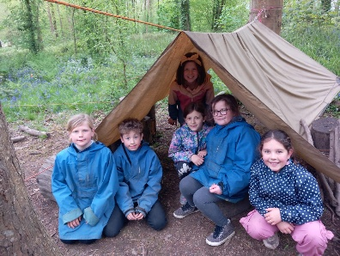
In addition, we always arrange insurance cover for all activities undertaken in recreational sessions or when the children are not carrying out activities run by Centre staff.

Costs and Payment
The total cost of the residential will be £229. If you wish to pay the entire cost before these dates then please do. These are payable through your SCOPAY account:
A first instalment of £58 is due by Friday 23rd January which will confirm your child’s as part of a deposit.
A second instalment of £58 is due by Friday 27th February.
A third instalment of £58 is due by Friday 27th March
A final instalment of £55 is due by Friday 24th April.
Please note that the full balance must be paid before your child can attend the residential. Please contact Mrs Rimmer (our school business manager) if you have any difficulties paying. She will be able to discuss an alternative payment plan with you.
Free School Meals Entitlement
If your child is eligible for free school meals, we are able to fund the cost of the trip and just ask for a £28 donation for the coach.
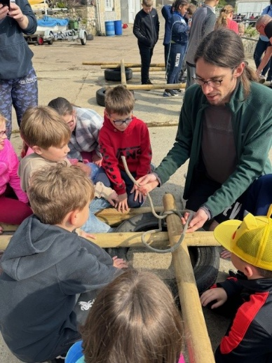

Frequently Asked Questions
Will my child be forced to complete an activity they don’t want to do?
No- we always give children two of the options you select in their form (please make a note of these as parents often forget what they selected) but if when they arrived at Conway they had changed their mind, we will try to get them into an alternative activity.
How many children are in each dormitory?
There are a range of rooms available ranging in size, some rooms can have two or three children in, some have up to eight. Girls and boys have separate rooms.
Can my child choose who they want to be in a room with?
Yes- we always ask the children who they would like to be in a dormitory with and try our best to accommodate their wishes.
Can you tell me who my child will be in a dormitory with before the visit?
We don’t do this as we’ve found that it’s best to let the children know when they arrive at the centre. We make sure all the children are happy and settled each night.
Can my child bring a night light?
We prefer it if they didn’t as a night light might disturb some of the other children in the dormitory, but we always make sure there is a light on outside the room (just in case children need the toilet in the night).
My child is a little scared of the water/ isn’t a strong swimmer, are they ok choosing a water activity?
Yes- the staff at the Conway centre will make sure all children are wearing life jackets/ correct safety equipment before taking part in an activity.
My child would like to know the food options/ has a dietary requirement, can we see the menus?
The Conway Centre can cater for all dietary requirements and will send us the menus shortly before the visit so the children can choose what they would like to eat. If your child has a dietary requirement then we’ll ask you to help them choose.
Are the children supervised during the night?
Each member of staff has a couple of dormitories to supervise during the night. They make sure all the children are happy and sit outside the room until the children are settled. The children know where this member of staff is based and can get them if needed. The staff do need their sleep too so we encourage the children to only do this if they are unwell.
Is there a toilet stop on the way to Conway?
We try to get there in one go, but on occasions we have stopped if some children need the toilet.

If there are any other questions, please email the school office at admin@bexton.cheshire.sch.uk or see Mr Waters/Miss Whiteley at the door during pick up/drop off.

Detailed Kit List- AS MUCH LABELLED AS POSSIBLE!

- Comfortable travelling clothes- Please pay heed to the weather report –warm clothes or sun-cream and hats depending upon the weather- we will be outside a lot! Trainers on feet please- we will be walking on uneven floors.
- Three further changes of clothes – trousers, leggings, T-shirts, jumpers etc
- Two fleeces/jumpers
- Clothes for the disco
- Underwear, socks (please factor in extras in case of wet weather)
- Nightwear
- Soap/shower gel
- Swimming costume if choosing water activities
- Towel
- Toothbrush/toothpaste
- Hairbrush
- Pair of trainers or walking boots (on top of the shoes that they have travelled in)
- Reading book
- Small teddy to go to sleep with
- Waterproof coat, hat, gloves
- Sun-cream / sun hat / lip balm (the children can get very sore lips due to being outside
- Labelled water bottle (not a disposable one)
- Two savoury snack bars (NO NUTS AND NO SWEETS) Treats will be provided by Bexton.

Any specialist equipment required including wellies, climbing shoes, sailing gear etc. will be provided by the Conway Centre.

Items Prohibited on the Residential
Mobile phones, smart watches, Fitbits (or similar), music players, tracking devices and any sort of electrical games e.g. Nintendo DS, are not permitted and will be confiscated if found.

Emergency Contact Arrangements
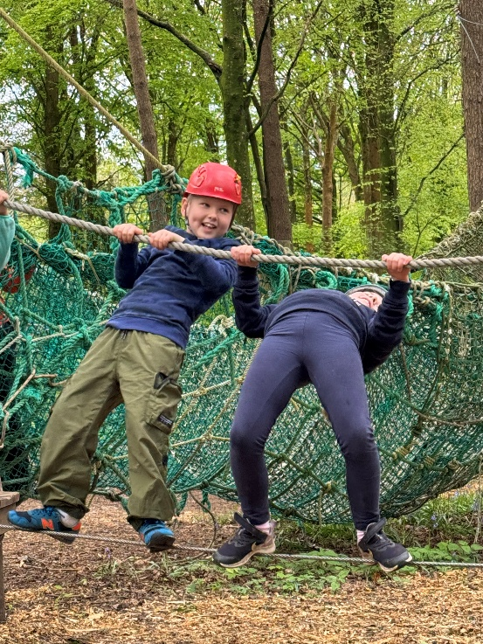

Canolfan Conway Centre
Llanfairpwll
Anglesey
LL61 6DJ

Tel: 01248 714501

