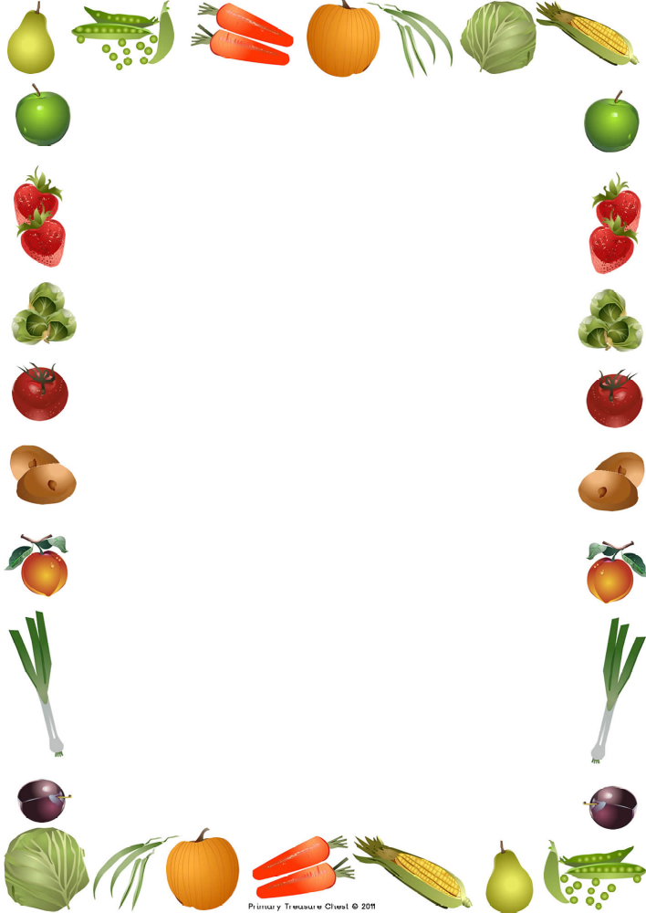
Harvest Service 2026
“Whatever you do, work at it with all your heart,
as working for the Lord.”
Colossians 3:23
Whole School – What a Journey
Birch – Harvest Art
A Harvest Prayer
Cherry – Food, Glorious Food
Whole School – Thank You God (For Our Wonderful Food)
Maple – Harvest Poem
A Harvest Prayer
Oak – The Sustainable Development Goals
Whole School – My Lighthouse
*Collections will be taken for SIlklife Foodbank

“Indeed, the Lord will give what is good,
and our land will yield its produce.”
Psalm 85:12

