Bollington St. John’s Church of England
Primary School
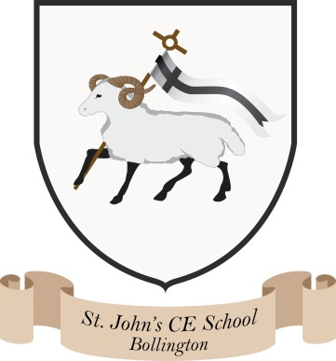
Where talent grows
Head Teacher: Mrs M. Walker
Head of Teaching, Learning and Assessment: Mrs E. Watson
“Whatever you do, work at it with all your heart, as working for the Lord”
Colossians 3:23
Green Policy
1 - St John’s Mission
2 - Overview
3 - Sustainability Strategy
4 - Ensuring Success – Role and Responsibilities
5 - Sustainability Action Plan 2025:
1. St John’s Mission
Sustainability is an integral part of day-to-day life at St John’s Primary School. We aim to be an environmentally responsible educational setting that actively reduces our carbon footprint and impact on the planet, and makes judicious use of resources, while developing a deep understanding of sustainable practice among pupils, staff and the wider school community.
At St John’s, being ‘sustainable’ means making thoughtful choices that care for God’s creation. By helping children form a meaningful connection with nature and our surroundings, we nurture respect, responsibility and a strong sense of stewardship for the environment, ensuring that animals, plants and natural resources are protected for future generations.
Guided by our Christian ethos of courageous advocacy, and in line with government ambitions to develop future leaders, we empower pupils to take the lead in sustainability projects. This approach gives children ownership of environmental action, enabling them to speak up, influence change and act as role models within the school and wider community.
We build upon our weekly Forest School sessions to deliver a curriculum in which the Sustainable Development Goals (SDGs) are embedded. Regular field trips allow pupils to observe the changing seasons and make meaningful links between outdoor experiences and classroom learning. Sustainability is woven across all subject areas, with teachers supported and signposted to clear opportunities to integrate sustainable themes into everyday teaching.

2. Overview
The Department of Education’s Sustainability & Climate Change Report (2022) has set their vision, for the United Kingdom to be the world-leading education sector in sustainability and climate change by 2030.
Education must equip children with the skills to be agents of change for a climate-smart future. With many children wishing to pursue a 'green career', there is clear opportunity to ensure alignment with these ambitions.
As an organisation we must demonstrate strong civic leadership and corporate responsibility, as such sustainability is of high importance to St John’s community.
Our long-term environmental priorities are to improve our environmental performance and play an active role in supporting the delivery of the United Nations Sustainable Development Goals (UN SDGs). We will also continue to engage with all relevant stakeholders and like-minded organisations to make our planet a better place to live.
As educators, we have a key role in supporting the delivery of the United Nations Sustainable Development Goals (UN SDGs). The SDGs are a set of 17 goals aimed at transforming the world by 2030 (see Figure 1). We will actively embed the fundamentals of the UN SDGs into all aspects of our school life.
Figure 1: The United Nation’s Sustainable Development Goals (UN SDGs)
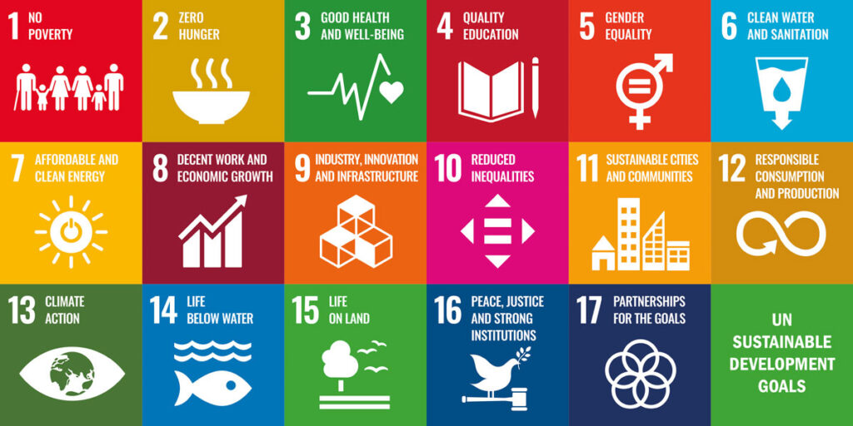
3. Sustainability Strategy
In order to demonstrate our commitment to carbon reduction and sustainability, St John’s aims to meet its social, legal and educational responsibilities via the implementation of the following sustainability strategy.
The Sustainability Strategy will focus on four key areas, which encompass all aspects of operations:
• Culture – behavioural changes, the way things are done
• Campus – buildings, energy and grounds
• Community –working together inside and outside of school
• Curriculum – embedding sustainability within the curriculum
The National Association for Environmental Education (NAEE) explains this by using the Four C’s model.

4. Ensuring success – Role and Responsibilities
In order to implement the strategy effectively, the Governors, Head Teacher and all teaching staff will ensure that the following points are adhered to:
- This strategy is widely communicated and updated as and when required, or at least annually.
- Communication will be provided regularly to the school community, schools governing body, informing them of progress made and ways to improve.
- We will set an energy, consumption and waste reduction performance improvement targets within our Sustainability Action Plan. We then will regularly monitor and evaluate, in order to establish a baseline, measure improvements and identify priority areas.
- Develop a curriculum, which promotes the need for environmental sustainability within which our SDGs are embedded.
- Our Eco-Council have regular meetings to discuss current, environmental issues and plan ways that we can be environmentally friendly in school.
- Sharing good practice with pupils, parents and the wider school communities, and encouraging them to adopt the initiatives outlined within this policy.
- Our programme of extracurricular activities and clubs also enables pupils to access further learning opportunities about sustainability.
- Children at St John’s take part in the Forest School programme where they build a relationship with nature.
• We will work through a Sustainability Action Plan to provides a clear roadmap to achieving the Government’s Net Carbon Zero Target.

5. Sustainability Action Plan 2026:
Our 2025 Sustainability Action Plan was developed as a response to the current and emerging environmental risks and challenges, and is aligned with the following:
UK’s 2050 net zero carbon target and de-carbonisation plan.
The Department for Education’s strategy for sustainability and climate change for the education and children’s services systems.
The Climate change Act 2008
The United Nations Agenda for Sustainable Development 2015
Through this action plan, we will establish strong foundations for the development of a longer-term, more ambitious strategy, targets and plan. We will engage staff and pupils across the school in the development of this longer-term strategy over the next 3 years.
Date: March 2026

