Bollington St. John’s Church of England
Primary School
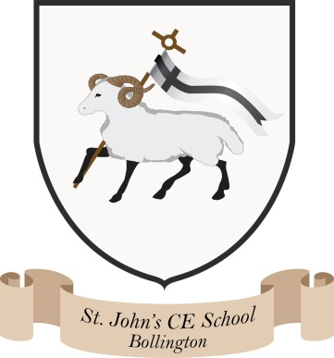
Where talent grows
Head Teacher: Mrs M. Walker
Head of Teaching, Learning and Assessment: Mrs E. Watson
“Whatever you do, work at it with all your heart, as working for the Lord” Colossians 3:23
Governing Body Structure 2025/2026

Curriculum, Teaching and Achievement  Chair  Tess Phillips | Attendance and Behaviour  Chair  John Rogers | Personal Development and Wellbeing  Chair  Carl Mallia | Leadership and Governance  Chair  Mike Akerman
Members  Ellen Watson  Carl Mallia  Sue Roberts  Melanie Walker  Tess Phillips  Clare Wearne | Members  John Rogers  Mike Akerman  Melanie Walker  Liz Newbon  Emma Bagshaw | Members  Carl Mallia  Ellen Watson  Rosie Hemmings  Nancy Goodrich  Lori Hawthorn  Melanie Walker | Members  Mike Akerman  Tess Phillips  Rosie Hemmings  Melanie Walker
School Development Plan and SEF Links
Curriculum, Teaching and Achievement  Committee | Attendance and Behaviour  Committee | Personal Development and Wellbeing Committee | Leadership and Governance  Committee
Curriculum and teaching  RE  Achievement  Mastery  EYFS  Assessment and targets  Progress/Tracking  Extra-curricular  Sport  ICT  Worship  Catch up strategies | Attendance  Behaviour  Bullying  Exclusions  E-Safety  Health & Safety (risk assessments including external visits)  Buildings/Lettings and estate  Sustainability  GDPR | Personal development  Wellbeing  Spiritual wellbeing and SMSC  British/Global Values and diversity  Cultural capital  School partnerships  Relationships and Sex Education  PSHE  Home school agreement  Transition  School Parliament and Ethos group  School meals and healthy lifestyles  Church links  Community | School leadership and governance  Ofsted and SIAMS  Safeguarding including Prevent  Inclusion  SEF/SDP  Admissions/Term dates  Senior Leadership Team  Staff CPD/Middle leaders  Head’s PM  Finances and budget  Pay  Personnel issues/Staff recruitment  Disciplinary and complaints  Governor’s training  Child Protection  SEND and PP  Vulnerable groups , G&T and Cared for Children  Pupil Premium
Staff / Governor Responsibilities | Staff / Governor Responsibilities | Staff / Governor Responsibilities | Staff / Governor Responsibilities
Literacy (including Reading, SPaG and Phonics) – Lucy Jobbins/Sue Roberts  Maths – Ellen Watson/Carl Mallia  RE – Erin Steyn/Tess Phillips  Hist/Geog – Lucy Jobbins/Emma Bagshaw  Science – Kelly Van/ Tess Phillips  EYFS – Lucy Jobbins/Sue Roberts  Sport – Sam Di Marco/Carl Mallia  Teaching, Learning and Assessment – Ellen Watson/Clare Wearne  Evolve Lead – Ellen Watson | GDPR – Becky Green/Melanie Walker/Emma Bagshaw  Health & Safety – David Morrall/John Rogers  Buildings – David Morrall/John Rogers  Sustainability Link – Kelly Van/Liz Newbon | Global – Ellen Watson/Carl Mallia  Mental Health and Well-Being – Erin Steyn/Rosie Hemmings/Lori Hawthorn  Community – Melanie Walker/John Rogers  PSHE/RSE – Erin Steyn/Nancy Goodrich | Safeguarding/Child Protection/E-Safety – Melanie Walker/Ellen Watson/Mike Akerman  Governor’s Training – Tess Phillips  Pupil Premium – Rebecca Gregory/ Rosie Hemmings  SEND – Rebecca Gregory/Rosie Hemmings  Cared for Children – Melanie Walker/Mike Akerman  G&T Lead – Ellen Watson
Individual committees would be convened if/when necessary.

