Bollington St. John’s Church of England
Primary School
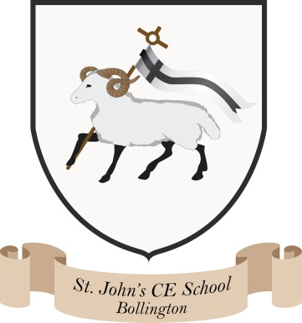
Where talent grows
Head Teacher: Mrs M. Walker
Head of Teaching, Learning and Assessment: Mrs E. Watson
“Whatever you do, work at it with all your heart, as working for the Lord”
Colossians 3:23

PSHE/RSE overview
We have created a bespoke curriculum map for PSHE/RSE/Wellbeing throughout our school based on the KAPOW scheme of work, Chris Winters Sex Education and the No Outsiders relationships scheme of work.
PSHE is taught weekly and assessed using assessment grids by both pupils and teachers. Class discussions, picture books and online resources form the basis of these lessons which are recorded in individual PSHE books. Reception has a class concept book.
Personal development, SMSC (spiritual, moral, social and cultural) and British/global values are also threaded through our PSHE curriculum and our wider curriculum.
Sex Education is taught in every year group termly using the Chris Winters resources. The lessons have a focus on families, relationships, safeguarding/keeping children safe. This resource encourages children to develop the skills of listening, empathy, talking about feelings and relationships with families and friends.
Relationship education is taught using the No Outsiders programme which is based on high quality picture books, which also contribute to class reading spines. Each lesson taught through a picture book, promotes a respect for diversity through education in schools. The programme is centred on the promotion of dialogue to counter fear and hate in society. This links closely with our global work and Philosophy for Children (P4C).
Mental health ambassadors are linked to the local high school. The children visit regularly and plan assemblies, events and presentations for the school.

