Frodsham CE Primary School 2024- 2025 Long Term Plan Nursery
As God’s family we love, learn and play together.

 | Autumn |  |  | Spring |  |  |  | Summer
Christian  Values | Love | Respect |  | Kindness |  | Community |  | Faith |  | Resilience
Spiritual Development | Me: I can be creative I can be curious  Others: I can celebrate others achievements I can be fair I can be kind  World: I can be thankful for the gift of creation I can find wonder in all things  God: I know I am loved by God for who I am I know I am one of God’s children.
RE  (Chester Diocese) | Christianity -Creation | Christianity -Christmas |  | Christianity –  The Good Samaritan |  | Christianity –  Easter |  | Christianity –  Noah’s Ark |  | Christianity -The Lost  Sheep
RE  (Chester Diocese) | World faith Celebrations – teach as they occur across the year - What do other people believe? Is it the same or different to Christianity?
 | Autumn 1 |  | Autumn 2 |  | Spring 1 |  | Spring 2 |  | Summer 1 | Summer 2
Character Strength Focus | Strengths of the Heart  Love |  | Strengths of the Head  Creativity |  | Strengths of Action  Courage |  | Strengths of Community  Leadership |  | Strengths of Meaning  Wisdom | Strengths of Self Reguation  Resilience
Amazing People | Lucy Kirby |  |  |  | Local Community Heroes |  |  |  | David Attenborough
General Themes  These themes may be adapted at various points to allow for children’s interests to flow through the provision. | Marvellous Me  I am unique  My senses  My family  Different types of families  Settling in  Establishing rules  Autumn |  | Celebrations  Autumn  Nursery Rhymes  Bonfire Night  Remembrance Day  Celebrations – Christmas, Diwali |  | Changes  Winter  Animals around the world  Climates / Hibernation  Staying healthy / Food  Easter  Chinese New Year |  | Time to Grow  Spring  Spring Plants  Planting seeds/beans  Frogspawn  Weather / seasons Materials |  | Our Wonderful World  Mini beasts  Our own caterpillars  Beside the seaside Pirates and treasure Under the sea | Once Upon a Time  Summer  Where do we live? Around the town – how do we get there?  Off on holiday / clothes  Vehicles past and present  Fly me to the moon Design your own vehicle
Possible Texts and Old Favourites | Owl Babies  Peace at Last  The Family Book  The Colour Monster  Brown Bear  Room on the broom  Funny bones |  | Nursery Rhymes  Guy Fawkes non-fiction  Bonfire Night- non fiction  Sparks in the sky  The Nativity Story |  | Polar Bear, Polar Bear  Lost and Found  Lunar New Year around the World  Handa’s surprise  Real Super Heroes  What Will I be? |  | The Easter Story  Jasper’s Beanstalk  Jack and The Beanstalk  The Teeny Tiny Tadpole  The seed  Oliver’s vegetables  Sunflowers  Mr Wolf’s Pancakes |  | The Very Hungry Caterpillar  Pirates love underpants  Commotion in the ocean | On the moon  Winnie in Space Whatever Next  What is the moon?  How to catch a star  The train ride
Characteristics of Effective Learning  Over Arching Principles  Play | Playing and exploring: - Children investigate and experience things, and ‘have a go’. Children who actively participate in their own play  develop a larger store of information and experiences to draw on which positively supports their learning.  Active learning: - Children concentrate and keep on trying if they encounter difficulties. They are proud of their own achievements. For children to develop into self-regulating, lifelong learners they are required to take ownership, accept challenges, and learn persistence. Creating and thinking critically: - Children develop their own ideas and make links between these ideas. They think flexibly and rationally, drawing on previous experiences which help them to solve problems and reach conclusions.  Unique Child: Every child is unique and has the potential to be resilient, capable, confident and self-assured.  Positive Relationships: Children flourish with warm, strong & positive partnerships between all staff and parents/carers. This promotes independence across the EYFS curriculum.  Enabling environments: Children learn and develop well in safe and secure environments where routines are established and where adults respond to their individual needs and help them to build upon their learning over time.  Learning and Development: Children develop and learn at different rates. We will support all children no matter where they are in their learning journey.  PLAY: In Nursery, our children will have an abundance of opportunities to learn through play. We will ensure that learning will be fun, engaging and we will challenge and support all children wherever their starting point. As an EYFS team and effective role models, we will provide high quality interactions in order to develop and deepen the children’s learning opportunities. We will deliver our curriculum through a balance of adult led and child initiated activities based on the EYFS Framework 21’ & children’s interests.

 | Autumn 1 | Autumn 2 |  | Spring 1 | Spring 2 |  | Summer 1 | Summer 2
General Themes | Marvellous Me | Celebrations |  | Changes | Time to Grow |  | Our Wonderful World | On the Move
Communication and Language  Whole EYFS Focus – C&L is developed throughout the year through high quality interactions, daily group discussions, PSHE times, stories, singing, Helicopter Stories, assemblies. | The development of children’s spoken language underpins all seven areas of learning and development. Children’s back-and-forth interactions from an early age form the foundations for language and cognitive development. The number and quality of the conversations they have with adults and peers throughout th e day in a language-rich environment is crucial. By commenting on what children are interested in or doing, and echoing back what they say with new vocabulary added, practitioners will build children's  language effectively. Reading frequently to children, and engaging them actively in stories, non-fiction, rhymes and poems, and then providing them with extensive opportunities to use and embed new words in a range of contexts, will give children the opportunity to thrive. Through conversation, story-telling and role play, where children share their ideas with support and modelling from their teacher, and sensitive questioning that invites them to elaborate, children become comfortable using a rich range of vocabulary and language  structures.
Listening, attention and understanding  Speaking | Settling in activities Making friends Children talking about experiences that are familiar to them  Rhyming and alliteration  Familiar Print  Sharing facts about me  Model talk routines through the day. For example, arriving in school: “Good morning, how are you?”  Set up class routines – carpet time etc. Dinner register  Poetry Basket | Settling in activities Develop vocabulary Tell me a story - retelling stories  Story language Listening and responding to longer stories and can remember much of what happens. Following instructions  Small world/role play Model new vocabulary through the day.  Choose books that will develop their vocabulary.  Nursery rhymes  Poetry Basket |  | Using language well Understand ‘why’ questions  Retell a story with story language  Story invention  Ask questions to find out more and to check they understand what has been said to them. Describe events in some detail.  Use longer sentences Learn rhymes, poems and songs.  Poetry Basket | Settling in activities Describe events in detail – time connectives Understand how to listen carefully and why listening is important.  Use picture cue cards to talk about an object: “What colour is it? Where would you find it?  Non-fiction instructions Sustained focus when listening to a story.  Poetry Basket |  | Settling in activities Reread some books so children learn the language necessary to talk about what is happening in each illustration and relate it to their own lives Develop their communication – recast what the children say using correct pronunciation Past and future tenses  Poetry Basket  Phonics RWI | Sharing news. Read aloud books to children that will extend their knowledge of the world and illustrate a current topic.  Select books containing photographs and pictures, for example, places in different weather conditions and seasons.  Use longer sentences of four to six words Be able to express a point of view.  Poetry Basket  Phonics RWI
 | Autumn 1 | Autumn 2 |  | Spring 1 | Spring 2 |  | Summer 1 | Summer 2
General Themes | Marvellous Me | Celebrations |  | Changes | Time to Grow |  | Our Wonderful World | On the Move
Personal, Social and Emotional Development | Children’s personal, social and emotional development (PSED) is crucial for children to lead healthy and happy lives and is fundamental to their cognitive development. Underpinning their personal development are the important attachments that shape their social world. Strong, warm and supportive relationships with adults enable children to learn how to understand their own feelings and those of others. Children should be supported to manage emotions, develop a positive sense of self, set themselves simple goals, have confidence in their own abilities, to persist and wait for what they want and direct attention as necessary. Through adult modelling and guidance, they will learn how to look after their bodies, including healthy eating, and manage personal needs independently. Through supported interaction with other children, they learn how to make good friendships, co-operate, and resolve conflicts peaceably. These attributes will provide a secure platform from which children can achieve at school and in later life.
 | Autumn - Relationships |  | Spring – Living in the Wider World |  |  |  | Summer – Health and Wellbeing
PSED Association  Focus | Families and Friendships | Respecting others and ourselves | Belonging to a Community |  |  | Money and Work | Physical Health and Wellbeing | Growing and Changing
Managing Self  Self-Regulation  Building relationships | Settling in  See themselves as a valuable individual.  Class Rules and Routines  Select and use activities and resources with help when needed. Supporting children to build relationships Free flow play Independence within the environment modelling play and using the resources.  Tidying up routines Express likes/ dislikes  Support to regulate big feelings.  Help to find solutions to conflicts- The Colour Monster stories | Recognise and name feelings  Self - Confidence Build constructive and respectful relationships.  Develop their sense of responsibility and membership of a community – give children tasks to carry out. |  | Learning about qualities and differences Celebrating differences  Identify and moderate own feelings.  Think about their own feelings and those of others use explicit examples of how others might feel in particular scenarios  Help to find solutions to conflicts and rivalries. – through discussion, stories and role play. Become more outgoing with unfamiliar people in a safe setting. | Relationships –Play with one or more other children  What makes a good friend?  Ways to be healthy Random acts of Kindness  Looking after pets Looking After our Planet  Self- regulation strategies.  Safe place  Taking turns, wait politely.  Tidy up after ourselves  Show more confidence in new social situations |  | Looking after others Friendships  Show resilience and perseverance in the face of challenge. Why we take turns, wait politely, tidy up after ourselves.  Begin to understand how others might be feeling.  Think of other perspectives | Winning and losing Changing me.  Look how far I've come!  Conscious discipline making good choices Model positive behaviour.  Manage own needs. See themselves as valuable individuals. Greater independence – not always needing an adult to remind them of a rule – explain why we have rules
 | Autumn 1 | Autumn 2 |  | Spring 1 | Spring 2 |  | Summer 1 | Summer 2
General Themes | Marvellous Me | Celebrations |  | Changes | Time to Grow |  | Our Wonderful World | On the Move
Physical Development | Physical activity is vital in children’s all-round development, enabling them to pursue happy, healthy and active lives. Gross and fine motor experiences develop incrementally throughout early childhood, starting with sensory explorations and the development of a child’s strength, co-ordination and positional awareness through tummy time, crawling and play movement with both objects and adults. By creating games and providing opportunities for play both indoors and outdoors, adults can support children to develop their core strength, stability, balance, spatial awareness, co-ordination and agility. Gross motor skills provide the foundation for developing healthy bodies and social and emotional well-being. Fine motor control and precision helps with hand-eye co-ordination, which is later linked to early literacy. Repeated and varied opportunities to explore and play with small world activities, puzzles, arts and crafts and the practice of using small tools, with feedback and support from adults, allow children to develop proficiency, control and confidence.
Fine motor  Daily opportunities for Fine Motor Activities  Funky fingers Activities  Dough disco | Threading, cutting, weaving, manipulate objects, use playdough.  Fine Motor activities. Draw lines and circles using gross motor movements.  Hold pencil/paint brush beyond whole hand grasp  Pencil Grip  Funky fingers challenges  Dough Disco | Threading, cutting, weaving,  Playdough.  Fine Motor activities.  Develop muscle tone to put pencil  pressure on paper. Use tools to  effect changes to materials.  Show preference for dominant hand.  Provide a range of resources.  Using a knife and fork.  Dough Disco |  | Threading, cutting, weaving,  Playdough.  Fine Motor activities.  Handle tools, objects,  construction and malleable materials with increasing control.  Encourage children to draw freely.  Pincer grip holding small items buttons/clothing.  Cutting with Scissors  Dough Disco | Threading, cutting, weaving,  Playdough.  Fine Motor activities.  Hold pencil effectively with  comfortable grip. Form some recognisable letters  Funky fingers  Dough Disco |  | Threading, cutting, weaving, playdough, Fine Motor activities. Develop pencil grip Use one hand consistently.  Cut along a straight line with scissors / Start to cut along a curved line.  Dough Disco | Threading, cutting, weaving, playdough, Fine Motor activities. Form some letters correctly  Begin to draw diagonal lines, like in a triangle.  Start to colour inside the lines of a picture. Start to draw pictures that are recognisable / Build things with smaller linking blocks, such as Duplo or Lego  Dough Disco
Gross motor  Free flow leading to outdoor play | Climbing – outdoor equipment  Different ways of moving to be explored with children. Encourage independence dressing – putting coat on etc | Ball skills-throwing and catching.  Crates play- climbing. Dance related activities  Provide a range of wheeled resources for children to balance, sit or ride on, or pull and push. Two wheeled balance bikes, scooters wheelbarrows, prams |  | Ball skills- aiming, dribbling, pushing, throwing & catching, patting, kicking. Provide a wide range of activities to support a broad range of abilities. Dance / moving to music | Balance- children moving with confidence  dance related activities  Provide opportunities for children to, spin, rock, tilt, fall, slide and bounce.  Look at the importance of the different aspects of a healthy lifestyle. |  | Obstacle activities children moving over, under, through and around equipment Encourage children to be highly active. Provide opportunities for children to, spin, rock, tilt, fall, slide and bounce.  Dance / moving to music | Races / team games involving gross motor movements dance related activities
PE Lessons  Complete PE | Walking 1 | Jumping 1 |  | Ourselves | Feet 1 |  | Rackets, bats, balls and balloons | Games for Understanding
 | Autumn 1 | Autumn 2 |  | Spring 1 | Spring 2 |  | Summer 1 | Summer 2
General Themes | Marvellous Me | Celebrations |  | Changes | Time to Grow |  | Our Wonderful World | On the Move
Literacy | It is crucial for children to develop a life-long love of reading. Reading consists of two dimensions: language comprehension and word reading. Language comprehension (necessary for both reading and writing) starts from birth. It only develops when adults talk with children about the world around them and the books (stories and non-fiction) they read with them, and  enjoy rhymes, poems and songs together. Skilled word reading, taught later, involves both the speedy working out of the pronunciation of unfamiliar printed words (decoding) and the speedy recognition of familiar printed words. Writing involves transcription (spelling and handwriting) and composition (articulating ideas and structuring them in speech, before writing)
Word Reading  Developing a passion for  Reading  Comprehension | Joining in with rhymes and showing an interest in stories with repeated refrains. Environment print. Having a favourite story/rhyme. Understand the five key concepts about print: - print has meaning - print can have different purposes - we read English text from left to right and from top to bottom - the names of the different parts of a book,  Recognising own name.  Focus on learning new vocabulary | Retell stories related to events through acting/role play. Letters/lists.  Nursery rhymes, familiar stories.  Begin to learn the key concepts about print Phonological awareness. Recognising own name/familiar words  Focus on learning new vocabulary, Conversations about stories,  Listen for rhymes in words. |  | Making up stories to act out Range of books, fiction and nonfiction. Five key concepts about print – name each part of a book Phonological awareness. Recognising own name Focus on learning new vocabulary. Conversations about stories. Listen for rhymes in words | Information leaflets about animals in the garden/plants and growing.  Weather chart. Understand the five key concepts about print – show children a wide range of print with different function. Recognising own name. Focus on learning new vocabulary. Conversations about stories. Listen for rhymes in words. |  | Storytelling. Understand the five key concepts about print.  What is a word? What is a sentence? Recognising own name Change words in a rhyme or story.  Focus on learning new vocabulary. Conversations about stories.  Listen for rhymes in words | Can draw pictures of characters/ event / setting in a story.  Map making and reading  Understand the five key concepts about print.  Recognising own name  Focus on learning new vocabulary Conversations about stories  Listen for rhymes in words
Writing | Dominant hand, tripod grip, mark making, giving meaning to marks  Squiggle and big writing on the carpet (tummy writing) Physical skills development – large muscle co-ordination Funky fingers to build up strength  Start to form letters from their name, Provision of clipboards, notebooks, calendars, whiteboards | Dominant hand, tripod grip, mark making, giving meaning to marks  Squiggle and big writing on the carpet (tummy writing)  Funky fingers to build up strength – small muscle co-ordination Start to form letters from their name – on paintings, pictures, writing etc.  Story scribing |  | Dominant hand, tripod grip, mark making, giving meaning to marks.  Squiggle and big writing.  Funky fingers to build up strength  Start to form letters from their name  Story scribing.  Use some of their print and letter knowledge in their early writing | Dominant hand, tripod grip, mark making, giving meaning to marks  Squiggle and Big writing.  Finger fun to build up strength Start to form letters from their name Use some of their print and letter knowledge in their early writing |  | Write some of all of their name Handwriting activities  Modelling letter formation,  Write letter strings  Model forming letters correctly. | Write some or all of their name  Use some of their print and letter knowledge in their early writing  Shopping lists, drawing and labelling maps  Model forming letters correctly
Phonics  2 year olds  Pre school | Aspect 1 – General sound discrimination – environmental  raise awareness of the sounds around them and develop their listening skills through listening walk, drumming on different items outside and comparing the sounds, playing sounds lotto games and making shakers.  Aspect 2 – General sound discrimination – instrumental sounds  develop awareness of sounds made by various instruments and noise makers through comparing and matching sound makers, playing instruments alongside a story and making loud and quiet sounds. | Aspect 3 – General sound discrimination – body percussion  develop awareness of sounds and rhythms. singing songs and action rhymes, listening to music and developing a sounds vocabulary.  Aspect 4 – Rhythm and rhyme  develop appreciation and experiences of rhythm and rhyme in speech. Activities include rhyming stories, rhyming bingo, clapping out the syllables in words and odd one out. |  | Aspect 5 – Alliteration  The focus is on initial sounds of words, with activities including I-Spy type games and matching objects which begin with the same sound.  Aspect 6 – Voice sounds  to distinguish between different vocal sounds and to begin oral blending and segmenting. Using Metal Mike  Nursery rhymes | Aspect 7 – Oral blending and segmenting  develop oral blending and segmenting skills.  Nursery rhymes |  | Phonics RWI  Aspect 1 – General sound discrimination – environmental  raise awareness of the sounds around them and develop their listening skills through listening walk, drumming on different items outside and comparing the sounds, playing sounds lotto games and making shakers. | Phonics RWI  Aspect 1 – General sound discrimination – environmental  raise awareness of the sounds around them and develop their listening skills through listening walk, drumming on different items outside and comparing the sounds, playing sounds lotto games and making shakers.
 | Autumn 1 | Autumn 2 |  | Spring 1 | Spring 2 |  | Summer 1 | Summer 2
General Themes | Marvellous me | Celebrations |  | Changes | Time to Grow |  | Our Wonderful World | On the Move
Mathematics (First 4 Maths)   | Developing a strong grounding in number is essential so that all children develop the necessary building blocks to excel mathematically. Children should be able to count confidently, develop a deep understanding of the numbers to 10, the relationships between them and the patterns within those numbers. By providing frequent and varied opportunities to build and apply this understanding -such as using manipulatives, including small pebbles and tens frames for organising counting - children will develop a secure base of knowledge and vocabulary from which mastery of mathematics is built. In addition, it is important that the curriculum includes rich opportunities for children to develop their spatial reasoning skills across all areas of mathematics including shape, space and measures. It is important that children develop positive attitudes and interests in mathematics, look for patterns and relationships, spot connections, ‘have a go’, talk to adults and peers about what they notice and not be afraid to make mistakes.  (Black focus objectives are for N2 children and some N1 children)  (Blue focus objectives are related objectives for younger children who have started Nursery in the term after their 2nd birthday)
 | 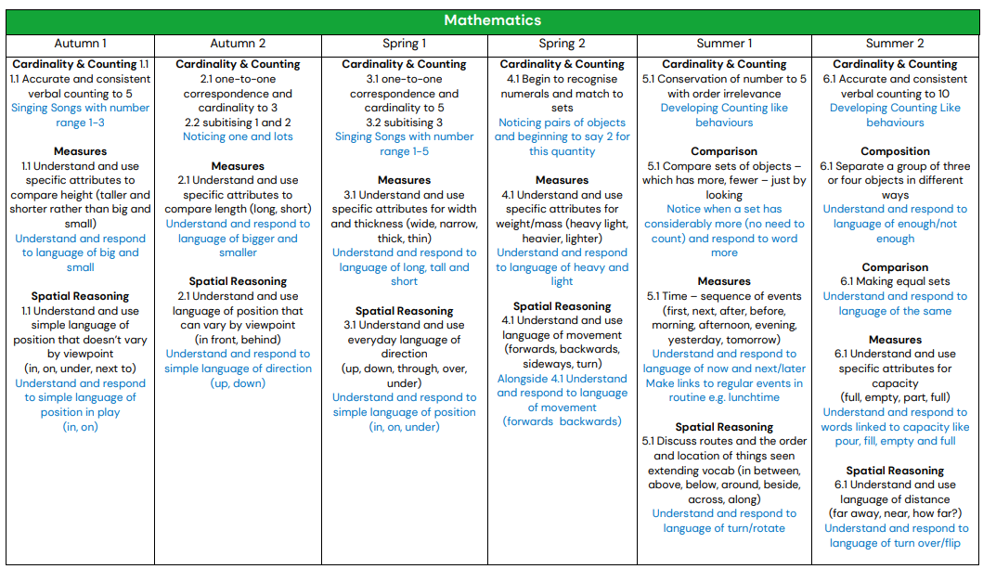

 | 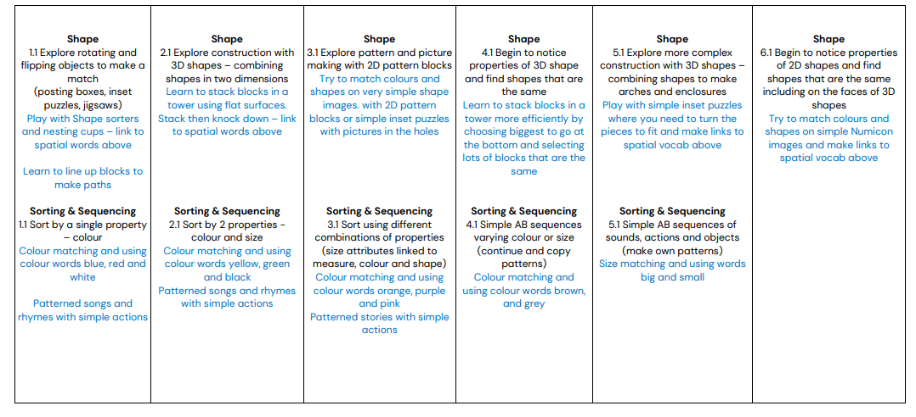
 | Autumn 1 | Autumn 2 | Spring 1 | Spring 2 | Summer 1 | Summer 2
Additional UTW Themes | Marvellous Me | Celebrations | Changes | Time to Grow | Our Wonderful World | On the Move
Understanding the World  People, culture & Communities  The natural world | Understanding the world involves guiding children to make sense of their physical world and their community. The frequency and range of children’s personal experiences increases their knowledge and sense of the world around them – from visiting parks, libraries and museums to meeting important members of society such as police officers, nurses and firefighters. In addition, listening to a broad selection of stories, non-fiction, rhymes and poems will foster their understanding of our culturally, socially, technologically and ecologically diverse world. As well as building important knowledge, this extends their familiarity with words that support understanding across domains. Enriching and widening children’s vocabulary will support later reading comprehension.
 | Begin to make sense of their own life story and family history – spend time with children talking about photos, memories. Talk about past events – stories and memories. How are we the same/different?  Help children to learn each other’s names, modelling correct pronunciation.  Talk about their 5 senses.  Use all their senses in hands on exploration of natural materials –Autumn.  Use outdoor area for children to explore freely. Mud kitchen. | Continue to develop positive attitudes about the differences between people. The diversity of British life.  Explore the seasons Autumn and Winter  Explore collections of materials with similar and/or different properties – make collections of natural materials: bark, leaves and seeds, conkers, shells and pebbles. Provide magnifying glasses etc.  Celebrate and value cultural, religious and community events and experiences. Diwali and Christmas stories | Show interest in different occupations.  People who help us – role play and small world play.  Stories of everyday superheroes.  What do you want to be when you grow up?  What kind of person do you want to be. Different material and the changes they notice.  Cooking, melting ice Model observational and investigational skills: ‘I wonder if…’ Using our senses to explore Winter | Plant seeds and care for growing plants Show and explain the concepts of growth, change and decay with natural materials.  Understand the key features of the life cycle of a plant.  Begin to understand the need to respect and care for the natural environment and all living things. Introduce new vocabulary related to their exploration. Encourage children to refer to books, wall displays and online resources. Using our senses to explore Spring | Understand the key features of the life an animal.  Help children to care for animals and to talk part in first hand scientific explorations of animal life cycles such as chick eggs or caterpillars.  Talk about what they see using a wide vocabulary.  Looking at maps and making own maps. | Know that there are different countries in the world - use maps, books, postcards, globe.  Moving on – induction into Reception Using our senses to explore Summer.  Explore and talk about different forces they can feel. Magnetic attraction and repulsion. Sinking and floating Explore how things work. Provide mechanical equipment for children to play with and investigate – wind up toys, pulleys. BeeBot, record player, iPad, cameras, telephones (past and present.) New buildings in our local area. Transport to and from school.
Science | Colour |  | Animals | Growing | Minibeasts
 | Autumn 1 | Autumn 2 | Spring 1 | Spring 2 | Summer 1 | Summer 2
General Themes | Marvellous Me | Celebrations | Changes | Time to Grow | Our Wonderful World | On the Move
Expressive arts and design  Children to explain their work to others. Children will have opportunities to learn and perform songs, nursery rhymes and poetry linked to their work / interests and passions.  Creating with Materials  Being imaginative and expressive | The development of children’s artistic and cultural awareness supports their imagination and creativity. It is important that children have regular opportunities to engage with the arts, enabling them to explore and play with a wide range of media and materials. The quality and variety of what children see, hear and participate in is crucial for developing their understanding, self-expression, vocabulary and ability to communicate through the arts. The frequency, repetition and depth of their experiences are fundamental to their progress in interpreting and appreciating what they hear, respond to and observe. Give children an insight into new musical worlds. Invite musicians in to play music to children and talk about it. Encourage children to listen attentively to music. Discuss changes and patterns as a piece of music develops.
 | Join in with songs; beginning to mix colours, Explore colour and colour mixing techniques –talk about differences join in with role play games and use resources available for props; build models using construction equipment.  Sing call-and-response songs, so that children can echo phrases of songs you sing.  Self-portraits.  Provide opportunities to work together to develop and realise creative ideas. | Listen to music and make their own dances in response. Nativity songs  Explore sounds patterns  Recite Nursery Rhymes  Manipulate malleable materials to create models | Respond to what they have heard, expressing their thoughts and feelings. | Make different textures; make patterns using different colours. Home Corner role play Encourage children to draw from their imagination and observation of plants.  Provide a wide range of props for play which encourage imagination. | Exploration of other countries –dressing up in different costumes.  Retelling familiar stories Provide children with a range of materials for children to construct with.  Children choose what they want to create. Music from other countries. Look at artists from across times and cultures | Puppet shows: Provide a wide range of props for play which encourage imagination. Design and make vehicles. Remember and sing entire songs.
Art and Design  Kapow  3 units (5 lessons in each unit) which can be taught in any order | Painting and mixed media:  Experiment with a variety of media; different brush sizes and tools.  Explore colour and colour mixing.  Explore lightening and darkening paint without the use of black or white.  Begin to control the types of marks made with the range of media.  Experiment with colour, shape and lines.  Experiment with space. |  | Drawing:  Create closed shapes with continuous lines and begin to use these shapes to represent objects.  Draw with increasing complexity and detail, such as representing a face with a circle and including details.  Use drawing to represent ideas like movement or loud noises.  Show different emotions in their drawings and paintings, like happiness, sadness, fear, etc.  Show different emotions in their drawings – happiness, sadness, fear, etc.  Use one-handed tools and equipment, for example, making snips in paper with scissors |  | Sculpture and 3D:  Use one-handed tools and equipment, for example, making snips in paper with scissors.  Explore different materials freely to develop their ideas about how to use them and what to make.  Develop their own ideas and then decide which materials to use to express them.  Join different materials and explore different textures.  Use a comfortable grip with good control when holding pens and pencils.  Show a preference for a dominant hand.
Design and Technology | Cooking and Nutrition  Focus – using a grater safely  Product - Pizza toppings  Use a range of small tools, including  scissors, paintbrushes and cutlery.  Understanding the importance of  healthy food choices. |  | Textiles  Focus – cutting out & joining fabric techniques  Product - Easter Basket  Use a range of small tools, including scissors, paintbrushes and cutlery.  Safely use and explore a variety of  materials, tools and techniques, experimenting with colour, design, texture, form and function.  Share their creations, explaining the  process they have used. |  | Junk Modelling  Focus - cutting and shaping with scissors, tape.  Product – Boat  Use a range of small tools, including scissors, paintbrushes and cutlery.  Safely use and explore a variety of materials, tools and techniques, experimenting with colour, design, texture, form and function.  Share their creations, explaining the process they have used.  Make use of props and materials when role playing characters in narratives and stories.
Outdoor  Learning | Forest School:  Team Building Games  Exploring the school grounds  Ribbon wands and chalking  Observing creation  Treasure Hunts  Autumn crowns  Autumn walk  Shapes outdoors  Seasonal and weather changes  Make a Log dog  Forest animals and where they live -  badgers  Nocturnal animals  Clay Hedgehogs  Make forest pictures |  | Forest School:  Shelters  Fires for cooking  Growing plants  Contribute to fire lighting by gathering fuel  Roast marshmallows  Pancakes  Seasonal and weather changes  Encourage interactions with the outdoors to  foster curiosity and give children freedom to  touch, smell and hear the natural world  Hands-on experiences – use senses to  explore  Follow simple maps of the school grounds  Snow days  Make a Stickman  Build a den for an animal  Planting seeds – beans, different vegetables |  | Forest School:  Using tools  Introduction to tools - peelers (with gloves)  for whittling, hammers, mallets, trowels and  forks for planting.  Pond dipping  Bug hunting and investigating  Making a bug hotel  After close observation, draw pictures of the  natural world  Features of local environment  Happa Zoming
 | Autumn Term |  | Spring Term |  | Summer Term
Enrichments | Diwali  Bonfire Night  Children in Need Day  Remembrance Sunday  Anti-bullying Week  Advent  Christmas |  | Mothering Sunday  Science Week  Internet Safety Week  Luna New Year  Shrove Tuesday/Ash Wednesday  Cooking pancakes  Lent  World book day  Harmony/Diversity Week  Holi  Sports/Comic Relief Day  Palm Sunday |  | Pentecost  Father’s Day  Pond Dipping  Aspirations Week  Sports Day  Transition into Reception

