
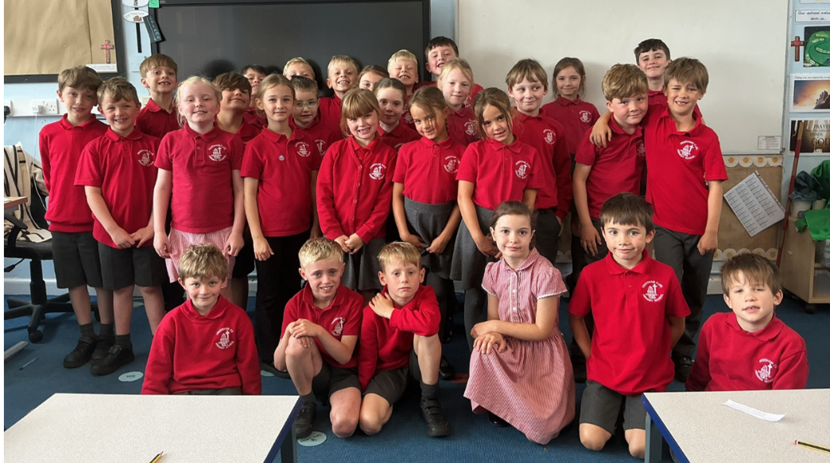
I hope you have all had a fabulous summer and are well rested for the new school year. I have had a brilliant first few weeks getting to know the children and they have made an amazing start to the year! I am also very excited to be joining the Frodsham CE family and look forward to working in partnership with you to support the children as they learn, grow and thrive throughout the year. This term we are exploring lots of exciting topics including the Stone Age and Plants. The curriculum maps are on the class web page for further information.

Staff
We are very fortunate to have Mrs Highdale working with us for part of each morning to support learning and help us grow this year. On Tuesday afternoons Mrs. Williams will teach PE lessons and on Wednesday afternoons, Mrs Palfreyman will teach PSHE and French lessons.

Reading
As the children move into KS2, reading continues to be a key focus. Whole class reading sessions give pupils the chance to explore a range of texts, develop comprehension, and build fluency and intonation. Children will also be provided with a banded reading book matched to their current reading ability, ensuring they are appropriately challenged and supported as they progress. Pupils should bring their reading book and record to school daily so that staff can log their progress and set weekly pages. In addition, each child has a ‘reading for pleasure’ book chosen from the class bookcase, which they may enjoy independently or with an adult at home. Reading diaries also contribute to our whole school ‘Read Around the World’ initiative, with stickers awarded weekly for home reading. Parents can further support by discussing texts and asking comprehension questions, helping foster a lifelong love of reading.

Homework
English and maths homework will be given out in alternate weeks on a Friday and due back the following Wednesday. There will also be weekly TT rockstars tournaments which the children are encouraged to play on. Children will also receive Spelling Shed login details and are encouraged to practise their weekly spellings regularly at home using the platform. If any account usernames and/or passwords are lost or not working, please don’t hesitate to get in contact.

PE
PE is on Tuesday afternoons, please ensure your child has a full PE kit in school for this. Kit should include appropriate footwear, and for girls, spare socks if tights are usually worn. In colder weather, a school jumper or hoodie can be worn with plain jogging bottoms. Long hair should be tied back and earrings must be removed for PE. If your child cannot do this independently, it must be done before school.

Water bottles
Water bottles are kept at the front of the classroom in baskets, and children have opportunities throughout the day to hydrate and refill bottles. Please ensure your child brings their water into school every day.

Celebrations/ Show and Tell
It is always lovely to hear what the children have been up to outside of school and any special achievements or occasions are invited to be shared with the class. Where possible, Show and Tell will take place on a Monday, although this may occasionally be moved to another day depending on our timetable and class commitments. You are welcome to email in any certificates/ pictures of these to admin@frodshamce.cheshire.sch.uk where they will be forwarded to myself. I would ask that when sending you put the child’s name and Year 3 in the subject line to help them get to me as quickly as possible. It is brilliant to see the children developing their speaking and listening skills and it is fantastic to see them sharing things important to them with the whole class.

Trips
We are looking forward to attending lots of exciting educational trips throughout the year to link with our learning and enrich our understanding. We hope to go on a trip in the autumn term. There will be more information on this in the coming weeks!

Worries
I am always very happy to discuss any concerns or general queries with you and please do not hesitate to get in touch. Please feel free to email in any concerns with your child’s name and year group as the subject line and I will always try to reply by the end of the day. For any larger concerns I am happy to arrange a convenient time to talk.

Meet the Teacher
There will be a meet the teacher evening on Thursday 17th September at 4:30pm which will run through some information for the year ahead and allow you to see the classroom and ask any questions you might have.

Again, I am very excited to be working with the children and yourselves, I hope we all have a brilliant year!

Best wishes,
Miss. Chesworth.

