In geography I will be exploring human and physical features of our school grounds. In History I will begin to explore how features of the local area have changed over time.
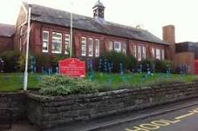
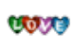
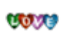
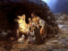
As part of outdoor learning I will be developing my skills in team building games, observing creation, taking part in curriculum based treasure hunts, looking at shapes outdoors and observing seasonal changes.
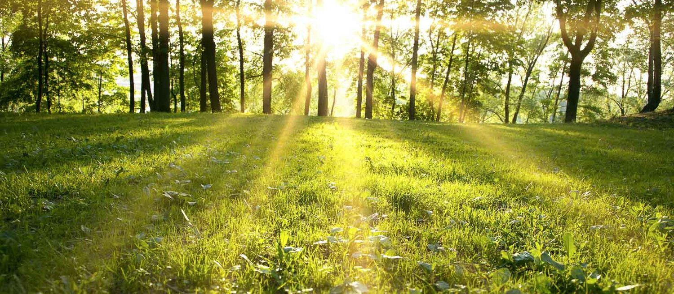
In Religious Education I will be learning about Courageous Advocacy, Creation, baptism and Incarnation:
How can I be a courageous advocate and speak up for injustices?
What does the story of creation teach people and how do people with different and similar worldviews believe the world began and how should we look after it?
Why is baptism special, how do people welcome babies and what does it mean to belong?
How do Christians welcome Jesus, why is Christmas celebrated by Christians and how will Christians celebrate Christmas in the local churches?

In PE I will be exploring ways to ensure my own health and well-being whilst developing my running, jumping and gymnastic skills.
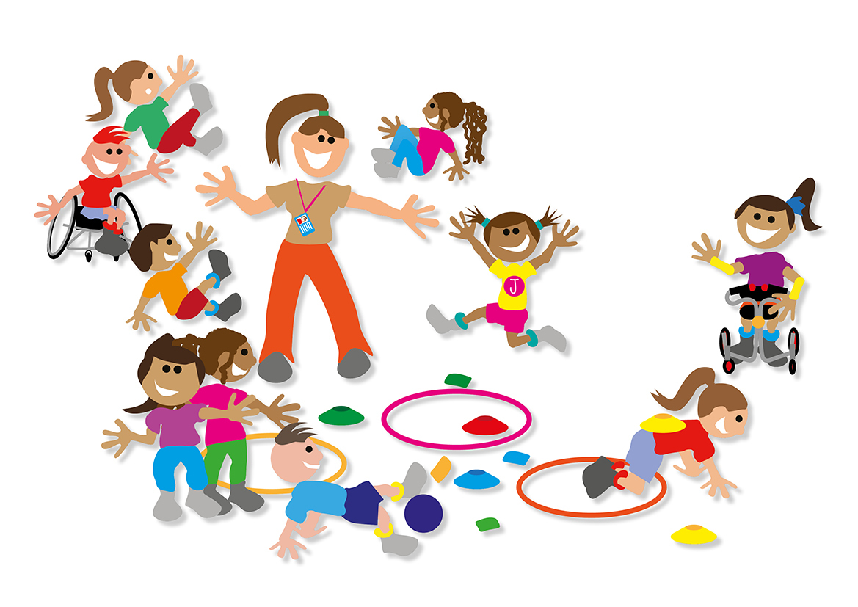
In art I will be developing my drawing skills. I will be exploring lines of different sizes and textures and how these can be used to make patterns. I will also find out about the artist Bridget Riley.
In DT I will be exploring how fruits can be used to make kebabs and why these are healthy for us.
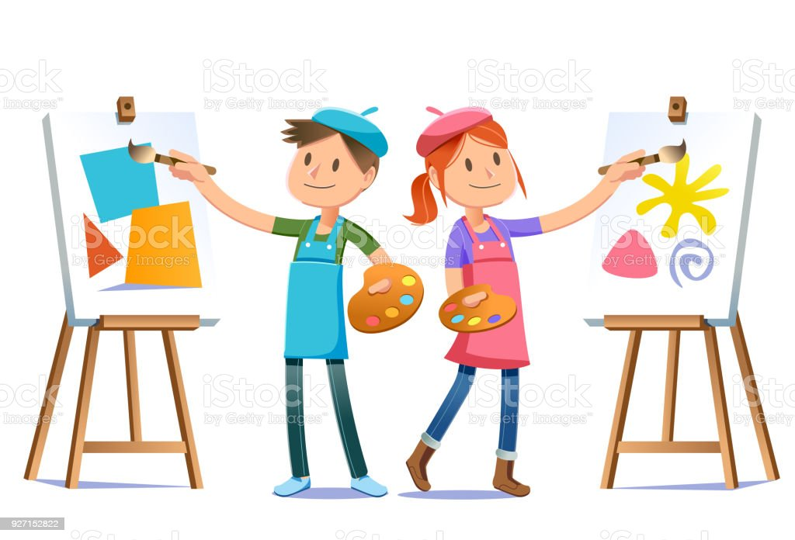

Year 1
Autumn Term

In computing I will be finding out about computing systems and network and how technology can help me in everyday life.

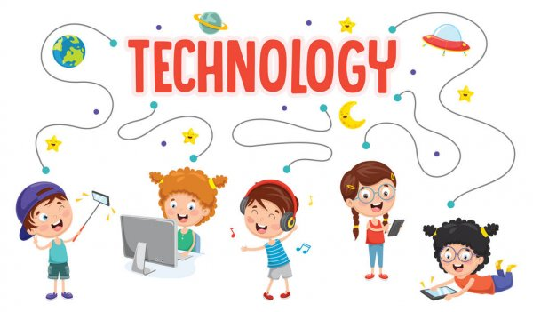
In music I will be learning about pulse, rhythm, dynamics and tempo using a range of songs and genres of music.
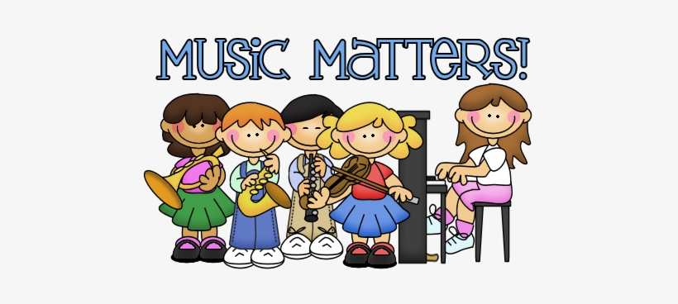
In PSHE I will be learning about how to make and have healthy relationships and how to respect myself and others.
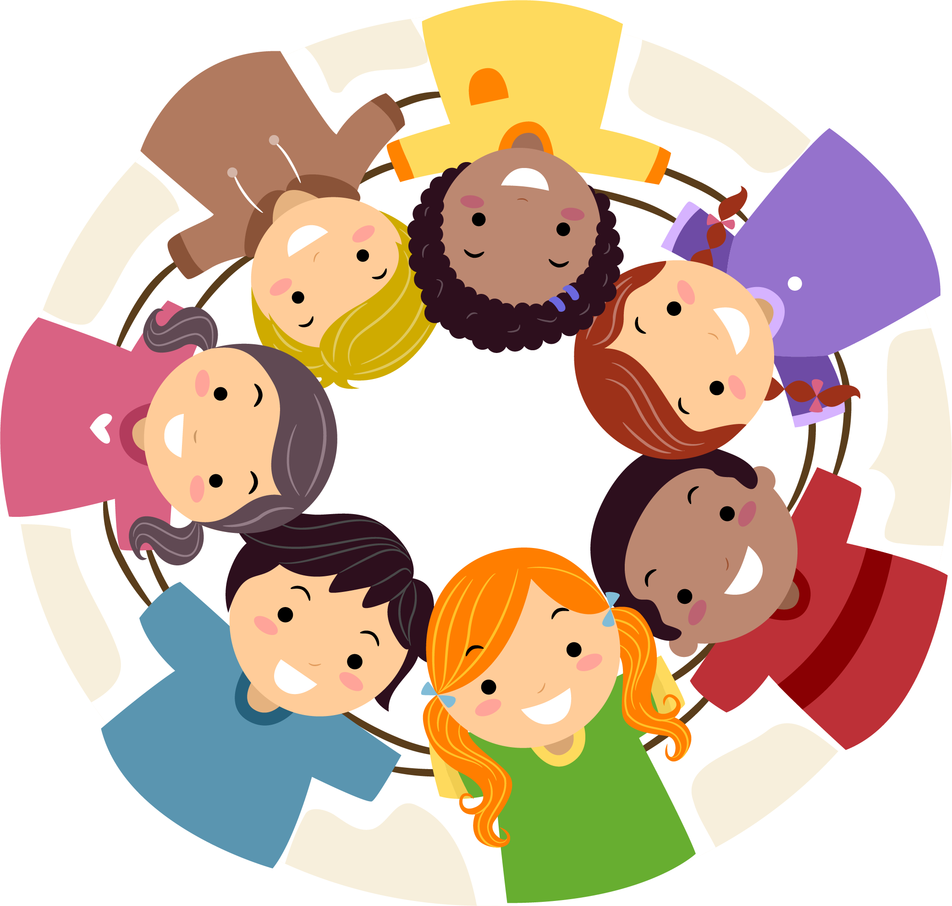
As a mathematician I will be working to secure my knowledge of:
Place value 0 – 10 and then to 0 - 20
Addition and subtraction within 10 and 20

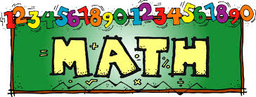

As a scientist I will be learning about the seasons and animals including humans:
Identify seasonal changes.
Identify different parts of the human body and show which part of the body is associated with each sense.
Identify and name a variety of common animals.
Sort animals into groups according to what they eat.
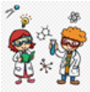
As a reader I will be learning how to:
Build my sight vocabulary skills and improve my ability to blend phonic sounds.
Begin to make inference on the basis of what is being said and done.
Discuss sequences of events in books and make predictions about what might happen next.
Discuss how information is shared in non-fiction books.
As a writer I will be learning how to:
Say a caption orally before independently writing it.
Write factual sentences about penguins to create a whole class penguin fact book.
Plan and write an adventure story based on the structure of ‘Lost and Found’.
Write a diary entry in the first person based on Nibbles’ adventures.
