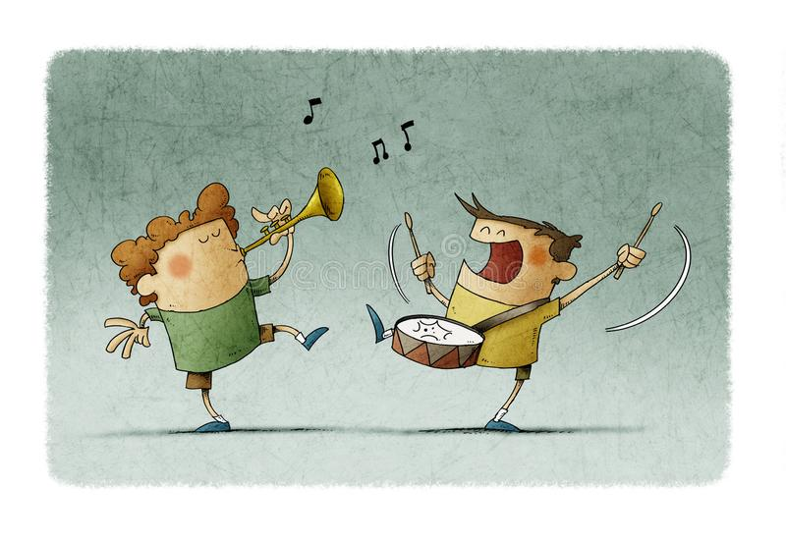
In music I will be developing further my skills of: dynamics, rhythm, tempo and pitch.
Describing the character, mood and story of a piece of music.
Comparing pieces of music and expressing how they make me feel.

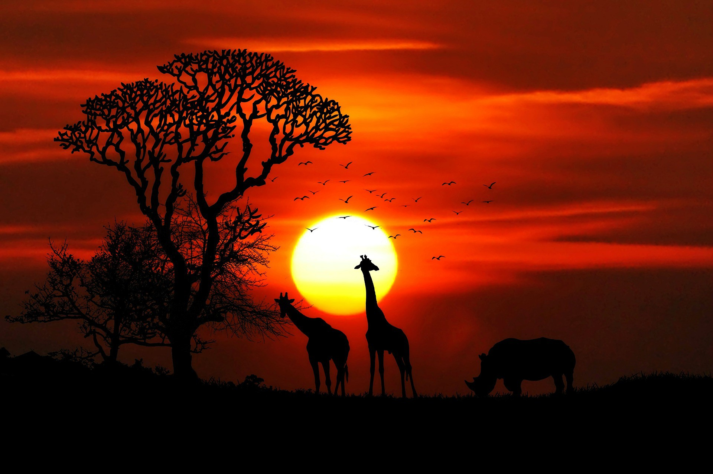
In geography I will be learning how to use a compass as well as exploring and comparing the UK and Africa before deciding which one I would rather live in!

As part of forest school I will be developing my understanding of life in the forest and how we can creatively use materials which are found there.

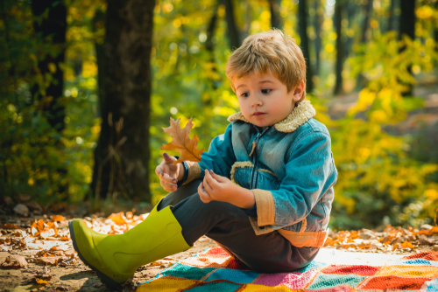
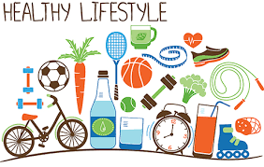
As a mathematician I will be continuing to secure my knowledge of:
Multiplication and division using concrete objects.
Fractions such as ½ and ¼.
Position, direction and movement, including whole, half, quarter and three-quarter turns

As a reader I will be developing my skills in:
Continuing to build my sight vocabulary skills and improving my ability to blend phonic sounds.
Making inferences on the basis of what is said and done in the text.
Discussing sequences of events in books and making predictions about what might happen next.
Discussing how information is shared in non-fiction books.
As a writer I will be developing my skills in:
Writing in both a fictional and factual style, including planning and writing stories, diary entries and information facts.
Segmenting and phonetically spelling words within my writing, including using plurals ‘s’ and ‘es’ as well as suffixes such as ‘ing’, ‘ed, ‘er’ and ‘est’.
Punctuating my work correctly with capital letters, full-stops, question marks and exclamation marks.
This terms main text will be:
Toys in Space by Mini Grey
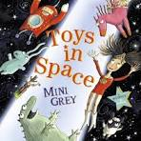

As a scientist I will be learning about plants:
I will be able to identify and label a range of plants including some trees.
I will be able to explain the structure of plants, including roots, stem, flower, etc.
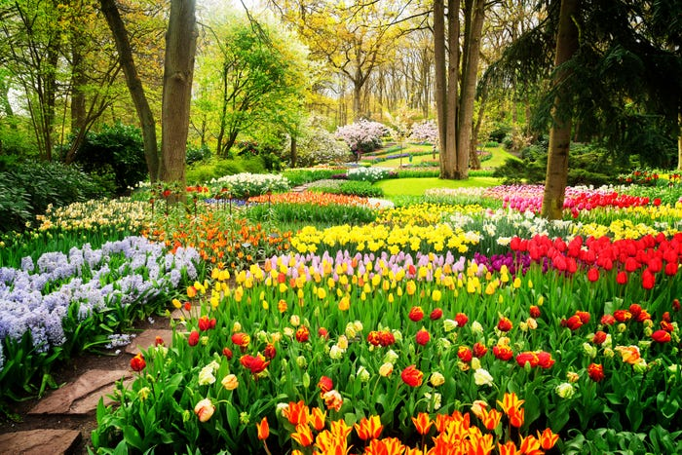

In PSHE I will be learning about how to keep safe and healthy, including looking after my mental health, as well as thinking about what makes me unique and special.
In PE I will be developing my jumping and skipping skills alongside extending my hand-eye co-ordination skills when using a bat and ball to play simple games with a partner and in groups.
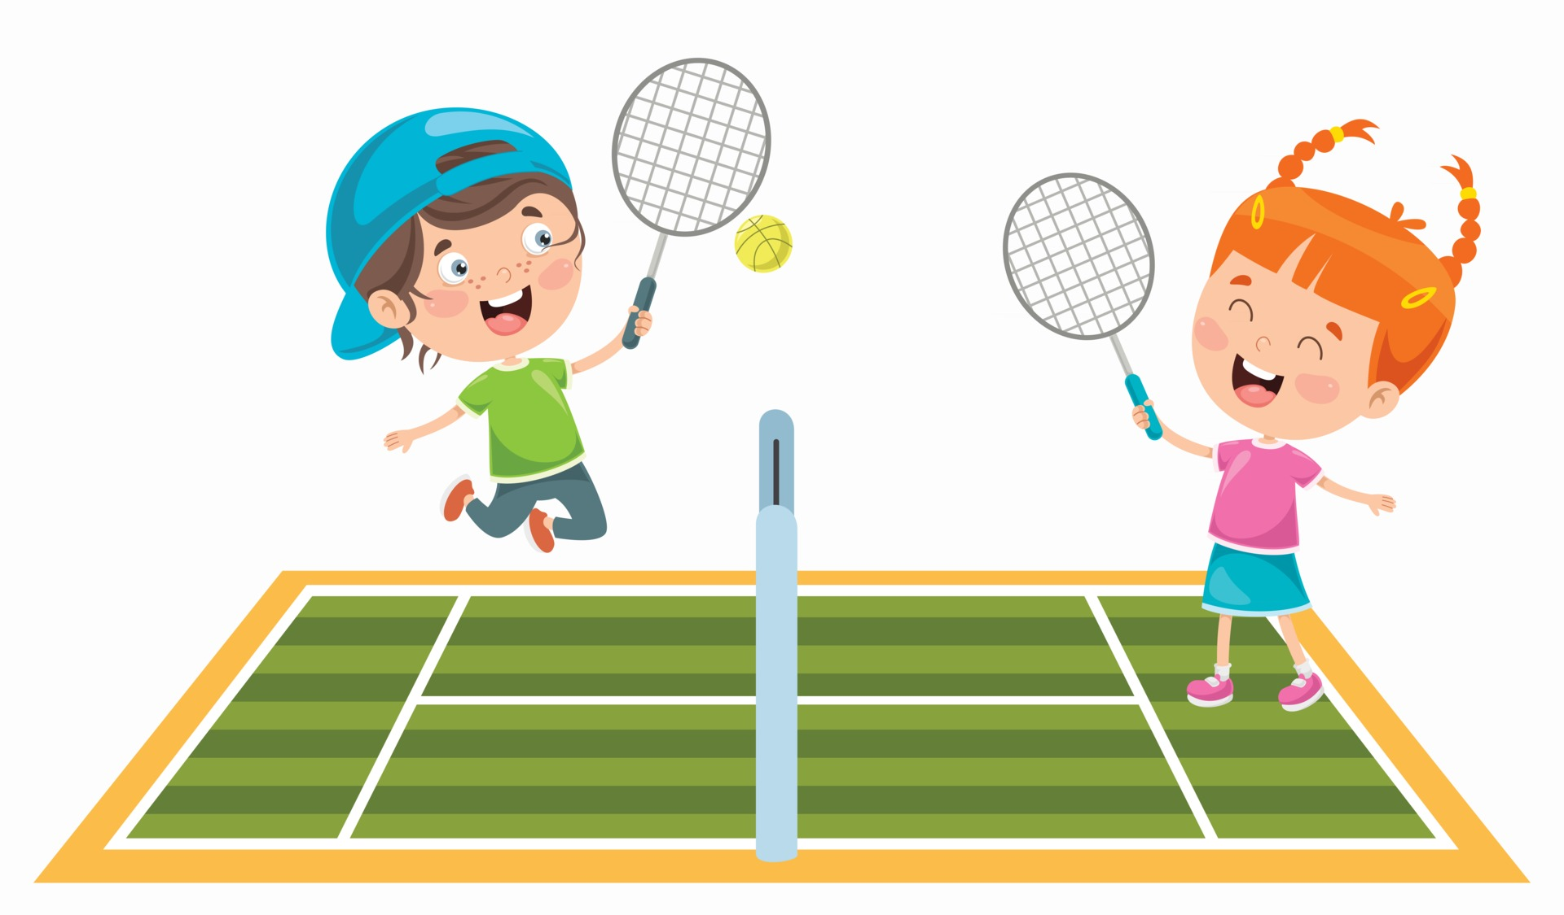
In art I will be further exploring how primary colours can be used to make secondary colours and how to make tones and shades of colour.
In DT I will be exploring how to use sliders and levers to make a moving picture.

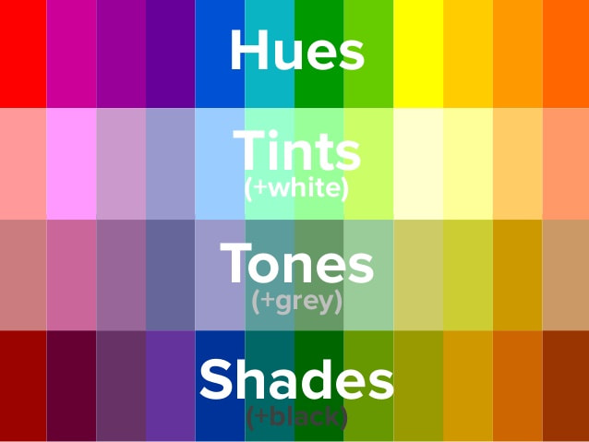
Year 1
Summer Term

In Religious Education I will be learning about:
What Muslims use to learn about and express their faith?
What did Jesus teach people about God’s love? Why did Jesus tell stories?
How is light used in religious festivals, rites of passage and worship?
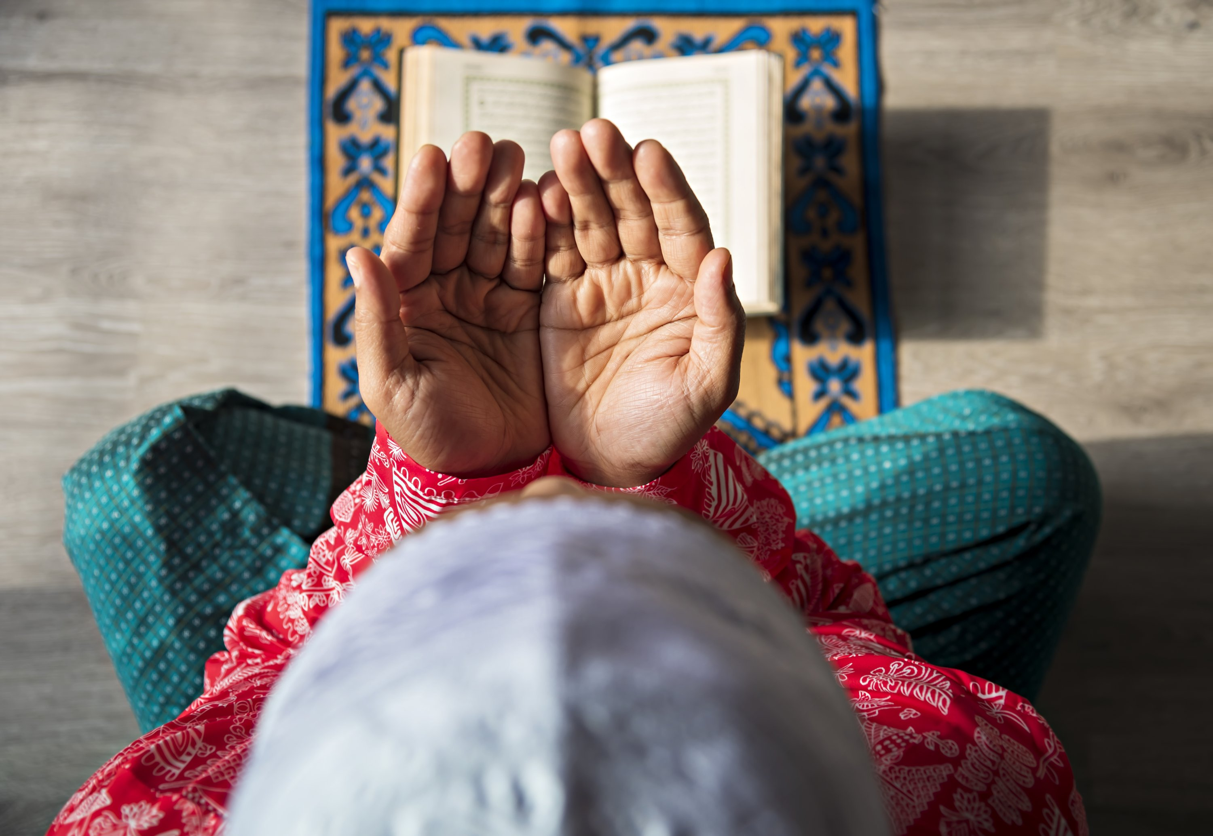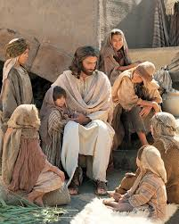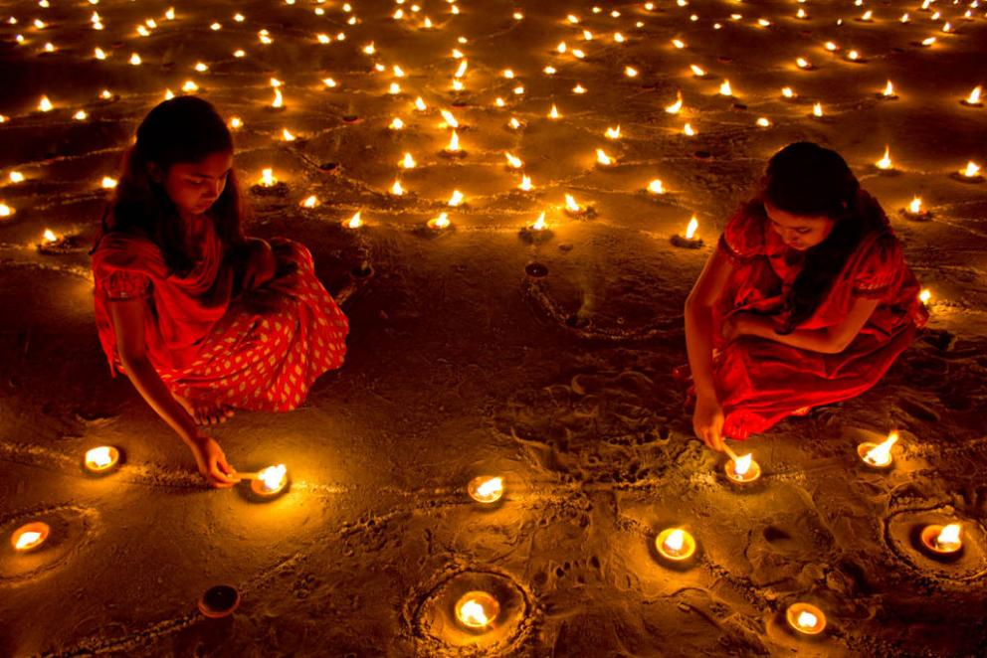

In computing I will be learning how to safely access the internet for simple research and to access images which I will then use to create a digital card.


