Frodsham CE School
Year 4 Weekly Spellings
We would be grateful if you could please help your child to practice these spellings ready for a test each Monday.
Test date  Mon 2nd March | Test date  Mon 9th March | Test date  Mon 16th March | Test date  Mon 23rd March | Test date  Mon 30th March
breath  business  caught  different  exercise  extreme  medicine  possession  although  thought | naughty  caught  fraught  automatic  astronaut  cause  author  applaud  taught  audience | invention  injection  action  hesitation  completion  stagnation  nomination  migration  conservation  selection | expression  discussion  confession  permission  admission  impression  obsession  procession  omission  concussion | musician  magician  electrician  politician  mathematician  technician  optician  beautician  physician  dietician

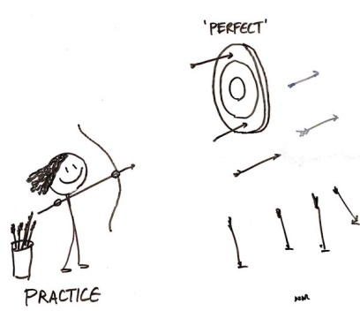
Thank you for your help with this, going over the words at home really does make a big difference to help the children learn and remember their spellings.
Mrs Palfreyman

