Frodsham CE School
Year 4 Weekly Spellings
We would be grateful if you could please help your child to practice these spellings ready for a quiz each Monday.
Test date  Mon 12th Jan | Test date  Mon 19th Jan | Test date  Mon 26th Jan | Test date  Mon 2nd Feb | Test date  Mon 9th Feb
expansion  extension  comprehension  tension  suspension  exclusion  provision  explosion  erosion  invasion | poisonous  dangerous  mountainous  marvellous  perilous  tremendous  enormous  jealous  precious  disastrous | courageous  outrageous  nervous  famous  adventurous  disadvantageous  ridiculous  carnivorous  rapturous  torturous | merriment  happiness  plentiful  penniless  happily  prettiest  nastiness  beautiful  pitiful  silliness | serious  obvious  curious  hideous  spontaneous  courteous  furious  various  victorious  gaseous
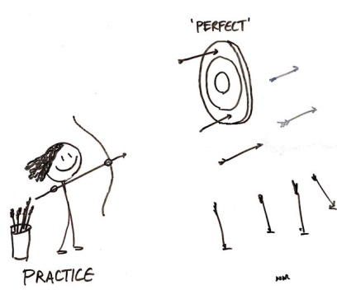
Thank you for your help with this, going over the words at home really does make a big difference to help the children learn and remember their spellings.
Mrs Palfreyman

