Dear Parents,

We hope that you all had a relaxing Christmas break and feel well rested. Thank you so much for all the lovely cards, gifts and messages. You are all very kind! We were also very grateful for your support with our reverse advent calendar, helping to support our local food bank and provide toiletry hampers for Women’s Aid.

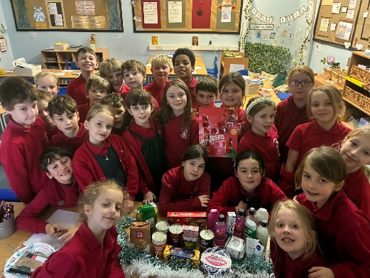
Year 4 had a fantastic autumn term, with highlights including our visit to Noddfa, our Ancient Greek topic and VR workshop, and publishing our writing based on Gorilla and Leon and the Place Between.

Curriculum
During the spring term our topic will be The Romans. We have attached a topic web that will enable you to see the learning journey that your child will be undertaking across the rest of the term.

PE
We are timetabled to have PE on a Monday and Friday so please remember to bring in PE kits after the weekend. Please make sure that your child keeps their PE kit in school for the whole week, due to any potential swaps and extra sessions and that every piece of clothing is labelled with their name.

Homework
Please encourage your child to read at home as much as possible and to have their reading diaries signed and dated. We will continue to check reading diaries as part of our Read Around the World Whole school challenge.
Spellings will be given out at the beginning of term for the whole term and spelling tests are on a Monday.
English and maths homework will continue to be set on a Friday, due in the following Wednesday. Please also encourage your child to learn their times tables. We will be practising these in class and will have a weekly times table check. The children have done a fantastic job so far learning and recalling their tables so thank you for your support.

We’re also very excited to share our class worship with you, which will be held in the school hall on Friday 23rd January at 9.05am. Year 4 will also be leading a Lenten service on Tuesday 17th March at 9.15am, which you are welcome to attend.

As always, feel free to pop over before or after school to speak to us if you have any concerns or questions or email admin if you would rather have an appointment. We look forward to continuing to work with you and your child and building on the fantastic autumn term that we have had. This is going to be an exciting term with our residential to look forward to and an educational visit linked to our Romans topic. Further details will follow.

Yours sincerely,

Mrs Hughes and Mrs Palfreyman

