Dear Parents and Families,

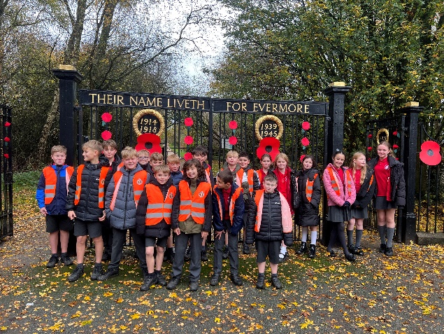
I hope you all had a lovely Christmas break and were able to enjoy some quality time with family. A huge thank you for the very kind gifts and cards, before the holidays.

Our class have really risen to the challenges of Year 6 and impressed us with the way they embraced their responsibilities as leaders and buddies during the autumn term. They have shown maturity, resilience and a fantastic attitude to learning. I am incredibly proud of them and am looking forward to another busy but very rewarding term ahead.

Staff
Y6 will continue to be supported by Miss Forster and Mrs Gardiner during mornings until Mrs Gardiner’s retirement in February. I will update you once future arrangements are confirmed. Mrs Palfreyman will continue teaching science for part of Wednesday morning, and Mrs Williams will teach PE on Wednesday afternoon.

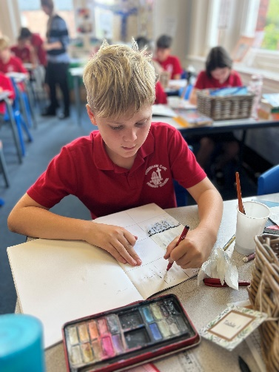
Learning focus and SATs
During the spring term, we aim to cover much of the Year 6 maths curriculum, as well as spelling, punctuation and grammar, alongside revising key learning from previous years. This will prepare your child for the SATs assessments, which will take place in the summer term from 11th–14th May. Further details will be shared at the SATs meeting, where I will explain the week in more depth.

Our aim is to ensure the children feel confident and positive about the assessments, giving them the opportunity to work hard, achieve their potential and enjoy some well-earned downtime afterwards. We will also move on from history to our local area geography topic, exploring Frodsham’s human and physical geography. This term’s topic web has been attached and outlines the units for each subject.

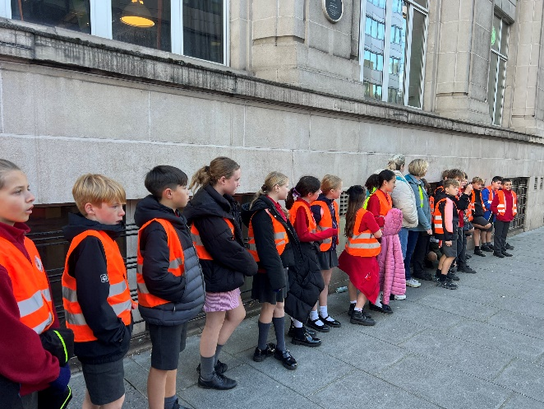
PSHE
Year 6 will also be having a PSHE focus this term. As well as following our PSHE Association curriculum and using the No Outsiders books, we will be doing some work on social stories and scenarios to support children in exploring different situations they may encounter. This aims to develop confidence, empathy and problem-solving skills, as well as supporting your child in making positive choices and building healthy relationships as they prepare for the transition to secondary school.

Homework
Your child has been given a new personal spelling grid for the half term, based on assessments of the Year 5 and 6 statutory spelling list (or Year 3 and 4 where appropriate). Children will practise these daily in school, but regular practice at home is also important. Discussing meanings and using spellings in sentences will really support their learning.

Homework routines will remain largely the same. However, I have introduced a new weekly Spelling Shed task, to further support spelling practice at home. This is a short five-minute activity designed to consolidate the words we have already covered during the week.

We will also continue with weekly arithmetic papers, which will either be available to view on Maths.co.uk or sent home as a paper copy. Children will mark and correct these in class, but additional support at home will help to build confidence and accuracy.

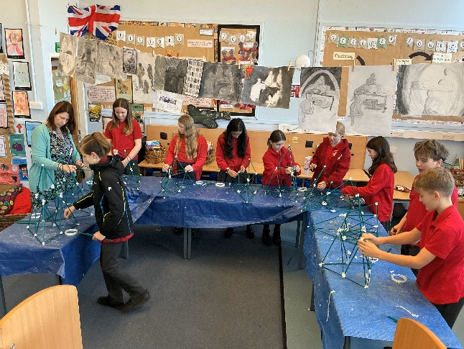
Dates
RE Trip (Sikh Gurdwara): Monday 12th January
SATs and Conway meeting: 4.30pm, Monday 19th January
Year 6 Forest School: Monday 9th February
Year 6 Lenten Service: 9.15am, Tuesday 3rd March, St Laurence Church

I have really enjoyed working with the class so far this year and am very much looking forward to the coming months. Thank you, as always, for your ongoing support at home. It truly makes a huge difference. Please do not hesitate to get in touch if you have any questions or concerns.

Kind regards,

Miss Cartwright

