Welcome back to Year 3!

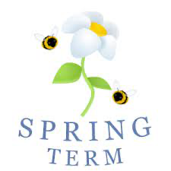
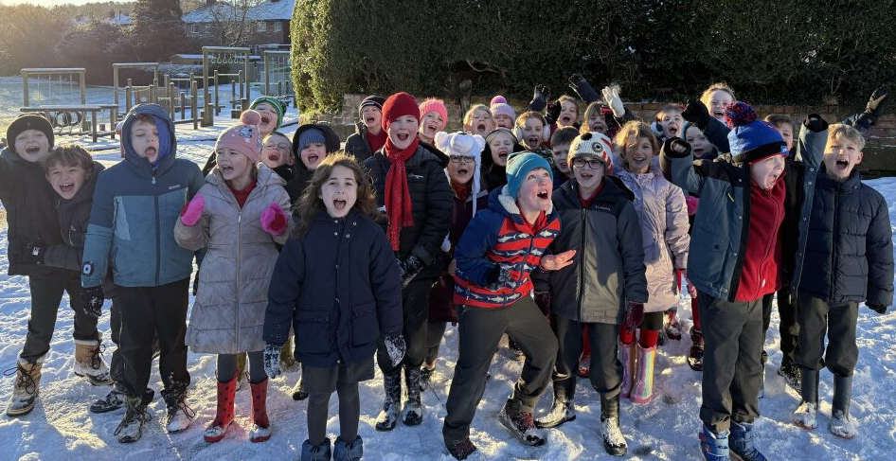

I hope you all had a fantastic Christmas holiday, New Year and a lovely break. Thank you again for your kind and generous gifts! We are super excited to welcome the children back to school and hear all about their Christmas holidays!

This term, through our geography learning we will be exploring our local area and comparing this to other cities. In our science unit: Humans including Animals, we will be investigating how our bodies work and answering the question ‘what makes us move’. Please see the attached curriculum map for further information.

Staff
We are fortunate to have Mrs Barlow and Miss Highdale working with us this term. On Tuesday afternoons Mrs Williams will take PE lessons.

Reading
After the success of the Guided Reading last year, we will be continuing this term with some new books. Following the structure, the children will have set pages to read each week and I will discuss this with them in class. It was lovely to see the children so engaged with the various texts and the progress made was exceptional. As always, we appreciate your support at home and detailed comments in reading diaries from home helps us to identify common areas that need development.

It is essential reading diaries are brought in every day as we will be looking through them in school and changing books accordingly.

Homework
English and maths homework will be given out weekly on a Friday and due back the following Wednesday. On the occasion that a creative homework is set, this will be the only piece given out. We may sometimes set homework online, and this will be communicated in the children’s homework books. There will also be weekly TT rockstars tournaments which the children are encouraged to play on. If any account usernames and/or passwords are lost or not working, please don’t hesitate to get in contact. We will also have weekly spelling tests on a Friday, the children may have different spellings based on the targets they are working towards, and these will be stuck into the back page of their reading diary at the start of each half term.

PE
PE is on Tuesday afternoons, please ensure your child has a full PE kit in school for this. Kit should include appropriate footwear (pumps for indoor activities and trainers for outdoor), plain black jogging bottoms (weather dependent) and for girls, spare socks if tights are usually worn. Long hair should be tied back for PE and earrings must be removed. If your child cannot do this independently, it must be done before school.

Water bottles
Water bottles are kept at the front of the classroom in baskets, and children have opportunities throughout the day to hydrate and refill bottles. Please ensure your child brings their water into school every day.

Celebrations/ Show and Tell
It is always lovely to hear what the children have been up to outside of school and any special achievements or occasions are invited to be shared with the class. We will have Show and Tell throughout the week, depending on our schedule and time available in class. You are welcome to email in any certificates/ pictures of these to admin@frodshamce.cheshire.sch.uk where they will be forwarded to myself. I would ask that when sending you put the child’s name and Year 3 in the subject line to help them get to me as quickly as possible. I know we had some lovely images and videos shared last term of the various activities the children get up to outside of school! It is brilliant to see the children developing their speaking and listening skills and it is fantastic to see them sharing things important to them with the whole class.

Worries
I am always very happy to discuss any concerns or general queries with you and please do not hesitate to get in touch. Please feel free to email in any concerns with your child’s name and year group as the subject line and I will always try to reply by the end of the day or catch you on the playground. For any larger concerns I am happy to arrange a convenient time to talk and discuss without a time constraint.

Dates
We will be in contact about upcoming trips and events, please check school spider for this.
Our class Worship is Friday 6th March, parents and carers are invited to join us at 9.05am.

Thank you all for such a fantastic Autumn Term and here is to an excellent Spring!

Miss. Kelly.

