As a mathematician I will be continuing to secure my knowledge of:
Place value within 20
Addition and Subtraction within 20
Geometry – learning about 2D and 3D shapes
Fractions – halves and quarters

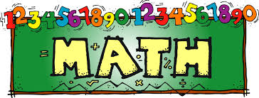

In PSHE I will be learning about how to live in the wider world including thinking about what it is like to belong to a community, how to communicate appropriately on line and the importance of jobs within the local community.

In music I will be learning about timbre, rhythmic patterns and musical vocabulary whilst listening to a wide range of classical and popular music.
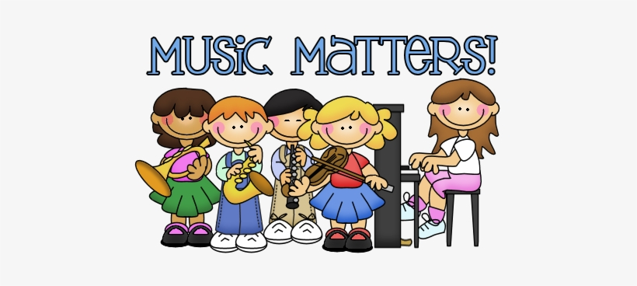
In history I will be looking at changes in living history and exploring how the local high street has evolved over the years

What do Muslims believe about Allah and Muhammad (PBUH)
What do you think is the most important part of the Easter story?
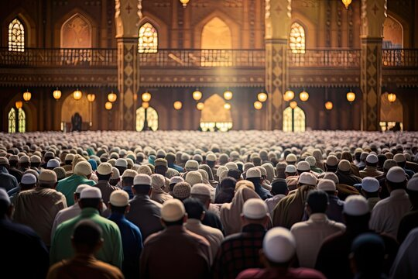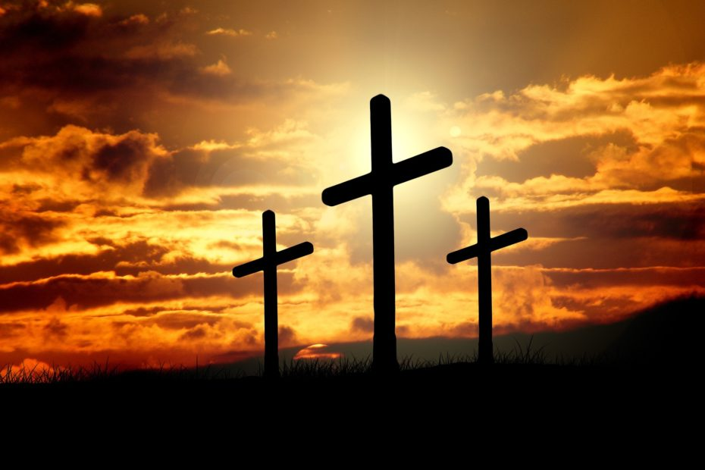

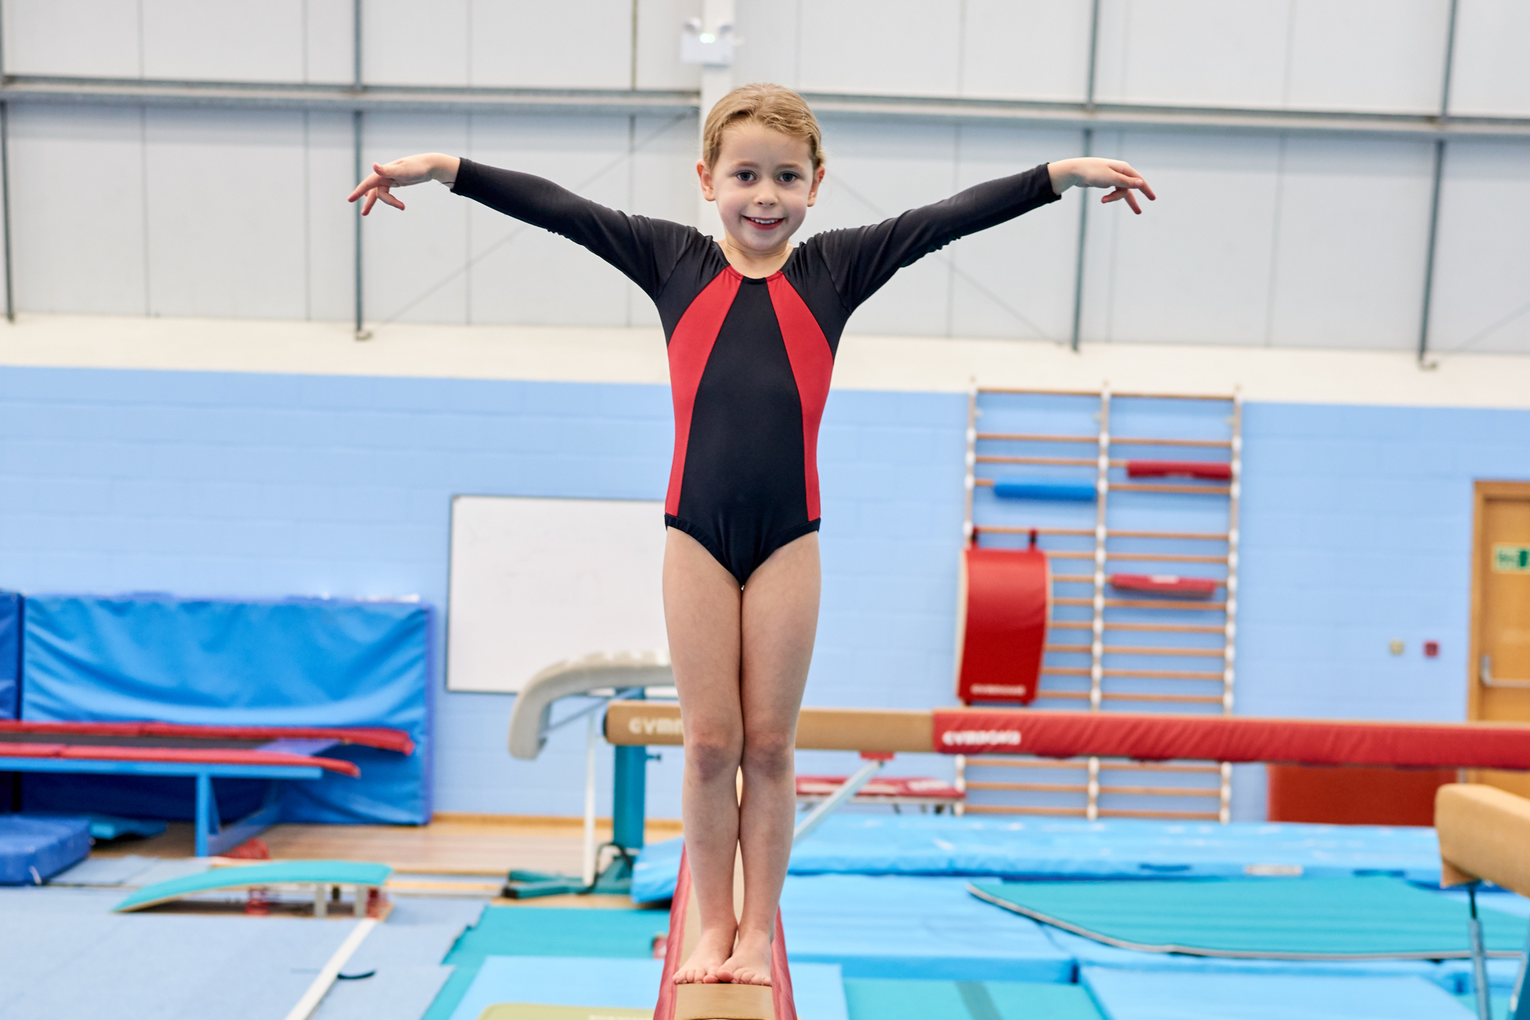
As a scientist I will be learning about materials:
I will be able to identify a range of materials such as wood, plastic, glass, metal, water and rock as well classify and group materials according to a range of physical properties.
I will be able to group animals using a variety of criteria.
As a reader I will be developing my skills in:
Building my sight vocabulary skills and improving my ability to blend phonic sounds.
Making inference on the basis of what is being said and done in the text.
Discussing sequences of events in books and making predictions about what might happen next.
Discussing how information is shared in non-fiction books.
As a writer I will be developing my skills in:
Orally rehearsing my ideas before independently writing them.
Writing in both a fictional and factual style, including planning and writing my own story.
Segmenting and phonetically spelling words within my writing.
Punctuating my work correctly with capital letters and full-stops.
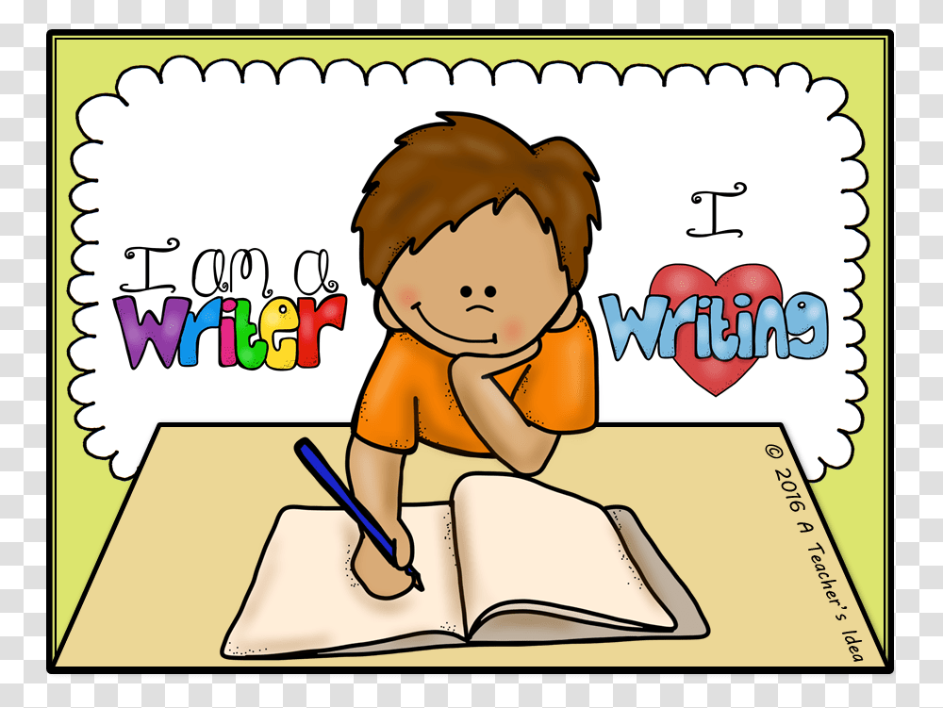

In PE I will be developing my foot work skills and learning how to control a ball as I move it around the area as well as developing my hand-eye co-ordination skills for throwing and catching.
I will also be developing my gymnastic
skills in movement and balance.

In art I will be using primary colours to make secondary colours and experimenting with different ways of applying paint to a surface.

In DT I will be learning about sliders and levers to create a class book.
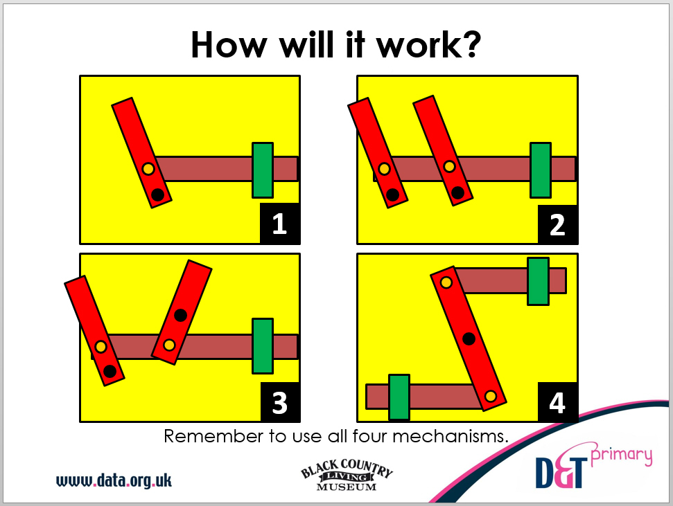

Year 1
Spring Term

In computing I will be exploring how to illustrate an eBook and how to browse the internet to find suitable images.
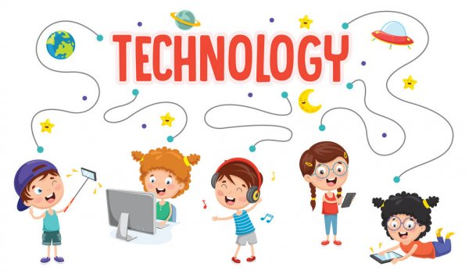
As part of forest school I will be developing my skills of working in a team to build and secure shelters as well as enjoying observing the changes in nature and the outdoors through the changing seasons.

