Dear Parents and Guardians,

Welcome to Year 6!

I hope you had a lovely summer and enjoyed some quality family time. I am looking forward to this academic year, working with your children in their final year at Frodsham CE Primary. As the oldest in the school, they have been eager to embrace responsibilities as leaders and buddies and they have risen to the challenge.

Staff
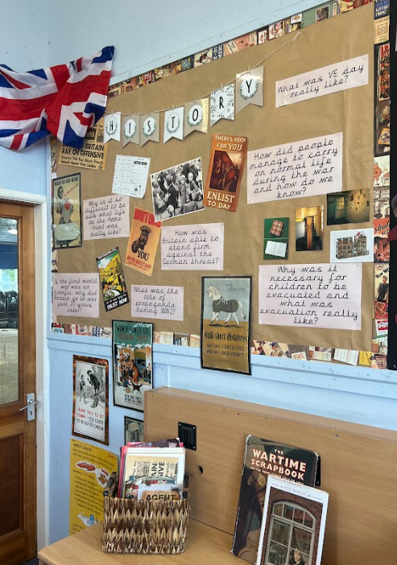
We are lucky to have a fantastic team working with the class; Mrs Gardiner and Miss Forster will be supporting each morning. On Wednesdays, Mrs Palfreyman will be teaching science and Mrs Williams will be teaching PE – a busy day! Together, we aim to make this year both fun and challenging, full of learning opportunities to succeed.

Learning focus
During the autumn term, much of the teaching and learning in Year 6 will be centred around our WW ll topic. So far, this has captured the interest of many individuals, who I’m sure would be able to tell you all about the lead up and start of the war. I have attached the topic web that allows you to see our curriculum and subjects in more detail. We will cover all the Year 6 National Curriculum objectives while also revisiting necessary areas from previous years.

PE
Please make sure that your child keeps their PE kit in school and that clothing is clearly labeled with their name, for Thursday's lessons and any other clubs or sporting opportunities.

Homework
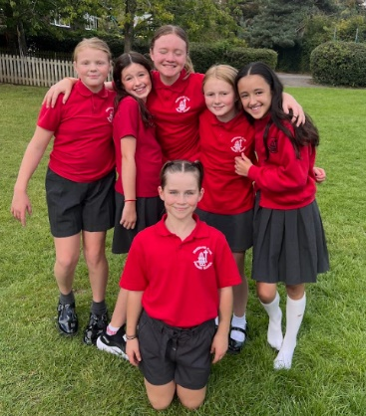
Your child’s personal spelling grid will be stuck in their English homework books and has been created based on an assessment of the Year 3 and 4 statutory spelling list. Once practised, we will move on to the Year 5 and 6 statutory words. Your child has time in school for daily practice of their weekly words and any additional practice at home would also be beneficial. English and maths homework will be set every Friday and due in the following Wednesday. Creative homework will be set once a half term and will replace English.

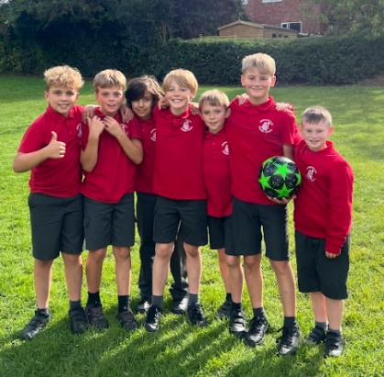
I encourage all children to use their TT Rockstars accounts to boost their multiplication and division skills. You child’s login details can be found in their homework book.
An arithmetic paper will be completed weekly and children will mark their own, with the support of the Year 6 team. We will go through a range of the questions and papers will be sent home with homework on Friday. This way, you can see how your child is getting on and work with them to correct their answers.
Reading books can be chosen from our class or school library areas and need to be brought in daily, for in school reading. I am pleased that we have many enthusiastic readers in our class, and I have no doubt that they will excel in our "Read Around the World" challenge. Children's reading records will be checked weekly, and 'miles' will be earned for each book read. Your child will greatly benefit from reading with an adult and engaging in discussions, to strengthen their comprehension skills.

Secondary school
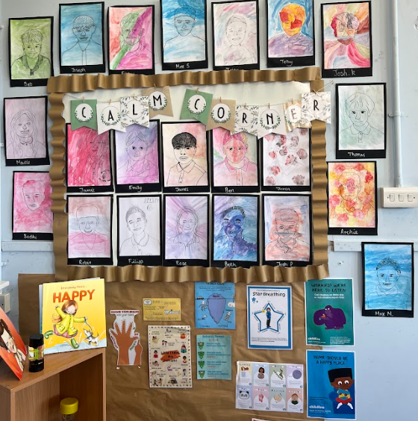
There is an open evening, at Helsby High School, on Thursday 25 September at 5:30-7:30pm. You will receive an email with further details, should you wish to attend. Also, a reminder that the deadline for secondary admissions is the 31st October 2025.

SATS
This academic year SATS will take place on Monday the 11th May to Thursday the 14th May 2026. The assessments are an opportunity for children to show off all of their hard work and learning from primary school and all pupils must attend. I will hold a parent information meeting in the new year, but if you would like to get started on some additional work for your child, the CPG revision books are a great tool. We can order these through school at a discounted price, so I will reach out to you next half term with the option to purchase.

Conway Centre
This year’s trip to the Conway Centre, Anglesey is scheduled for Monday, 8th June to Friday, 12th June 2026. Please see Mrs Kirby’s letter for more information around options and pricing. Based on calculations, the approximate price for this trip is £500. The final figure will follow, as well as the option to pay by installments on ParentPay. If you have any worries about paying for this visit, please do contact the school office or myself.

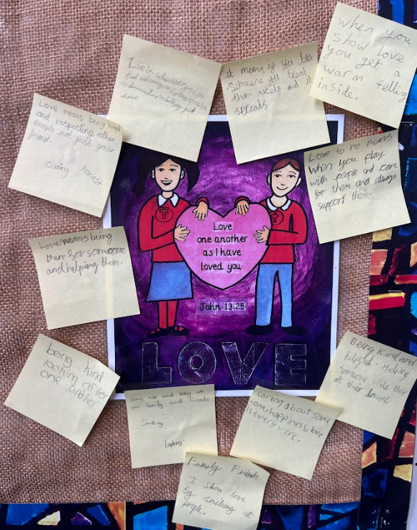
Other dates
Bikeability: Monday 6th - Friday 10th October
Year 6 Forest School: Friday 24th October
WWII trip to Liverpool: Thursday 23rd October (approx. £21)
Y6 Class Assembly: Friday 5th December. 9.05am
Greenacres Farm Park Trip: Nov/Dec (date TBC; approx. £15)
Christmas Theatre Trip: 18th December (approx. £10)
Trip to Sikh Gurdwara, Liverpool: Monday 12th January 2026

It has been an absolute joy getting to know the class and watching them embrace the new challenges, in their first week of Year 6. I’m excited to work with your child and help them reach their full potential. If you have any questions or would like to discuss anything further, please do not hesitate to contact myself or the office to arrange a convenient time for a chat. I will also be available during pick-up times.
Kind regards,
Miss Cartwright

