
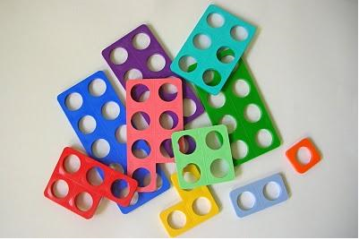

In reception we have introduced this resource to the children during their maths lessons. They have loved playing games using the coloured shapes, placing them in order and making pictures on the Numicon boards.

Numicon is a range of multi-sensory maths resources using imagery, models and signs to raise mathematical achievement.

It helps to develops mathematical fluency by using a visual, practical base to develop conceptual understanding and fluent recall. It helps children to reason mathematically through the use of concrete objects and encourages children to explain and justify mathematical concepts developing them into confident problem-solvers.

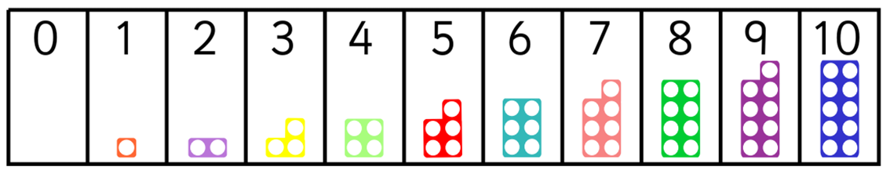

Numicon can help us make confident and competent Mathematicians, as well as making learning fun and interactive. During their child-initiated time, we add the different coloured shapes into the continuous provision in the classroom, such as shapes in the sand pit and the play dough, Numicon shapes and boards in the Mathematics area to make pictures using the shapes.
If you would like to find out more about Numicon, have a look at their website
www.numicon.com where there is lots of information including some short video clips
explaining the approach.

