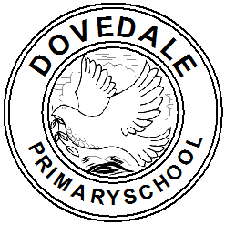YEAR 3 CURRICULUM MAP 2020-2021
Dovedale Primary School

SUBJECT | Autumn 1 Autumn 2 |  | Spring 1 Spring 2 |  | Summer 1 Summer 2
English | The Iron Man  by Ted Hughes & Chris Mould  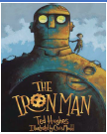 | Fox  by Margaret Wild and Ron Brooks  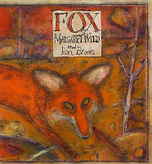 | Jemmy Button  by Valerio Vidali  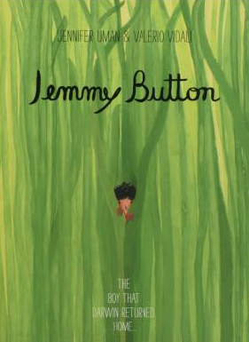 | Return  by Aaron Becker  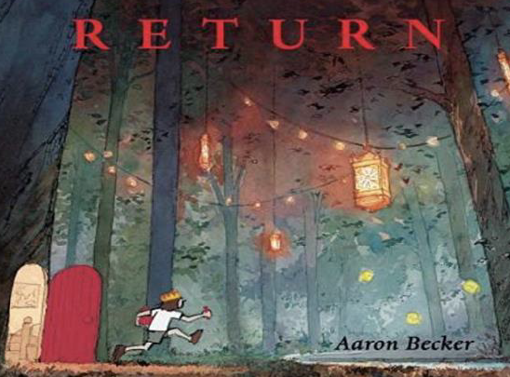 | Into the Forest  by Anthony Browne  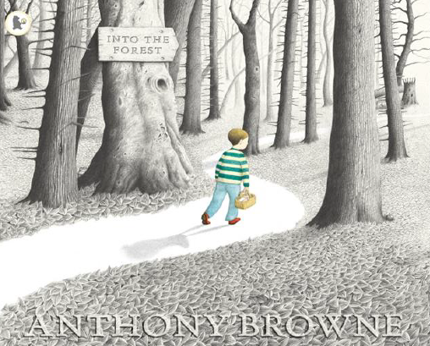 | Seen and Not Heard  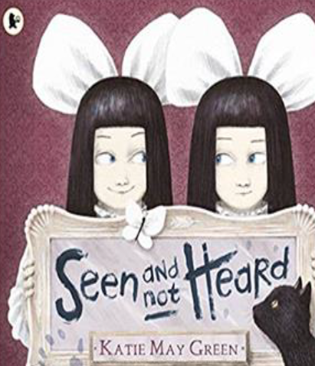  by Katie May Green
English | Writing Outcomes: Approaching Threat Narrative and Explanation  Narrative: Approach threat.  Writing Purpose: To narrate  Explanation: How to capture the Iron Man  Writing purpose: To inform | Writing Outcomes:  Fable Narrative and Information Report  Narrative: Fable Narrative  Writing Purpose: To narrate  Persuasion: Fox Report  Writing Purpose: To persuade | Writing Outcomes:  Return Narrative and Letters  Narrative: Jemmy Button  Writing Purpose: To narrate (return narrative)  Letters: Letter from Jemmy  Writing Purpose: To write a letter | Writing Outcomes:  Setting Narrative and Travel Report  Narrative: Setting Narrative  Writing Purpose: To narrate  Information: Travel Report  Writing Purpose: To inform | Writing Outcomes:  Lost Narrative and Newspaper Report  Narrative: Lost Narrative  Writing Purpose: To narrate  Recount: Newspaper Report  Writing Purpose: To recount | Writing Outcomes:  Character Narrative and Instructions  Narrative: Character Narrative  Writing Purpose: To narrate  Instructions: How to be a mischievous child  Writing Purpose: To instruct
Spellings  (RWI) | -Adding the prefixes dis- and in-  -Adding im– to root words beginning with m or p  -Adding the suffix -ous  Drop the e before adding -ous | -Adding the suffix -ly – swap the le for –ly  -Words ending in -ture  -Adding –ation to verbs to form nouns  Drop the e before adding -ation | Words with the c sound spelt ch  Words with the sh sound spelt ch  Adding the suffix -ion  If the word ends in t, just add –ion  If the word ends in te, drop the e before adding -ion | Adding the suffix -ian  If the word ends in cs, drop the s before adding -ian  Adding the prefix re-  Adding the prefix anti- | Adding the prefix super-  Adding the prefix sub- | Spelling Assessment  Identify gaps within learning  Review previous learning
Statutory Spellings | accidentally  accident  answer  address  arrive  appear  bicycle  believe | breath  breathe  build  busy  business  calendar  caught  centre  century | certain  circle  complete  consider  continue  decide  describe  different | difficult  disappear  early  earth  eight  eighth  enough  exercise  experience | through  thought  various  weight  woman  women  occasion  occasionally  special  notice | experiment  extreme  famous  favourite  February  forward  forwards  fruit  grammar
Maths | Number: Place Value – 3 weeks  Addition and Subtraction - 5 weeks  Multiplication and Division - 3 weeks  Week 12 Consolidation |  | Number: – Multiplication and Division - 3 weeks  Measurement: Money, Statistics, Length and Perimeter - 6 weeks  Number: Fractions - 2 weeks  Week 12 Consolidation |  | Number: Fractions – 3 weeks  Measurement: Time – 3 weeks  Geometry: Properties of shape – 2 weeks  Measurement: Mass and Capacity – 3 weeks  Week 12 Consolidation
Science | Rocks  To compare and group together different kinds of rocks on the basis of their appearance and simple physical properties | Forces & Magnets  To investigate how magnetic forces act through different materials. | Plants  To explore the requirements of plants for life and growth (air, light, water, nutrients from soil, and room to grow) and how they vary from plant to plant. | Light  To investigate how moving a light source changes the size of an object's shadow. | Animals including Humans  To investigate the importance of nutrition and why humans need the right types and amount of food.  Identifying that humans and some other animals have skeletons and muscles for support, protection and movement.
History | British History:  Stone Age to Iron Age  To describe similarities and differences between people, events and objects. |  | Local History Study:  Superlambananas and what they symbolise |  | Ancient History:  The Roman Empire and its impact on Britain
Geography | Basic skills sessions |  | Where on Earth are we?  All about Asia! |  |  | Local Field Work
Art | Drawing skills  Stone Age Drawings  To produce a range of drawings/mark making on brown paper working with a variety of equipment.  Chalk/charcoal /paint /different tools  Portraits of a Neolithic man/woman—pencil/chalks  Stone age mark making |  | Painting skills  Colour wheel— investigate correct placement of colours. Mix different colour tints and complete in style of Sean Scully. Experiment with tonking/scraffito. |  | Movement  Continue developing drawing & painting skills  Photography: capturing movement  3D: exploring figures—make a sculpture using twigs/masking tape  Collage: Paper figures based on Matisse  Henri Matisse 1950+  Antony Gormley –present day & Alberto Giacometti 1920+
DT |  | Textiles:  2D shapes and 3D product design. Make and evaluate a Christmas decoration for home. |  | Food technology:  Healthy & varied diet  Preparing fruit and vegetables. Design, make and evaluate a fruit smoothie for themselves. |  | Mechanisms  Wheels and axles  Design, make and evaluate a push / pull toy for themselves.
Computing | Focus: Digital Productivity (IT)  Typing skills, IT best practice, generic software, internet skills. |  | Focus: Computing (CS)  Computational thinking, gaming, programming & coding, models & simulations, technical terms, hardware & software |  | Focus: Digital Creativity (DL)  Animation & video, 2D & 3D design,  e-books, photography, movies
PSHE | Being Me in My World | Celebrating Difference | Dreams and Goals | Healthy Me | Relationships | Changes
PE | Health and Fitness  (Inc. Sports Hall Athletics) | Gymnastics | Dance | Competitive tactical sport (Emphasis on attack and defence) | Competitive tactical sport (Emphasis on attack and defence) | Athletics
RE | Hinduism and Diwali  Does celebrating Diwali bring a feeling of belonging to a Hindu child? | Christianity and Christmas  Has Christmas lost its true meaning? | Christianity and Jesus’ Miracles  Could Jesus really heal people? | Christianity and Easter-forgiveness  What is ‘good’ about Good Friday? | Hindu Beliefs  Do Sikhs think it is important to share? | Sikhism: Sharing and Community and Prayer and Worship  What is the best way for a Sikh to show commitment to God?
Music | Let your spirit fly  Aural memory - rhythms | Glockenspiel Stage 1  Aural memory - rhythms | Three Little Birds  Pitch - melody | The Dragon song  Pitch - melody | Bringing Us Together  Interrelated dimensions of music | Reflect, rewind & replay  Interrelated dimensions of music
French | Moi (All about me) | Jeux et chansons  (Games & songs) | On fait la fete  (Celebrations) | Portraits | Les quatre amis  (The four friends) | Ca pousse  (Growing things)
Possible Enrichment  Opportunities | National Poetry Day  Black History Week  National Poetry Day  Peer massage / Yoga |  | Internet Safety Day  World Book Day | Geography Day – Map skills  Geography visits (earthquakes in Japan) |  | Science Day – We can investigate

