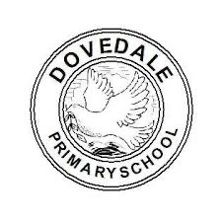
EYFS Curriculum Overview
Key question and concepts |  | 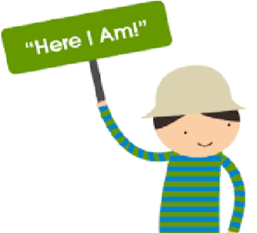    Discover ‘Me’. Should we try to make everyone happy?  Belonging, friendship, conflict, identity |  | Explore ‘The Stars’. What can we see 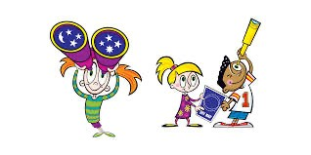beyond our classroom?  Dreams, Change, Care |  | Create ‘Footsteps’. How do our actions 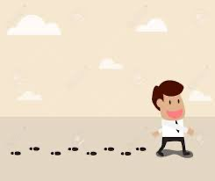affect the great outdoors?  Responsibility, harmony, movement
 |  | Autumn 1 | Autumn 2 | Spring 1 | Spring 2 | Summer 1 | Summer 2
Communication & Language | Listening,  Attention and  Understanding  ELG 01 | Children are always practising the skills in C&L. The list below highlights some of the opportunities the children have to development their communication and language.  - Circle time  - Storytime  - Adult led/child led activities  - Through purposeful play  - Literacy Read to Write  - Shared reading
Communication & Language | Speaking  ELG 02
Communication & Language | The  FANTASTIC’s | 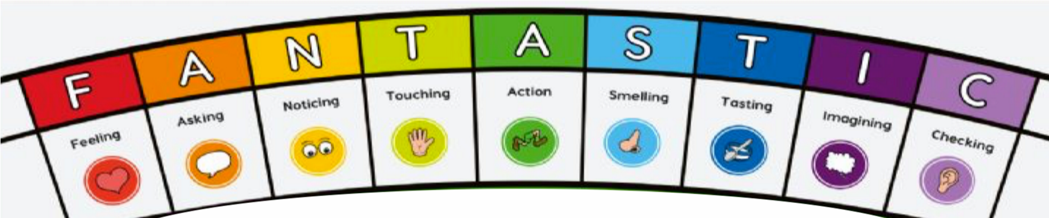
Communication & Language | Focus Nursery rhymes to  support  Understanding the World | Polly put the kettle on |  | Jack and Jill |  | Rub a dub dub, three men in a tub
Communication & Language | Focus Nursery rhymes to  support  Understanding the World | Other nursery rhymes to be sent home every week (*use BBC Rhymes and songs)

Personal, social and  emotional development | Self-Regulation  ELG 03 | PSED is also explored through day to day social interactions during child-led and adult-led activities, ability to  follow rules and expectations set in school, response to circle time, mindfulness, peer massage, yoga, using the toilet, changing footwear and putting on their coat.
Personal, social and  emotional development | Managing Self ELG 04 | Jigsaw unit:  Being me in my world  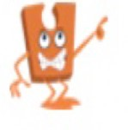 | Jigsaw unit:  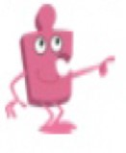  Celebrating difference | Jigsaw unit:  Dreams and goals  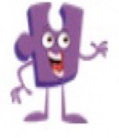 | Jigsaw unit:  Healthy me  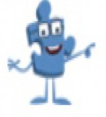 | Jigsaw unit:  Relationships  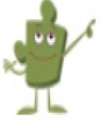 | Jigsaw unit:  Changing me  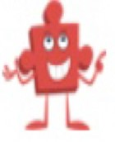
Personal, social and  emotional development | Building  Relationships ELG 05
Physical development | Gross Motor  Skills  ELG 06 | Fundamental | movement skills | Spatial awareness | Using small equipment | Ball skills | Obstacle courses and races
Physical development | Gross Motor  Skills  ELG 06 |  |  | Indoor/Outdoo Squiggle whil | r environment  e you wiggle
Physical development | Fine Motor  Skills  ELG 07 | 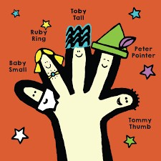 |  | Squiggle whil Dough  Finger Indoor/Outd | e you wiggle  Disco  Gym oor activities |  | 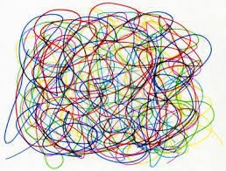
Literacy | Comprehension ELG 08  Wider reading  Shared reading | Sequence  (VIPERS)  - Sharing a  shell  - When Frank was Four  - Stuck  - Dogger  - Non-fiction animal books | Vocab  (VIPERS)  - Whatever Next  - Owl Babies  - Can’t you sleep little bear  - Non-fiction The Awesome Night Sky | Explain  (VIPERS)  - Window  - Supertato  - Super worm  - The Jolly  Postman  - Non-fiction:  People who help us books | Retrieval  (VIPERS)  - What really happened to LRRH?  - There’s no dragon in this story  - Revolting rhymes  - Jack and the Beanstalk  - Non-fiction  Paws and Claws! | Predict  (VIPERS)  - The Snail and the whale  - The Rainbow  Fish  - Paper planes  - Non fiction: One Tiny Turtle | Infer  (VIPERS)  - The tiny seed  - The Magic  Pencil  - The Promise • Non-fiction Ready steady grow!

 | Word Reading ELG 09 | 
 | Writing ELG 10 | 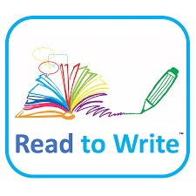
 | Writing ELG 10 | 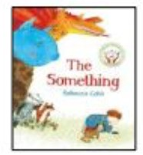  To tell and write a losing story | 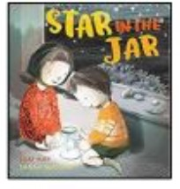  To tell and write a finding story. | 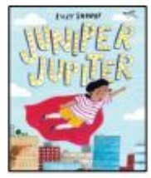  To tell and write a superhero story | 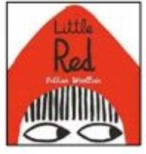  To tell and write a traditional tale | 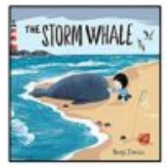  To tell and write a friendship story |  | 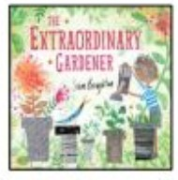  To tell and write a transformational story
 | Other genres explored | Recount animal information/inform | Poster to inform and describe | Letter to inform | Instructions to trap an animal | Poem to describe |  | Instructions to grow a plant
 | Grammar: word | is, it, in, at, and, the | I, no, go, to | he,she,we | me, be, was, no | my, they, her, all are |  | Have, like, some, come, you, were,  little, one, all, do, when, out, what
 | Grammar: sentence | Make labels, captions and lists |  | Combining words to make short sentences |  | Combining words to make short sentences. Use ‘and’ to join words and clauses.
 | Grammar: text | Sequencing spoken sentences to form  short narratives orally. To use  repeated story  language. Begin to  use time adverbials.  (First, next, then) | Help retell stories orally to support writing. | Sequence sentences to form short narratives. Help retell stories orally to support writing (depending on developmental stage)
 | Grammar: punctuation | Letter formation | Build on previous unit plus separation of words with spaces | Build on previous unit plus personal pronoun, capital letters and full stops |  |  | Build on previous unit plus capital letters for names

Mathematics | Numbers ELG 11 | Getting to know you Just like me! | It’s Me 1,2,3 Light and Dark | Alive in 5! Growing 6,7,8 |  |  | Building 9 and 10 Consolidation | On the Move  Superhero to 20 and  Beyond | First, Then, Now  Find my Pattern
Mathematics | Numbers ELG 11 | Match and sort Compare amounts | Representing, comparing,  and composition of numbers to 5  One more and less |  |  |  | *** To be c | onfirmed ***
Mathematics | Numerical  Pattern  ELG 12 | Compare size, mass and capacity  Exploring pattern | Circles and triangles  Positional Language  Shapes with 4 sides Time
Understanding the world | Past and  Present  ELG 13 | How have I change | d since I was a baby? | What are our favou y  RE |  |  | rite celebrations each  ear?  link | Why do we wear di different time  Geogra | fferent clothes at s of the year?  phy link
Understanding the world | People, Culture and  communities  ELG 14  (with RE links) | Special people at home and in school   | Sending letters, giving gifts and saying thank you   | New Year’s Eve and New Year  resolutions   |  |  | Recognising signs of  Easter   | Stories with morals linked to different faiths   | Special Places we visit in our lives  
Understanding the world | The Natural  World  ELG 15 | Habitats  (geography/science) Link to literacy | Materials (science)  Art and mark making link | Local area vs space (geography) |  |  | Animal including humans (science)  Link to PSED | Seasons (geography) | Plants (science)
Understanding the world | EXTRA  The Digital World | Computer Science  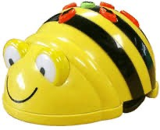  Exploring Beebots |  | Information technology    Taking photographs  Using simple programs  Technology hunt |  |  |  | Computer Science  Beetbot screen emulator  Programming a ladybird  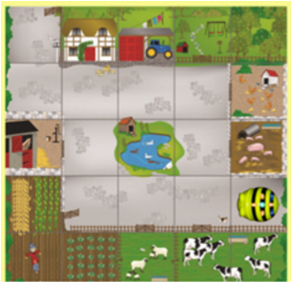
Expressive arts and design | Creating with  Materials  ELG 16 | Drawing skills  Painting – mark making with different materials, textures and objects  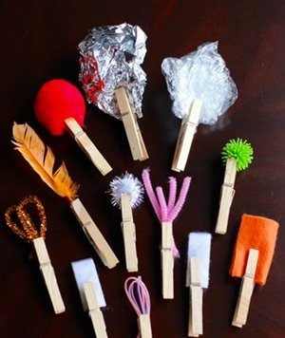 |  | Drawing skills  Painting skills inspired by Jackson Pollack  (drip painting)  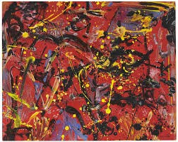 |  |  |  | Continue to develop drawing and painting skills  Responding to natural materials  Textiles and 3D sculpture  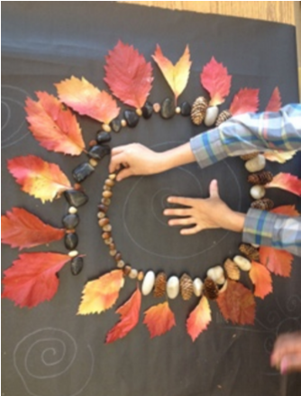Andy Goldsworthy  1980+  Math link to  pattern  s
Expressive arts and design | Creating with  Materials  ELG 16 | Self portraits  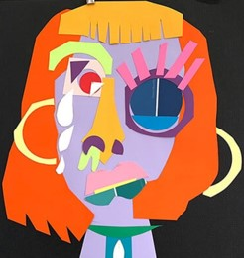 | Bon fire pictures with colour mixing and  printing with straws  Christmas cards (D&T) | Kandinsky art  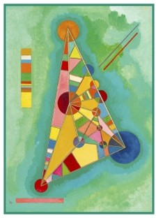 |  |  | Easter art/ spring drawings of daffodils | Sea life pictures  Hokusai (The great wave)  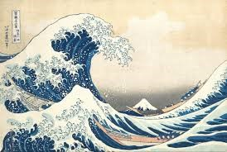 | Water Lilies
 |  |  |  |  | Maths link |  | Easter art/ spring drawings of daffodils |  | Water Lilies
Expressive arts and design | Being imaginative and  Expressive  ELG 17  Music | The environment allows children to represent their own ideas throug  Communication and language link |  |  |  |  |  | h art, music, roleplay.
Expressive arts and design | Being imaginative and  Expressive  ELG 17  Music | Listen and respond to different music Begin to feel the pulse, rhythm and move to music. |  |  |  |  |  | Focus on funk music | Consolidate

