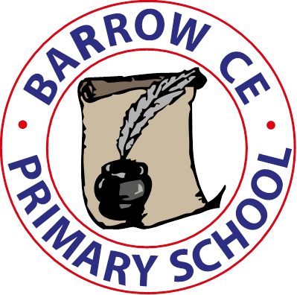
Barrow C of E Primary School
School Term Dates 2026-27

Autumn Term 2026

Tuesday 1st September INSET Day
Wednesday 2nd September School re-opens
Thursday 22nd October School closed for half term
Friday 23rd October INSET Day

Monday 2nd November School re-opens
Friday 18th December School closes for Christmas holiday

Spring Term 2027

Monday 4th January School INSET Day
Tuesday 5th January School re-opens
Friday 12th February School closes for half term
Monday 22nd February School re-opens
Thursday 25th March School closes for Spring Break

Summer term 2027

Monday 12th April School re-opens
Friday 28th May School closes for half term

Monday 7th June INSET Day
Tuesday 8th June School re-opens
Tuesday 20th July School closes for summer holidays
Wednesday 21st July INSET Day

Autumn Term 2027

Tuesday 31st August 2027 – INSET DAY
Wednesday 1st September 2027 School re-opens

