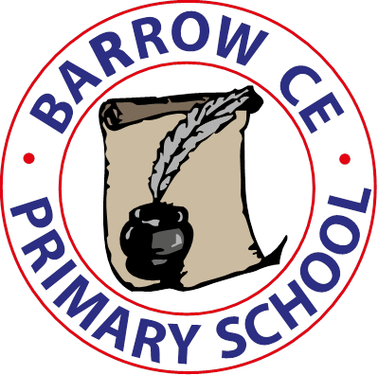
Barrow CE Primary School Spirituality Policy

November 2025
“Let your light shine” (Matthew 5:16)
“Let your light shine before others, that they may see your good deeds and glorify your Father in heaven.” – Matthew 5:16
At Barrow CE Primary School, our Christian vision, “Let your light shine”, guides every aspect of school life. As a small, nurturing Church of England school, we are blessed to know every child and family closely. We value the warmth and closeness this brings, helping every child feel seen, loved, and celebrated as a unique child of God.
We believe in the holistic growth of each child—spiritually, emotionally, socially, academically, and creatively. Through strong relationships, high expectations, and joyful learning experiences, we encourage children to discover and develop their God-given gifts so they may confidently shine their light in the world.

Rationale
Spirituality shapes how we see ourselves, others, the world, and God. It is found in stillness and in creativity, in wonder and in curiosity, in nature and in community, in prayer and in imagination.
At Barrow CE, spirituality is expressed through connection with:
- God and the Holy Spirit
- Meaning, purpose, and belonging
- Awe, wonder, beauty, and joy
- Creation, nature, and the world around us
- Art, music, story, and imaginative expression
- Love, community, and relationships
As a small school, we cherish the ability to nurture deep, personal spiritual journeys for every child.

Aims
We aim to:
- Provide a warm, faith-filled environment where every child feels known, valued, and supported.
- Nurture children’s spiritual identity, confidence, and sense of worth in God’s love.
- Inspire curiosity, questioning, and thoughtful reflection about faith, self, and the world.
- Foster empathy, kindness, forgiveness, and understanding.
- Encourage awe and reverence for God’s creation.
- Celebrate creativity and imagination as gifts from God.
- Provide time and space for stillness, prayer, wonder, and artistic expression.
- Teach Christian values, stories, and Anglican traditions.
- Encourage children to express their spirituality through prayer, creative responses, silence, worship, service, and play.
- Support each child to reach their potential and let their light shine.

Spirituality Through Nature & Outdoor Learning
We believe that creation reveals God's love and creativity. Our children experience awe and wonder through:
- Forest School sessions that spark curiosity, resilience, reflection, and wonder
- Daily time in our beautiful, peaceful school grounds
- Exploring nature through our pond, observing wildlife and life cycles
- Growing and caring for plants in our school allotments and gardens
- Learning outdoors, noticing the changing seasons and rhythms of nature
- Visits beyond school, exploring wider natural and cultural environments
- Visitors who share expertise, faith, and stories from the natural world
Children develop gratitude, responsibility, and stewardship for God’s earth, recognising the beauty and fragility of creation.

Creativity, Art & Imagination in Spiritual Growth
We believe creativity is a powerful gift from God and a key expression of the soul. Children experience spirituality through:
- Art, painting, and drawing
- Sculpture, modelling, textiles and mixed media
- Music, singing, and role-play
- Dance, movement, and drama
- Storytelling, poetry, and creative writing
- Imaginative play and free creative exploration
- Designing, building, and inventing
- Collective artistic projects and displays that celebrate shared values and identity
Creative opportunities encourage children to wonder, reflect, express feelings, celebrate beauty, appreciate differences, and joyfully explore faith and meaning.

Curriculum & Worship
Spiritual growth is woven through all subjects and experiences. It is nurtured through:
- Collective Worship and class worship
- Pupil-written prayers and prayer spaces
- Bible stories, Christian values, and ethical reflection
- Art, music, nature, creativity, and reflective practice
- Encouraging curiosity, questioning, and deep thinking
- Celebrating each child’s achievements and character
Our vicar visits regularly to lead worship and support spiritual development. We also gather at St Bartholomew’s Church throughout the year, welcoming families to join our celebrations.

Community, Love & Service
As a small school family, we value our strong relationships with parents and carers. We invite families to be active partners in school life and spiritual development. We live out our Christian values through:
- Charity days and fundraising for others
- Community events and shared celebrations
- Welcoming visitors who inspire and enrich our spiritual life
- Daily acts of kindness, respect, and service

School Environment & Ethos
We ensure that:
- Everyone feels safe, loved, and included
- Every child is valued and nurtured as a unique individual
- Staff model Christian values and respectful relationships
- Reflection and prayer spaces are available in classrooms and outdoors
- Children have time to be still, to question, to create, and to notice beauty

Through loving relationships, joyful creativity, time in nature, worship, prayer, and rich learning experiences, we encourage every child at Barrow CE Primary School to grow spiritually, flourish fully, and let their light shine brightly for God and the world

