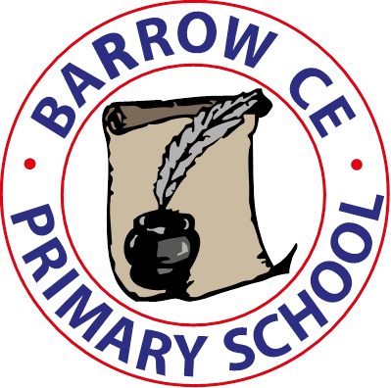
Barrow CE Primary School
Safer Eating Policy
December 2025

Safer Eating Policy

1. Introduction

At Barrow CE Primary School, our Christian vision, ‘Let Your Light Shine’ (Matthew 5:16), guides everything we do. We believe every child is valued, unique and capable of flourishing. We are committed to providing an environment where all children can grow in confidence and shine brightly. This Safer Eating Policy reflects our responsibility to keep children safe and well, ensuring that mealtimes are safe, inclusive and nurturing within our school community.

2. Purpose & Scope

This policy outlines the school’s approach to ensuring safe eating practices in line with the EYFS 2025 framework. It applies to all staff, volunteers, and individuals involved in preparing, serving, or supervising food and meals.

3. Key Principles

• Mealtimes form an important aspect of safeguarding and wellbeing.
• Food provided should be healthy, balanced and nutritious.
• Choking risks and allergies must be minimised.
• Children must be supervised at all times while eating.

4. Dietary Information & Allergies

Parents/carers must provide full and accurate dietary information prior to admission. Allergy or dietary action plans will be created for children with identified needs.

5. Food Preparation & Safety

Food must be prepared in line with hygiene and safety standards. High-risk choking foods are not permitted for children under five. Meals and snacks must follow nutritional guidance.

6. Supervision During Mealtimes

A pediatric first aid trained member of staff must be present at all mealtimes.

Children must be seated safely during mealtimes and always supervised within sight and hearing.

In our family-group lunch hall, midday assistants actively circulate between tables to ensure that children across all age groups are monitored effectively. While it is not always possible to remain in a fixed position, staff ensure that they are regularly facing children as they move around the hall, enabling clear visibility of eating behaviours, early signs of choking, or any signs of allergic reaction. Staff prioritise positioning themselves so that every table receives regular face-to-face checks, and children know that an adult is always close by and attentive.

7. Incident Recording

All choking or allergy-related incidents, including near misses, must be recorded and parents informed promptly.

8. Roles & Responsibilities

Senior leaders ensure implementation and training. Staff follow this policy and complete required training. Parents must keep dietary information up to date.

9. Communication with Parents

Menu, dietary expectations and allergy information will be shared with parents. Expectations for safely packed lunches will also be communicated.

10. Policy Review

This policy will be reviewed annually or earlier if required.
Next Review: Autumn 2028

