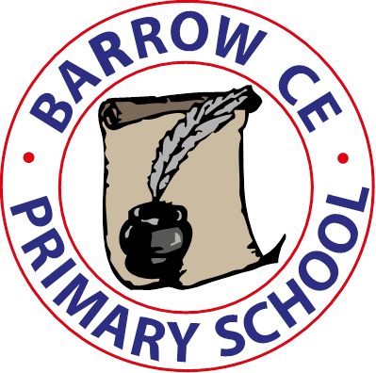 | Barrow CE Primary School  Admissions Statement  September 2024
Barrow CE Primary School adopts Cheshire West and Cheshire local authority policy and criteria for all Reception class admissions to the school. All information for admissions criteria and applications can be found at:
https://www.cheshirewestandchester.gov.uk/residents/education-and-learning/school-admissions/school-admissions.aspx
Please follow this direct link to the information you need for applying for a Reception class place in September 2025:
https://www.cheshirewestandchester.gov.uk/residents/education-and-learning/school-admissions/reception-admissions
If you need any additional information, please contact the school office on 01244 445154 or at Admin@barrowce.cheshire.sch.uk.
Alternatively, you can contact email CWAC school admissions team at: admissions@cheshirewestandchester.gov.uk, by telephone on 0300 123 7039, or by post at: School Admissions, Cheshire West and Chester Council, Wyvern House, The Drumber, Winsford, CW7 1AH.
In-year admissions for all Barrow CE Primary School year groups and September 2024 admissions for Year Groups 1-6 will be handled directly by the school.
The school will continue to abide by the agreed admissions criteria, as published by CWAC on the above website.
The school currently has an admission limit of 14 pupils per year group.

