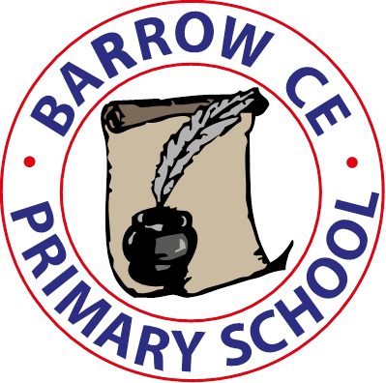
Barrow C of E Primary School
School Term Dates 2024-25

Autumn Term 2024

Monday 2nd September INSET Day
Tuesday 3rd September School re-opens
Friday 24th October School closes for half term
Friday 25th October INSET Day

Monday 4th November School re-opens
Friday 20th December School closes for Christmas holiday

Spring Term 2025

Monday 6th January School INSET Day
Tuesday 7th January School re-opens
Friday 14th February School closes for half term
Monday 24th February School re-opens
Friday 4th April School closes for Spring Break

Summer term 2025

Wednesday 23rd April School re-opens
Friday 23rd May School closes for half term

Monday 2nd June INSET Day
Tuesday 3rd June School re-opens
Tuesday 22nd July School closes for summer holidays
Wednesday 23rd July INSET Day

Autumn Term 2025

Monday 1st September 2025

