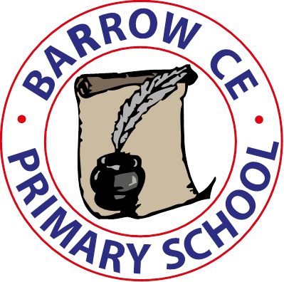 | Barrow CE Primary School  Privacy Notice for parents, carers and pupils  January 2023

Who will own my data once I submit It?
Barrow CE Primary School

Why do you need my information?
We use the pupil data:
- to support pupil learning
- to monitor and report on pupil progress
- to provide appropriate pastoral care
- to assess the quality of our services
- to comply with the law regarding data sharing

The categories of pupil information that we collect, hold and share include:
- Personal information (such as name, unique pupil number and address)
- Characteristics (such as ethnicity, language, nationality, country of birth and free school meal eligibility)
- Attendance information (such as sessions attended, number of absences and absence reasons) Assessment information
- Exclusions/behavioural information
- Relevant medical information
- Special educational needs information

What allows you to use my information?
We collect and process pupil information as part of our public functions under both the Data Protection Act 2018 and Article 6, part (e) of the General Data Protection Regulation.
The legislation and guidance that allows us to do this in the UK includes, but is not limited to:
- The Education Pupil Registration (England) Regulations 2006
- Education (Information About Individual Pupils) (England) Regulations 2013
- Education Act 2002
- Education Act 2011
- Government Guidance on Schools and Education

Who will my information be shared with?
We routinely share pupil information with:
- schools that the pupils attend after leaving us
- our local authority
- the Department for Education (DfE)
To find out more about the data collection requirements placed on us by the Department for Education (for example; via the school census) go to the Department for Education’s website. We are required by law, to provide information about our pupils to the Department for Education as part of statutory data collections, such as the school census and early years’ census. Some of this information is then stored in the National Pupil Database.
Visit the National Pupil Database (NPD) website for further information on the National Pupil Database. The Department for Education may share information about our pupils from the National Pupil Database with third parties who promote the education or well-being of children in England by:
- conducting research or analysis
- producing statistics
- providing information, advice or guidance
To be granted access to pupil information, organisations must comply with strict terms and conditions covering the confidentiality and handling of the data, security arrangements and retention and use of the data in compliance with the General Data Protection Regulation.
For more information about the department’s data sharing process, please visit the Department of Education’s website.

Do I have to provide this information and what will happen if I don’t?
The majority of pupil information you provide to us is mandatory as part of our public functions under both the Data Protection Act and Article 6, part (e) of the General Data Protection Regulation, when we collect data outside of this, we will rely on your consent to collect and store your personal data.

How long will you keep this data for and why?
The length of time we keep various forms of data is outlined in our Data Retention Policy, using the current guidance laid out by the Local Authority.

How will my information be stored?
- SIMS School Information Management System
- Pupil record folders
- Paper copies filed and stored securely

The school uses the services of SchoolMoney, to facilitate payment for school meals and trips. SchoolMoney is the sole owner of any such information collected. SchoolMoney’s privacy policy can be found at: Privacy Policy - SchoolMoney.

What rights do I have when it comes to my data?
Under the Data Protection Act and General Data Protection Regulation you have the right to request access to the information that we hold about you.
To make a request for your personal information, or be given access to your child’s educational record, contact the School’s Data Controller Headteacher Mr Paul Hudson. Further details can be found in the Data Protection Policy.
You also have the right to:
- object to processing of personal data that is likely to cause, or is causing, damage or distress prevent processing for the purpose of direct marketing
- object to decisions being taken by automated means
- in certain circumstances, have inaccurate personal data rectified, blocked, erased or destroyed.

Who can I complain to if I am unhappy about how my data is used?
If you have a concern about the way we are collecting or using your personal data, you should raise your concern with us in the first instance.
- Email: admin@barrowce.cheshire.sch.uk
- Email: SchoolDPO@cheshirewestandchester.gov.uk
- By post: Data Protection Officer, Barrow CE Primary School, Great Barrow, Chester, CH3 7HW
You also have the right to complain to the Information Commissioner’s Office (ICO) using the following details:
- ICO website
- By post: The Information Commissioner's Office, Wycliffe House, Water Lane, Wilmslow, Cheshire, SK9 5AF
- Telephone: 08456 30 60 60 or 01625 54 57 45

Will this information be used to take automated decisions about me?
No

Will my data be transferred abroad and why?
No

