
Welcome to Oak Class!
I am very much looking forward to being your teacher this year and hope you are excited to be moving up to the next year group too! Here is a little information to help you settle in.

Classroom
Our classroom is located by the school office and you will leave your coats and bag in the cloakroom just outside the classroom.
The school day begins at 8.45am and we encourage children to say their goodbyes outside the school gate (open at 8.40am) and walk down to the cloakrooms and classroom independently.
Please note we have a no pencil case in school rule as all the equipment needed is provided.
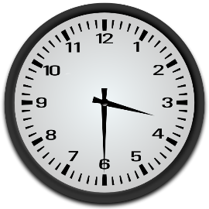
Home time
Children will be dismissed from the school building at 3.30pm when their parent/carer collects them from outside the school (Ferma Lane entrance). Please let us know if another adult is collecting your child.


Dinners
Please continue to use the school money online system to order and pay for dinners and morning snack.

Areas of Learning

Throughout the Autumn Term, we will be studying a history-based topic about the Stone Age to Iron Age.. Within Science, we will be learning about Animals Including Humans. Some of our English, Computing and Artwork will be linked to these subjects too.

P.E

Oak Class will have P.E on a Thursday afternoon and a Forest School session on a Wednesday afternoon. They will require a school P.E. T-shirt, black shorts and trainers. This along with waterproof Forest School clothing should be kept in school to be sent home for washing at half-term. When the weather gets colder, please send in black jog pants or tracksuit trousers as we try to use the outside space as much as possible.


Homework
- ‘Strive for 5’ reading sessions a week at home (including Bug Club) and get your reading record signed. This will earn you a raffle ticket and your chance to win a book token each half term.
- Practise your spellings and times tables (inc.TTRS) throughout the week in preparation for ongoing assessments.
- Homework will be given on a Monday to be returned by Friday of the same week.
- Please ensure your child has a special time set aside (no more than 20 min sessions) in a quiet place with no distractions in order to complete their homework tasks. Encourage your child to explain their task to you as a way of demonstrating their understanding.
If you have any further questions, please do not hesitate to contact us via the school office on 01244 445154 where a phone conversation can be arranged.
Looking forward to a happy and exciting year ahead.
Miss Dakeyne

