

Welcome to Willow Class
I am very much looking forward to being your teacher this year and hope you are excited to be moving up to the next year group too! Here is a little information to help you settle in.
Classroom

Years 5 and 6 will be based in the mobile classroom with access to our own cloakroom and toilets.
The school day begins at 8.45am and we encourage you to say your goodbyes outside the school gate and walk down to the cloakroom and classroom independently.
Remember: we have a no pencil case in school rule as all equipment required is in the classroom.

Home time
You will be dismissed from school at 3.30pm when your parent/carer collects you from outside the school (Ferma Lane). Your parent carer should please let us know if another adult is collecting you. If your parent/carer wishes you to walk home independently (Yr 6 only), then please ask them to indicate this in writing to the headteacher.

Dinners
Please continue to use the school money online system to order and pay for dinners and morning snack.

Topics
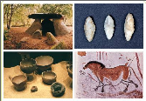
Throughout the Autumn Term we will be studying a history-based topic about the Stone Age to Iron Age. Within Science we are looking at Evolution and Inheritance exploring how living things adapt, pass on traits, and change over time. As geographers, we will be finding out about the major mountains of the world and the UK. We will look at the different ways in which mountains have been formed.
Homework

- Read at least 5 times a week (including Bug Club) and get your reading record signed.
- Practise your spellings and times tables (inc.TTRS) throughout the week in preparation for ongoing assessments.
- Spelling homework will be given on a Monday and assessment carried out on a Friday.
- Please ensure your parents/carers organise a special time set aside (no more than 20 min sessions) in a quiet place with no distractions in order to complete your homework tasks. They should encourage you to explain the task to them as a way of demonstrating your understanding.
P.E and school sport
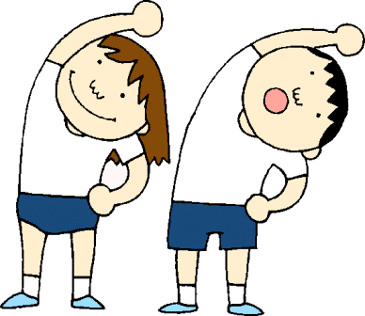
Willow Class will have P.E. on a Thursday afternoon and a Forest School session on a Wednesday afternoon. You will require a school P.E. T-shirt, black shorts (jog pants in colder weather) and trainers. This along with Forest School clothing (long trousers, long-sleeved top and waterproofs) should be kept in school to be sent home for washing at half-term.
During the Autumn Term, you will have an additional swimming lesson on Tuesday morning at Christleton High School (see letter attached).
If your parents/carers have any further questions, please do not hesitate to contact us via the school office on 01244 445154 where a phone conversation can be arranged.
Looking forward to a happy and exciting year ahead.


Mrs Goodwin

