Acorn Class Long Term Plans 2025 to 2026
Subject | Autumn 1 | Autumn 2 | Spring 1 | Spring 2 | Summer 1 |  | Summer 2
English | Where the Wild Things Are  Writing  Outcomes:  Portal story  Information text | The Last Wolf  Writing Outcomes:  Hunting narrative  Recipes to instruct | Grandad’s Island  Writing Outcomes:  Return Narrative  Animal information text | The Bog Baby  Writing  Outcomes:  Finding Narrative  Instructions | The King Who Banned the Dark  Writing Outcomes:  Banning narrative  Letter to persuade |  | Rosie Revere Engineer  Writing Outcomes:  Invention narrative  Explanation text
Reading  Steps to Read  (Year 2) | 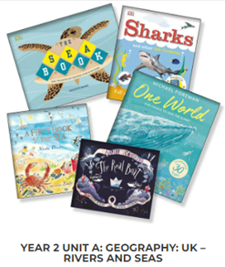 | 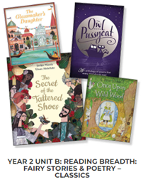 | 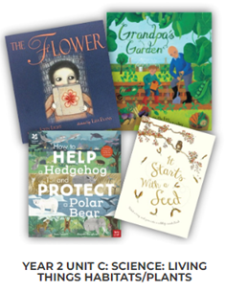 | 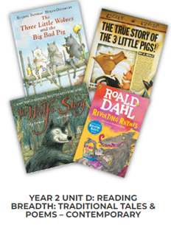 | VIPERS  Jim’s Beanstalk by Ramond Briggs  The Enormous Crocodile By Roald Dahl  The Enchanted Wood by Enid Blyton
Maths  Power Maths WRM Edition Mixed Age Planning | Year One | Year Two | Year One | Year Two | Year One |  | Year Two
 | Numbers to 10.  Part-whole within 10.  Addition within 10.  Subtraction within 10.  2D and 3D shapes. | Numbers to 100.  Addition and Subtraction 1.  Addition and Subtraction 2.  Properties of shape. | Numbers to 20.  Addition and subtraction within 20.  Introducing length and height.  Introducing mass and capacity. | Numbers to 100.  Multiplication and division 1.  Multiplication and division 2.  length and height.  Mass, capacity and temperature. | Multiplication and division.  Fractions.  Numbers to 50.  Time.  Position and direction.  Money.  Numbers to 100 |  | Statistics.  Fractions.  Time.  Position and direction.  Money.  Problem solving and efficient methods.
Science | Animals including humans. How can we group different animals?  Seasonal changes Autumn/Winter |  | Everyday materials. What is our school made of?  Seasonal changes: a spring walk | Plants. Which birds and plants would we find in Barrow?  Seasonal changes: Spring/Summer
R.E | Why is the bible such a special book?  QF Unit 2.1 | Christmas Why was the birth of Jesus such good news? QF 2.2 | How do symbols help us to understand the Easter story?  QF Unit 2.4 (13) | Old Testament stories  What do these stories teach people about God? QF Unit S3 | What is  Humanism? What do humanists think a good life is all about? H4S (24,25,26,27,28) | Why are Holy buildings important to people of faith NB Focus on church & the synagogue QF Unit 2.5
History | How has Barrow School changed over time? (Parents and Grandparents) |  | How has Barrow village changed over the last 100 years? |  | Who were the significant monarchs of our country?
Geography | What is it like in Barrow?  (Locality) |  | What is the UK made up of?  (UK) |  | How is life different in China?  (Wider World)
Art and Design | Drawing Focus  Spirals  Drawing inspired by illustrators |  | Painting Focus  Exploring watercolour |  | Sculpture Focus  Making birds  Stick transformation project
Design Technology | Structures  Fairground Wheel  Moving Monster |  | Textiles  Bay Bear’s Chair |  | Cooking and Nutrition  Balanced Diet
Computing | Online safety & Exploring Purple Mash  Grouping and sorting | Lego builders  Spreadsheets | Effective searching  Technology Outside School | Spreadsheets | Questioning |  | Animated Story Books
PHSE | My Happy Mind  Meet your brain | My Happy Mind  Celebrate | My Happy Mind  Appreciate | My Happy Mind  Relate | My Happy Mind  Engage |  | PHSE Focus
SMSC – No Outsiders | Elmer by David McKee  Ten Little Pirates by Mike Brownlow | That’s not how you do it by Ariane Hoffman- Maniyar | My World Your World by Melanie Walsh | Max The Champion by Sean Stockdale | Everybody’s Welcome by Patricia Heggarty |  | My Grandpa is Amazing by Nick Butterworth
Music | My Musical Heartbeat  Harvest Festival | Playing in an orchestra  Nativity Performance | Exploring sounds | Recognising different sounds  Easter Service | Having fun with improvisation |  | Our big concert
P.E | Games - Throwing and Catching | Dance – Starry Skies | Gymnastics – Traditional Tales | Dance- The Seasons | Athletics- Animal Olympics |  | Games – Target Games

