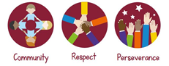


Design & Technology Subject Handbook

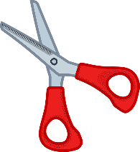
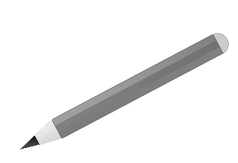
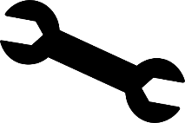

Our vision and rationale for Design and Technology

Design and technology is a valued part of our curriculum at Meole Brace Primary School where pupils can explore and evaluate existing products, and design, create and evaluate a product they have made.
Our Design and Technology curriculum allows our children to develop our three core values of perseverance, respect and community whilst engaging, inspiring and challenging our pupils.
Throughout the year groups children learn the knowledge, understanding and skills needed to engage in an iterative process of designing and creating, through a variety of practical and creative activities. Children build upon their structural knowledge and learn useful life skills alongside creating a variety of products designed for the home, school, local community, and industries in the wider environment. Our Design and Technology curriculums hangs upon the skill of evaluation which is first done to existing products and later on their own product which they have created.
Children are taught a range of techniques from cutting and preparing Cooking and nutrition to using cams to make mechanisms. We have a clear progression throughout Design and Technology in the school with many of the subject areas appearing in multiple year groups. For example, in Year One we make a fruit salad with the main focus being the design, in Year Two we make a Pizza with the main focus being tools and equipment usage, and by Year 6 children create their own bread with the focus being on the selection of ingredients.
Through collaborative discussions about their work children are encouraged to form evaluative opinions that are also respectful. Work is celebrated across the school and with the wider community through local festivals, art week, and after school clubs.
Our children are able to have opportunities to work collaboratively with their peers and with the wider community through links with local secondary schools.

Art and design at Meole Brace offers knowledge, creativity and a development of skills.

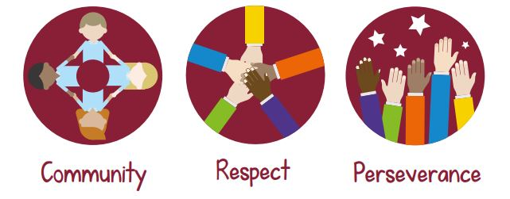

Curriculum Subject Leader

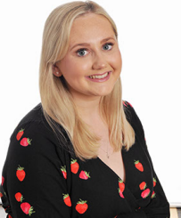

Mrs Helena Mason

National Curriculum Progression for Design and Technology

EYFS | Year 1 | Year 2 | Year 3 | Year 4 | Year 5 | Year 6
 | Design  - design purposeful, functional, appealing products for themselves and other users based on design criteria  - generate, develop, model and communicate their ideas through talking, drawing, templates, mock-ups and, where appropriate, information and communication technology  Make  - select from and use a range of tools and equipment to perform practical tasks [for example, cutting, shaping, joining and finishing]  - select from and use a wide range of materials and components, including construction materials, textiles and ingredients, according to their characteristics  Evaluate  - explore and evaluate a range of existing products  - evaluate their ideas and products against design criteria  Technical knowledge  - build structures, exploring how they can be made stronger, stiffer and more stable  - explore and use mechanisms [for example, levers, sliders, wheels and axles], in their products.  Cooking and nutrition  - use the basic principles of a healthy and varied diet to prepare dishes  - understand where Cooking and nutrition comes from. |  | Design  - use research and develop design criteria to inform the design of innovative, functional, appealing products that are fit for purpose, aimed at particular individuals or groups  - generate, develop, model and communicate their ideas through discussion, annotated sketches, cross-sectional and exploded diagrams, prototypes, pattern pieces and computer-aided design  Make  - select from and use a wider range of tools and equipment to perform practical tasks [for example, cutting, shaping, joining and finishing], accurately  - select from and use a wider range of materials and components, including construction materials, textiles and ingredients, according to their functional properties and aesthetic qualities  Evaluate  - investigate and analyse a range of existing products  - evaluate their ideas and products against their own design criteria and consider the views of others to improve their work  - understand how key events and individuals in design and technology have helped shape the world  Technical knowledge  - apply their understanding of how to strengthen, stiffen and reinforce more complex structures  - understand and use mechanical systems in their products [for example, gears, pulleys, cams, levers and linkages]  - understand and use electrical systems in their products [for example, series circuits incorporating switches, bulbs, buzzers and motors]  - apply their understanding of computing to program, monitor and control their products.  Cooking and nutrition  - understand and apply the principles of a healthy and varied diet  - prepare and cook a variety of predominantly savoury dishes using a range of cooking techniques  - understand seasonality, and know where and how a variety of ingredients are grown, reared, caught and processed.

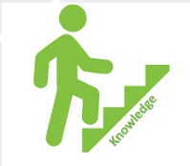
Design and Technology Progression of knowledge

 |  | Nursery | Reception | Year 1 | Year 2 | Year 3 | Year 4 | Year 5 | Year 6
 | Concepts and Themes
Design | Core Knowledge | In EYFS we:  Think of ideas.  Communicate ideas and plans through talk and drawing.  Plan and make decisions about how to approach a task. |  | I know how to design purposeful, functional, appealing products for myself, and other users based on design criteria.  I know how to generate, develop, model, and communicate my ideas through talking, drawing, templates, mock-ups and, where appropriate, information and communication technology | I know how to design purposeful, functional, appealing products for myself, and other users based on design criteria  I know how to generate, develop, model, and communicate my ideas through talking, drawing, templates, mock-ups and, where appropriate, information and communication technology. | I know how to develop design criteria to inform the design of innovative, functional, appealing products that are fit for purpose, aimed at individuals or groups  I know how to generate my ideas with growing confidence for an item considering its purpose and users.  I know how to label drawings when designing and planning, showing materials and components.  I know I can learn about inventors, designers, engineers who have developed groundbreaking products. | I know how to develop design criteria to inform the design of innovative, functional, appealing products that are fit for purpose, aimed at individuals or groups  I know how to generate ideas with confidence for an item considering its purpose and users.  I know how to annotate labelled drawings when designing and planning, showing materials and components.  I know I can learn about inventors, designers, engineers who have developed groundbreaking products. | I know to use research and develop design criteria to inform the design of functional, appealing products that are fit for purpose, aimed at individuals or groups I know how to generate, develop, model, and communicate my ideas through discussion, annotated sketches and pattern pieces.  I know how to annotate labelled drawings when designing and planning, showing materials and components.  I know I can learn about inventors, designers, engineers who have developed groundbreaking products | I know to use research and develop design criteria to inform the design of innovative, functional, appealing products that are fit for purpose, aimed at individuals or groups  I know how to generate, develop, model, and communicate my ideas through discussion, annotated sketches, cross-sectional and exploded diagrams, prototypes, pattern pieces and computer-aided design
Design | Vocabulary | Design, texture, purpose, build, plan, measure, design, join. |  | Design, appealing, products, communicate, ideas, plan | Design, appealing, products, communicate, ideas, plan | Design, appealing, products, communicate, ideas, plan, purpose, users, label, materials, inventors, designers, engineers | Design, appealing, products, communicate, ideas, plan, purpose, users, label, materials, inventors, designers, engineers | Design, functional, appealing, communicate, ideas, annotate, plan, materials, inventors, designers, engineers, products, | Design, functional, appealing, communicate, ideas, annotate, plan, materials, inventors, designers, engineers, products, fit for purpose, diagrams
Make | Core Knowledge | In EYFS we:  Practice using tools such as scissors, glue, and a hole punch.  Develop skills of weaving with paper, string, and wool.  Handle equipment and tools effectively.  Safely use and explore a variety of materials, tools, and techniques, experimenting with colour, design, texture, form and function.  Handle equipment and tools effectively.  Safely use and explore a variety of materials, tools, and techniques, experimenting with colour, design, texture, form and function.  Build and construct with a wide range of objects, selecting appropriate resources. |  | I know how to select from and use a range of tools and equipment to perform practical tasks.  I know how to select from and use a range of materials and components, including construction materials and ingredients, according to their characteristics | I know how to select from and use a range of tools and equipment to perform practical tasks I know how to select from and use a wide range of materials and components, including construction materials, textiles, and ingredients, according to their characteristics | I know how to select from range of tools and equipment to perform practical tasks I know how to select from and use a broader range of materials and components, including construction materials, textiles, and ingredients, according to their functional properties and aesthetic qualities. | I know how to select from range of tools and equipment to perform practical tasks  I know how to select from and use a limited range of materials and components, including construction materials, textiles and ingredients, according to their functional properties and aesthetic qualities. | I know how to select from and use a wider range of tools and equipment to perform practical tasks [for example, cutting, shaping, joining, and finishing], accurately  select from and use a wider range of materials and components, including construction materials, textiles, and ingredients, according to their functional properties and aesthetic qualities | I know how to select from and use a wider range of tools and equipment to perform practical tasks [for example, cutting, shaping, joining, and finishing], accurately  select from and use a wider range of materials and components, including construction materials, textiles, and ingredients, according to their functional properties and aesthetic qualities
Make | Vocabulary | Tools, scissors, glue, cut, stick, weave, fabric, material, safely, colour, design, texture, purpose, build, plan, measure, design, join. |  | Tools, equipment, craft knives, glue guns, scissors, cut, stick, materials, design, texture, material, assemble, model, mechanism, template, test. | Tools, equipment, craft knives, glue guns, scissors, cut, stick, materials, stitch, sew, decorate, stencil, template, fabric, hand puppet, mechanism, motion, running stitch, shape | Tools, equipment, craft knives, glue guns, scissors, cut, stick, materials, stitch, sew, applique, running-stitch, seam, stencil, 2D shapes, 3D shapes, design criteria, feature, bridge, arched bridge, beam bridge | Tools, equipment, assemble, mock-up, running stitch, template, target-audience, function, applique, | Caption, design, design criteria, function, mechanism, prototype, structure, accurate, annotate, fabric, sew, shape, template, air resistance, chassis, | Caption, design, design criteria, function, mechanism, prototype, structure, accurate, annotate, fabric, sew, shape, template, battery, component, conductor, motor,
Evaluate | Core Knowledge | In EYFS we:  Check how well our activities are going.  Adapt our work when necessary.  Review how well my approach worked.  Evaluate my own and others work verbally. |  | I know how to explore and evaluate a range of existing products  I know how to evaluate my ideas and products against design criteria | I know how to explore and evaluate a range of existing products  I know how to evaluate ideas and products against design criteria | I know how to investigate and analyse a range of existing products I know how to evaluate my ideas and products against my own design criteria and consider the views of others to improve their work  I know how key events and individuals in design and technology have helped shape the world | I know how to investigate and analyse a range of existing products  I know how to evaluate my ideas and products against my own design criteria and consider the views of others to improve their work I know and understand key events and individuals in design and technology have helped shape the world | I know how to investigate and analyse a range of existing products  I know how to evaluate my ideas and products against their own design criteria to improve my work  I know and understand how key events and individuals in design and technology have helped shape the world | I know how to investigate and analyse a range of existing products  I know how to evaluate their ideas and products against their own design criteria and consider the views of others to improve their work  I know and understand how key events and individuals in design and technology have helped shape the world
Evaluate | Vocabulary | Evaluate, product, ideas |  | Evaluate, product, ideas, improve | Evaluate, product, ideas, improve | Evaluate, product, ideas, improve, investigate, analyse, views of others | Evaluate, product, ideas, improve, investigate, analyse, views of others | Evaluate, product, ideas, improve, investigate, analyse, views of others | Evaluate, product, ideas, improve, investigate, analyse, views of others
Technical knowledge | Core Knowledge | In EYFS we:  Design and build structures, which we can adapt to make stronger. |  | I know how to build structures, exploring how they can be made stronger, stiffer and more stable  I know how to explore and use mechanisms (for example, different types of hinges), in their products. | I know how to build structures, exploring how they can be made stronger, stiffer and more stable. I know how to explore and use mechanisms [for example, levers, sliders, wheels and axles], in my  products. | I know how to apply my understanding of how to strengthen, stiffen and reinforce structures  I know how to and can use mechanical systems in my products [for example, gears, pulleys, cams, levers and linkages] | I know how to apply my understanding of how to strengthen, stiffen and reinforce structures  I know how to and can use mechanical systems in my products [for example, gears, pulleys, cams, levers and linkages] | I know how to apply my understanding of how to strengthen, stiffen and reinforce more complex structures  I know and understand what suitable ingredients are to promote a healthy, balanced diet. | I know how to apply my understanding of how to strengthen, stiffen and reinforce more complex structures I know how to use mechanical systems in their products [for example, gears, pulleys, cams, levers and linkages]  I know what electrical systems are in my products  I know how to apply my understanding of computing to program, monitor and control my products
Technical knowledge | Vocabulary | Rebuild, adapt, stronger |  | Stronger, stiffer, stable, levers, sliders, wheels, axies | Stronger, stiffer, stable, levers, sliders, wheels, axies | Strengthen, stiffen, reinforce, gears, pulleys, cams, levers, linkages, series circuits, switches, buzzers, bulbs, motors, program, monitor, control products. | Strengthen, stiffen, reinforce, gears, pulleys, cams, levers, linkages, series circuits, switches, buzzers, bulbs, motors, program, monitor, control products. | Strengthen, stiffen, reinforce, gears, pulleys, cams, levers, linkages, series circuits, switches, buzzers, bulbs, motors, program, monitor, control products. | Strengthen, stiffen, reinforce, gears, pulleys, cams, levers, linkages, series circuits, switches, buzzers, bulbs, motors, program, monitor, control products.
Cooking and nutrition | Core Knowledge | In EYFS we:  Practise stirring, mixing, pouring and blending ingredients during cookery activities.  Handle equipment and tools effectively  Observe changes. |  | I know the basic principles of a healthy and varied diet to prepare dishes I know where Cooking and nutrition comes from. | I know and understand the basic principles of a healthy and varied diet to prepare dishes I know and understand where Cooking and nutrition comes from. | I know how to apply the principles of a healthy and varied diet to prepare and cook a variety of dishes.  I know how to use a range of cooking techniques.  I know where and how a variety of ingredients are grown, reared, caught and processed. | I know how to apply the principles of a healthy and varied diet to prepare and cook a variety of dishes.  I know how to use a range of cooking techniques.  I know about seasonality and which Cooking and nutritions are best during each season.  I know where and how a variety of ingredients are grown, reared, caught and processed. | I know how to apply the principles of a healthy and varied diet to prepare and cook a variety of dishes.  I know how to use a range of cooking techniques.  I know about seasonality and which food is best during each season.  I know where and how a variety of ingredients are grown, reared, caught and processed. | I know how to apply the principles of a healthy and varied diet to prepare and cook a variety of dishes.  I know how to use a range of cooking techniques.  I know about seasonality and which food is best during each season.  I know where and how a variety of ingredients are grown, reared, caught and processed.
Cooking and nutrition |  | Mix, pour, blend, ingredients, cook, bake, bowl, spoon, knife, chopping board, healthy, unhealthy, sweet, savoury. |  | Mix, pour, blend, ingredients, cook, bake, bowl, spoon, knife, chopping board, healthy, unhealthy, sweet, savoury, varied diet, | Mix, pour, blend, ingredients, cook, bake, bowl, spoon, knife, chopping board, healthy, unhealthy, sweet, savoury, varied diet, | Mix, pour, blend, ingredients, cook, bake, boil, roast, bowl, spoon, knife, chopping board, healthy, unhealthy, sweet, savoury, varied diet, seasonality, grown, reared, caught, processed. | Mix, pour, blend, ingredients, cook, bake, boil, roast, bowl, spoon, knife, chopping board, healthy, unhealthy, sweet, savoury, varied diet, seasonality, grown, reared, caught, processed. | Mix, pour, blend, ingredients, cook, bake, boil, roast, bowl, spoon, knife, chopping board, healthy, unhealthy, sweet, savoury, varied diet, seasonality, grown, reared, caught, processed. | Mix, pour, blend, ingredients, cook, bake, boil, roast, bowl, spoon, knife, chopping board, healthy, unhealthy, sweet, savoury, varied diet, seasonality, grown, reared, caught, processed.

Design and Technology Unit Coverage

 | Autumn Term | Spring Term | Summer Term
Year R | - Textiles - Sea creature representations | - Textiles - Exploring textures with tools | - Structures - building castles with flat and solid shapes
Year 1 | - Structures – A strong chair for Baby Bear | - Mechanisms – Castle drawbridge / trap door | - Cooking and Nutrition – Making a Fruit Salad
Year 2 | - Mechanisms – Moving Christmas card – wheels, levers and sliders | - Cooking and nutrition – Making a healthy pizza | - Textiles – joining fabric to create a pirate puppet
Year 3 | - Mechanisms – making a moving vehicle | - Cooking and nutrition – Making a healthy sandwich | - Structures – Bridges and aqueducts
Year 4 | - Mechanisms – cam mechanisms to make a moving volcano | - Cooking and nutrition – Making Tudor biscuits healthy | - Textiles – sewing and needlework to make a bag for a Rainforest explorer
Year 5 | - Structures – Make a Saxon shelter | - Mechanism – make a vehicle with linked wheels | - Cooking and nutrition – Making flatbread and design a healthy Greek salad
Year 6 | - Mechanisms – Electrical alarm for a vehicle | - Textiles - Recycled materials to make a cushion cover | - Cooking and Nutrition – Making bread and seasonal soup.

Adaptive Teaching in Design and Technology

Creating an Inclusive Environment
- Visual aids and auditory equipment where appropriate.
- Classroom layout and space given to support children with physical disabilities.
- Opportunities for individual, paired and group work.
- Encouraging experimentation and confidence in sharing own ideas.
- A platform for children to share ideas verbally and through sharing work. – eg gallery walk around to explore and appreciate others’ work.
- Exploring own methods of achieving a design brief, alongside taught methods.
- Clear models for all.
- Equipment adapted to user’s needs.
- Modelling and demonstrating every element of the project, including the D&T booklets and expectations of designs and written work.

Supporting learners who are reading below age-related expectations
- Visual aids.
- Simplified layout and language.
- Clear modelling by adults.
- Group or paired work for peer supporting opportunities.
- Word banks.

Supporting learners who struggle to retain vocabulary
- D&T mats with useful/key vocabulary.
- Clear lesson model - Emphasis on evaluation, design, make, evaluate throughout each year group.
- Pictorials and visual aids.
- Modelled vocabulary throughout lessons correctly with consistent use.
- Word banks for written tasks.

Supporting learners to develop conceptual understanding
- Retrieval for learning – recapping prior knowledge.
- Linking lesson to world knowledge. All projects evaluate existing products at the beginning.
- Linked skills learnt to real life – e.g. cutting with a knife (and other kitchen skills) to working with different materials and equipment.
- Modelling and demonstrating every element of the project, including the D&T booklets and expectations of designs and written work.
- Opportunities for hands on exploration and learning.
- Projects completed thoroughly in a block of lessons, to allow continuity in knowledge and progression through the design process.
- Allowing time to research and develop own ideas and understanding.
Supporting learners who struggle with attention
- Movement and brain breaks.
- Lessons are varied and child led.
- Teaching time is concise to enable children to explore skills and have practical time.
- Hands on physical learning.
- Paired, group or individual work.
- Research time.
- Retrieval for learning to develop on prior knowledge and tackle misconceptions.
- Positioning of children. Teacher and TA support.
- Videos and images to make engaging.
Supporting learners with physical impairment
- Extra space given for children with physical impairment.
- Promoting independence where appropriate.
- Activities adapted to allow successful outcomes – e.g. size of paper, materials offered, adapted equipment.
- Paired work and support from peers.
- Use of technology – e.g., clicker, laptop work, Nano mouse.
- Written tasks adapted to make accessible.
- Supported 1:1 from adult.
- Guided activities – focusing on key skills – e.g. cutting.

Supporting knowledge retention

Early Years | Key Stage 1 | Key Stage 2
- Fine motor skills – introduction to using scissors etc.  - Child initiated exploration – making own designs and choosing resources.  - Question based evaluation of designs. Children encouraged to consider how it could be improved. Opportunities to re-create ideas.  - Vocabulary encouraged and modelled correctly. | - Continuation of developing fine motor skills.  - Introduction to D&T booklets – explicit design process (evaluation of existing product, design brief, design, evaluation.)  - Retrieval practice, word banks and key vocabulary. – Modelled and explored.  - Use of correct vocabulary.  - Own evaluations linked to evaluation of existing product.  - Knowledge mats in each project booklet.  - Misconceptions addressed – through evaluation process and exploration of skills. | - Using a wider range of equipment to secure fine motor skills and develop new skills.  - D&T booklets – children are aware of design process and ideas are developed.  - More opportunities for research to inform own designs.  - Retrieval practice, word banks and key vocabulary. – High expectations for use of vocabulary.  - Skills learnt in previous years will be built upon and explored further.  - Knowledge mats in each project booklet.  - Misconceptions addressed – through evaluation process and exploration of skills. Reminders of previous projects and skills learnt.

Curriculum Reading
 | Autumn Term | Spring Term | Summer Term
EYFS | 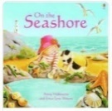  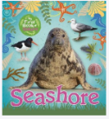   |  | 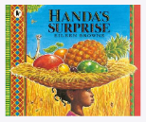  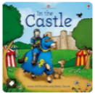
Year 1 | 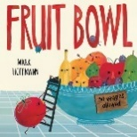  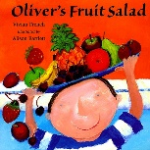  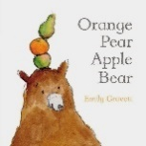 | 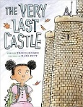  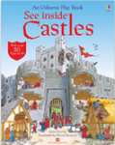 | 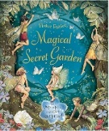
Year 2 |  | 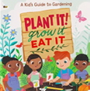  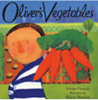  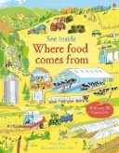  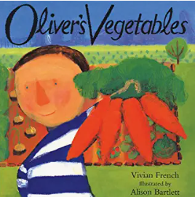 | 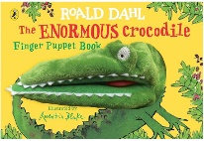      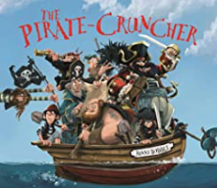
Year 3 | 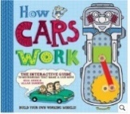  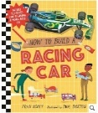 | 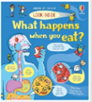  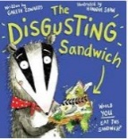 | 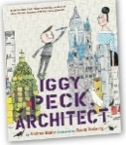
Year 4 | 
Year 5 | 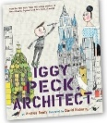
Year 6 |  | 