Art Scheme of Work



National Curriculum |  | KS1  Pupils should be taught:  - To use a range of materials creatively to design and make products  - To use drawing, painting and sculpture to develop and share their ideas, experiences and imagination  - To develop a wide range of art and design techniques in using colour, pattern, texture, line, shape, form and space  - about the work of a range of artists, craft makers and designers, describing the differences and similarities between different practices and disciplines, and making links to their own work. |  |  | KS2  Pupils should be taught to:  - Pupils should be taught to develop their techniques, including their control and their use of materials, with creativity, experimentation and an increasing awareness of different kinds of art, craft and design.  - To create sketch books to record their observations and use them to review and revisit ideas  - To improve their mastery of art and design techniques, including drawing, painting and sculpture with a range of materials for example, pencil, charcoal, paint, clay.  - about great artists, architects and designers in history
Study of  Artists |  | - Can look at and describe what they see, think and feel when looking at the work of artists, craft makers and designers.  - Identify different art forms and suggest reasons for the meaning of the work.  - Can use their understanding of how an artist has created their work to improve their own. |  |  | - Can describe the work of artists, crafts people, architects and designers to build understanding and discuss this with others.  - Can learn about ‘how to’ from studying other artists’ work.  - Can use work of other artists/cultures as a stimulus to develop ideas and ways of making and the decoration.
Creating Ideas |  | Pupils should  - Work from observation and known objects – draw from memory and imagination  - Use imagination to form simple images from given starting points or a description  - Begin to collect ideas in sketchbooks – use experiences and ideas as inspiration for art work  - Work with different materials  - Begin to think what materials best suit the task  - Use language to interpret observations - line, shape, pattern, colour, texture, form  - To reflect on and critically evaluate their own work and that of others |  |  | Pupils should  - Create sketch books to record their observations and use them to review and revisit ideas.  - Improve their mastery of art and design techniques including drawing, painting and sculpture with a range of materials  - To reflect on and critically evaluate their own work and that of others
 | Skill | EYFS | KS1 | LKS2 |  | UKS2
Skills and Techniques | Drawing and Mark Making | - Enjoy simple mark making using: fingers, hands, chalk, pens, pencils, brushes.  - Explore big movements with the whole body while drawing  - Experiment with a variety of tools to draw lines e.g. pens, pencils, wax crayons, markers etc. | - Begin to control lines to create simple drawings from observations, remembered or imagined  - Draw lines of different thicknesses  - Begin to add detail to line drawings Colour within the line  - Explore pastels on black paper / card  - Show pattern and texture by adding dots and lines  - Use different thicknesses of felt tip pens / chalks / wax crayon and pastel | - Use sketch books to record drawings from observation  - Explore line, tone and texture using a range of media including HB to 6B pencils eg pastels, chalk, paint, pen and ink and felt tips  - Sketch familiar objects from different viewpoints  - Develop detail by adding shadow to observational drawing  - Use hatching and cross hatching to show tone and texture |  | - Use drawing to explore line, tone, texture, form and colour.  - Experiment with more advanced sketching techniques e.g. cross hatching (from Y3/4), pointillism, sidestrokes, use of rubber to draw/highlight.  - Use a range of mediums on a range of backgrounds (drawing media as above and different papers)  - Use a variety of techniques to add interesting effects (e.g. reflections, shadows, direction of sunlight).  - Sketch still life compositions/ landscapes/ humans and animals  - Explore the effects of charcoal/ graphite sticks  - Begin to use simple perspective in their work, i.e. foreground, middle ground and background.  - Begin to develop an awareness of composition, scale and proportion  - Use light drawing as a base for composition e.g. painting/collage.  - Sketch indoors and outdoors.
Skills and Techniques | Painting | - Explore making marks on a variety of papers  - Use a variety of tools to spread paint - straws, matchsticks as well as brushes.  - Explore painting using big movements onto big surfaces | - Name colours and use appropriately  - Y2 – Develop an understanding of what primary and secondary colours are using a colour wheel  - Add white to colours to make tints and black to make tones  - Add different materials to paint to produce different textural effects eg salt / sand  - Colour / paint within an enclosed space  - Hold a paintbrush correctly and clean it before changing colours  - Use the correct brush for the required space.  - Make marks using paint with a variety of tools  - Create colour washes and incorporate wax resist (oil / pastels / crayons)  - Recognise hot and cold colours | - Choose from a range of brush sizes and use appropriately  - Confidently mix colours to make a range of tones  - Explore complementary and opposing colours  - Use black and white to create lighter and darker shades / tints of one colour  - Experiment with watercolour exploring intensity of colour to develop shades  - Recognise and use neutral colours (Black, white, grey)  - Identify and work with ‘earthy’ colours |  | - Choose from a range of brush sizes and use appropriately.  - Develop fine brush strokes using the lower range of paint brushes  - Draw lightly first and then paint a range of images; still life compositions / landscapes / humans and animals etc  - Use a colour wheel to introduce tertiary colours.  - Identify and work with complimentary opposite colours / colour harmonies.  - Explore using limited colour palettes.  - Develop watercolour techniques on dampened textured paper.  - Introduce acrylic paint.  - Apply acrylic paint to board or canvas using palette knives, pieces of card, sponges and rags.  - Use brush techniques and the qualities of paint to create texture.
Skills and Techniques | Printing | - Explore printmaking using different parts of the body e.g. fingers, hands, feet.  - Explore simple repeat patterns using found objects. | - Explore and make patterns by printing with a range of hard and soft materials eg corks / sponges / fruit / vegetables  - Create repeating patterns  - Create simple printing blocks from polystyrene tiles  - Use rollers and printing inks and trays  - Experiment with over printing with simple shapes to add detail  - Mimic print from environment eg wallpaper | - Recognise what makes a good print.  - Create printing blocks (e.g. from coiled string glued to a block) used relief or impressed method on plasticine, clay or polystyrene press print tiles.  - Use rollers and printing inks and trays.  - Design and create repeating patterns.  - Replicate patterns observed in natural or built environments.  - Further develop the printing techniques, mono-printing and block printing.  - Print with two colour overlays.  - Experiment with overlapping and overprinting, contrasting shapes and colours. |  | - Develop a print from a drawing.  - Create an accurate pattern, showing fine detail.  - Create more complex prints using stimuli from nature /culture.  - Design prints for real purposes e.g. fabrics, wallpaper or wrapping paper.  - Make relief-print tiles e.g. using card, string, wool.  - Build up layers of colours.  - Combine printing with other 2D techniques eg painting /sketching
Skills and Techniques | Collage | - Handle different materials from class ‘bit box’.  - Sort materials according to specific qualities e.g. warm, cold, soft, shiny etc.  - Cut and stick a variety of materials | - Create images using a variety of media eg photocopies, fabric, crepe paper, magazines  - Collect, sort and group materials for different purposes in different ways eg texture, colour  - Choose, arrange and glue materials to different backgrounds to create a final piece  - Fold, crumple, tear and overlap papers and materials  - Cut wide and narrow paper strips  - Use the natural environment or townscape as stimulus  - Collect natural materials to create a temporary outdoor collage | - Use a range of stimulus for collage work.  - Develop individual and group collages working on a range of scales.  - Work from a plan to produce a collage.  - Experiment with a range of collage techniques such as tearing, cutting, overlapping, tessellation, mosaic, montage and layering to create images or effects.  - Select and arrange materials for a striking effect.  - Develop skill with scissors to cut complex shapes.  - Explore cutting and a range of joining skills  - Apply glue accurately. |  | - Use a range of media to create collages.  - Select materials by colour and texture to match intentions.  - Mix textures (rough and smooth, plain and patterned).  - Explore the translucent nature of tissue paper.  - Add collage to a printed or painted background.
Skills and Techniques | Textiles | - Use graphic materials e.g. oil pastels, pens etc to make marks and drawings onto fabric.  - Explore wrapping, weaving, tying, looping etc natural and man- made materials onto a fence, net framework etc.  - Join materials using glue | - Use materials eg dye, oil pastels, pens to make marks onto fabric (Hapa Zome Forest School)  - Dye fabrics suing natural ingredients eg berries, grasses, flowers, leaves  - Apply colour to fabric with tye dye / dipping  - Explore weaving using natural and recycled materials  - Explore weaving suing one or two colours  - Cut and shape fabric using scissors  - Explore sewing using running stitch | - Show awareness of natural environment through colour matching.  - Develop sewing skills using simple a variety of threads and wool – cross stitch and back stitch  - Embellish using stitching and appliqué techniques / quilt fabric  - Develop skills in cutting and joining fabrics  - Use a variety of techniques e.g. printing. dying, plaiting, pinning, weaving and stitching to create different textural effects. |  | - Embellish designs/ objects using the stitches from LKS2 (backstitch, cross stitch) and develop blanket stitch  - Further develop appliqué techniques.  - Create more complex patterns when embellishing  - Demonstrate an awareness of the potential of the uses of material e.g. silk/canvas/felt.  - Explore a range of more advanced fabric techniques eg batik, silk painting  - Create detailed designs for fabric work
Skills and Techniques | 3D/Sculpture | - Explore a variety of malleable materials e.g. rolled up paper, clay, play dough, plasticine, cooking dough.  - Explore a variety of 3D materials e.g. straws, sticks, leaves etc. Construct towers, bridges, tunnels using building blocks and cardboard boxes. | - Experiment constructing with and joining recycled, natural and manmade materials.  - Look at objects/sculptures and try to recreate them using natural and/or every day, recycled materials.  - Create natural material group sculptures on a larger scale  - Consider covering these with papier-mâché.  - Manipulate malleable materials in a variety of ways i.e. pinching, rolling, twisting, squeezing, creating holes and hollows, smoothing or scratching for texture and coiling.  - Work safely with materials and tools.  - Add details and textures using tools.  - Create mini sculptures using malleable materials. | - Work safely with materials and tools.  - Investigate a range of different materials and experiment with how they can be connected together to form more complex structures.  - Create sculptures on a larger scale as a group.  - Use papier-mâché.  - Develop confidence working with clay techniques from KS1, adding greater detail and texture.  - Investigate ways of joining clay e.g. scratch and slip.  - Explore slabbing.  - Use tools to carve and add shapes, texture and pattern  - Add colour once clay is dried. |  | - Design and create sculpture both small and large scale individually or in large groups.  - Use recycled or natural objects to form sculptures.  - Use pipe cleaners, wires or withies to create frames for a range of structures to include human/animal forms at some point  - Pad out structures made from wire or withies e.g. with cotton wool/ wadding/ scrunched newspaper /tape and cover e.g. with mod roc, papier-mâché or plaster of paris  - Make masks from a range of cultures of traditions building a collage element into the sculptural process.
Skills and Techniques | Photography/Digital Media

Drawing | - Children should be given the chance to work on a variety of scales  - Sketch books should be ‘owned’ by pupils. They can be used to experiment, gather, collect and reflect. Teachers should not be afraid if they seem chaotic. They are a place to put unresolved ideas into the world. They are rarely linear.  - Teachers should not be afraid to approach drawing as a ‘journey’. The process is as important as the outcome. Working from a ‘display-backwards’ mentality often stifles creativity.  - Warm up drawing activities can ‘set the scene’ for the main activity. It should create a bridge to the main session.  https://www.accessart.org.uk/national-curriculum-planning-art-drawing/  - Blind contour drawings  https://www.accessart.org.uk/making-a-blind-contour-drawing/  - Work from your shoulder not your wrist or fingers  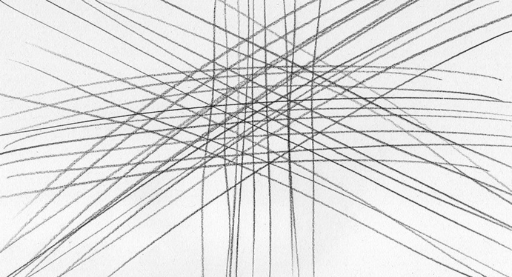  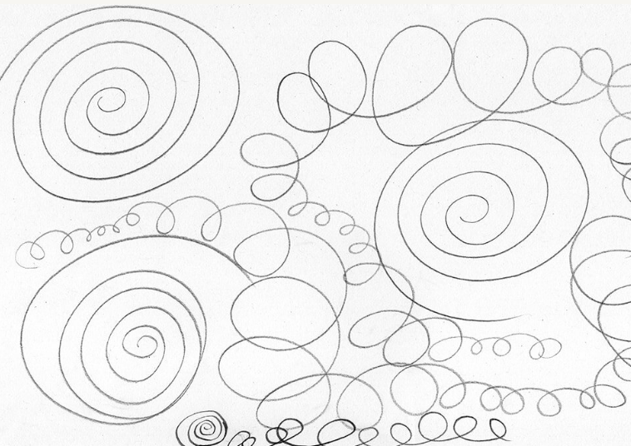  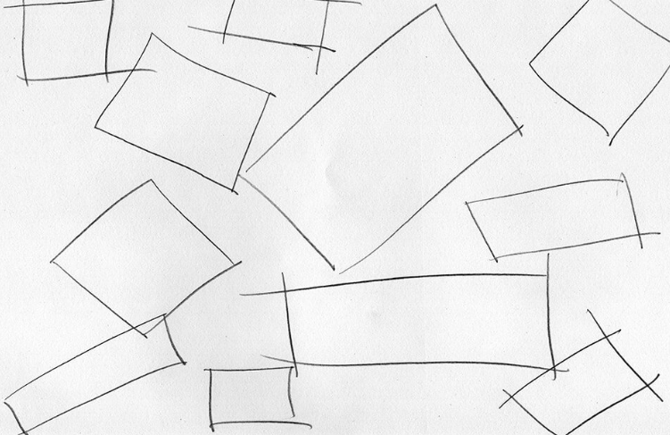  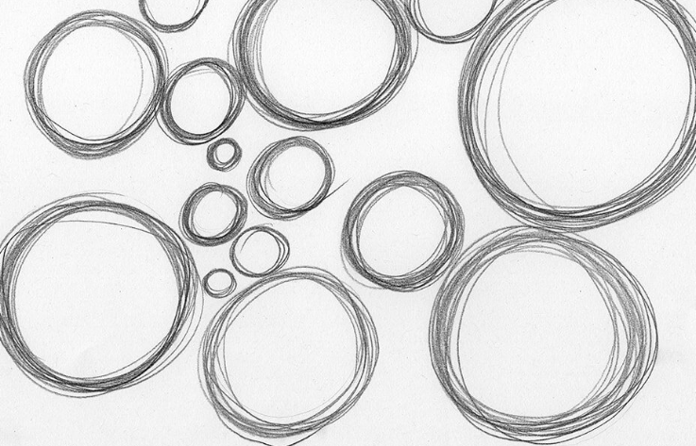  - Pencil pressure  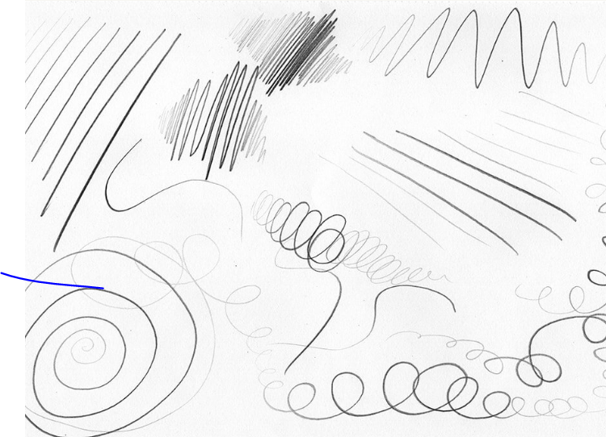
Sculpture | - Drawing by feel and then touch – hide objects in plastic bags – ask children to draw the object from sense of touch. Take the object out of the bag and explore drawing it by sight or by ‘looking’. Then reflect on the tasks and their sensory awareness – both visual and tactile. Then give children a lump of clay. Manipulate it from memory of the object they have just drawn.  - Sculpture = making, not designing on paper first (Design through making)  - Sculpture can be an additive process (construction) or through taking away (carving).  - Use sketch books as a creative tool

