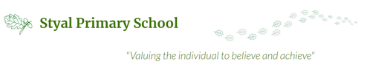

Why is Art important at Styal Primary School?

At Styal children embrace their ideas and thought and become artists in their own right. In order to achieve this, children will be given opportunities to explore and interpret a variety of well represented artists, forming opinions and finding what inspires them along the way.
- It inspires our children
- It allows them to be inspirational
- It opens up different windows on cultures from around the world
- It gives our children chance to respect other people’s opinions
- It teaches our children the skills they need to be creative
- It gives our children chance to express themselves
- It allows children to succeed
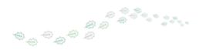

Why are our Sketch Books Important?
- It can provide a record of children’s learning and progress in Art
- To make children more confident and independent artists
- It is used as a place to practice, develop and focus their work
- To help children know it’s okay to make mistakes
- It can provide somewhere for us to record information about artists, architects and designers
- They are passed up from class to class to allow for progression to be seen

We are committed to developing a clear progression of skills and knowledge as they make their way through school.
Children will leave Styal Primary School equipped with tools and techniques to express their thoughts and ideas creatively.

