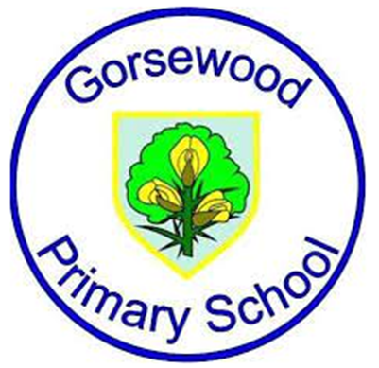
GORSEWOOD PRIMARY SCHOOL
Long term overview - 2026-2027 Writing Roots Texts (Literacy Tree) - tbc throughout the year at salient times

Year group | Autumn 1 | Autumn 2 | Spring 1 | Spring 2 | Summer 1 | Summer 2
Reception | Whole School Book focus - ‘Here we are - notes for living on planet Earth’ by Oliver Jeffers  Oi Frog by Kes Gray & Jim Field  And Tango makes Three by Justin Richardson & Peter Parnell | The Lights that Dance in the Night by Yuval Zommer | Whole School Book focus -‘Winter Sleep - A hibernation story’ by Sean Taylor & Alex Morss  Bringing the rain to Kapti Plain by Verma Aardema  Anansi the Spider by Gerald McDermott | ‘The Extraordinary Gardner’ by Sam Boughton  The Tiny Seed by Eric Carle | Izzy Gizmo by Pip Jones  Izzy Gizmo and the Invention Convention by Pip Jones | ‘Super Millie’ by Stephanie Clarkson  The Magic Paintbrush by Julia Donaldson
Year 1 | Whole School Book focus - ‘Here we are - notes for living on planet Earth’ by Oliver Jeffers  Beegu by Alexis Deacon  The Comet by Joe Todd Stanton | Iggy Peck Architect by Andrea Beaty & David Roberts  Yeti and the Bird by Nadia Shireen | Whole School Book focus - ‘Winter Sleep - A hibernation story’ by Sean Taylor & Alex Morss  Sidney, Stella and the moon by Emma Yarlett | Naughty Bus by Jan & Jerry Oke  Pig the Pug by Aaron Blabey | Leo and the Octopus by Isabelle Marinov  Stanley’s Stick by John Hegley | The Sea Saw by Tom Percival  Stella and the seagull by Georgina Stevens
Year 2 | Whole School Book focus - ‘Here we are - notes for living on planet Earth’ by Oliver Jeffers  Last stop, Market Street by Matt de la Pena  Me and You by Anthony Browne | Rosie Revere - Engineer by Andrea Beaty  The Owl and the pussycat by Edward Lear | Whole School Book focus - ‘Winter Sleep - A hibernation story’ by Sean Taylor & Alex Morss  A walk in London by Salvatore Rubbino | Ocean meets the sky by Terry Fan & Eric Fan  The Journey Home by Frann Preston Gannon | ‘Dear Earth’ by Isabel Otter & Clara Anganuzzi | The Great Fire of London by Emma Adams
Year 3 | Whole School Book focus - ‘Here we are - notes for living on planet Earth’ by Oliver Jeffers  Small in the City by Sydney Smith | The First Drawing by Mordicai Gerstein | Whole School Book focus - ‘Winter Sleep - A hibernation story’ by Sean Taylor & Alex Morss  Wilderness by Steve McCarthy | How to Live Forever by Colin Thompson | ‘Escape from Pompeii’ by Christina Balit | Cinderella of the Nile by Beverley Naidoo
Year 4 | Whole School Book focus - ‘Here we are - notes for living on planet Earth’ by Oliver Jeffers  The Iron Man by Ted Hughes | Until I met Dudley by Roger McGough | Whole School Book focus - ‘Winter Sleep - A hibernation story’ by Sean Taylor & Alex Morss  The Ever-Changing Earth by Grahame Baker-Smith | Weslandia by Paul Fleischman | Riddle Runes by Janina Ramirez | The Lion the Witch and the Wardrobe by CS Lewis
Year 5 | Whole School Book focus - ‘Here we are - notes for living on planet Earth’ by Oliver Jeffers  The Lost Thing by Shaun Tan | The Rainplayer by David Wisniewski | Whole School Book focus - ‘Winter Sleep - A hibernation story’ by Sean Taylor & Alex Morss  The Whale by Ethan & Vita Murrow | Freedom Bird by Jerdine Nolen  or  ‘The Tempest’ by William Shakespeare  or  ‘The Island’ by Armin Creder | ‘The Lizzie Belle Mysteries’ by J T Williams | Percy Jackson Hidden Figures by Rick Riordan
Year 6 | Whole School Book focus - ‘Here we are - notes for living on planet Earth’ by Oliver Jeffers  ‘The Arrival’ by Shaun Tan | Suffragette: ‘The Battle for Equality’ by David Roberts | Whole School Book focus - ‘Winter Sleep - A hibernation story’ by Sean Taylor & Alex Morss  Can we Save the Tiger? By Martin Jenkins | Resist by Tom Palmer | Some Places more than Others by Renee Watson | Windrush Child by Benjamin Zephaniah

