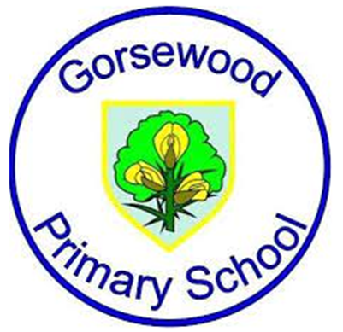
GORSEWOOD PRIMARY SCHOOL
Long term overview - COMPUTING

Year group | Autumn 1 | Autumn 2 | Spring 1 | Spring 2 | Summer 1 | Summer 2
Reception | Online Safety | Information Technology | Computer Science  Twinkl - Making a robot | Computer Science  Twinkl - Beebots | Digital Literacy - Editing Photos | Digital Literacy - Brushes
Year 1 | Common Sense Education  Digital Citizenship | Twinkl  Computer Skills | Twinkl  Word Processing Skills | Twinkl  Programming Toys | Twinkl  Programming with ScratchJR | Twinkl  Using and Applying
Year 1 | E-Safety ongoing throughout the year linked to PSHE and RSE.
Year 2 | Common Sense Education  Digital Citizenship | Twinkl  Online Safety | Twinkl  Using the Internet | CS First  Introduction to CS First | Twinkl  Computer Art | Twinkl  Using and Applying
Year 2 | E-Safety ongoing throughout the year linked to PSHE and RSE.
Year 3 | Be Internet Legends  Digital Wellbeing  Y3 Sharp Pillar  Y3 Alert Pillar | Be Internet Legends  Y3 Secure Pillar  Y3 Kind Pillar  Y3 Brave Pillar | CS First  CS First Unplugged | CS First  Storytelling Unit | CS First  Characterisation | CS First  An unusual Discovery
Year 3 | E-Safety ongoing throughout the year linked to PSHE and RSE.
Year 4 | Be Internet Legends  Digital Wellbeing  Y4 Sharp Pillar  Y4 Alert Pillar | Be Internet Legends  Y4 Secure Pillar  Y4 Kind Pillar  Y4 Brave Pillar | CS First  Music and Sound | CS First  Code your Hero | CS First  Interactive Presentation | CS First  CS First Unplugged
Year 4 | E-Safety ongoing throughout the year linked to PSHE and RSE.
Year 5 | Be Internet Legends  Digital Wellbeing  Y5 Sharp Pillar  Y5 Alert Pillar | Be Internet Legends  Y5 Secure Pillar  Y5 Kind Pillar  Y5 Brave Pillar | CS First  Friends | CS First  Animate a name | CS First  Dialogue | CS First  Narration
Year 5 | E-Safety ongoing throughout the year linked to PSHE and RSE.
Year 6 | Be Internet Legends  Digital Wellbeing  Y6 Sharp Pillar  Y6 Alert Pillar | Be Internet Legends  Y6 Secure Pillar  Y6 Kind Pillar  Y6 Brave Pillar | CS First  Create your own Google Logo | CS First  Design a game | CS First  Figurative Language | CS First  Pitch your Passion
Year 6 | E-Safety ongoing throughout the year linked to PSHE and RSE.

