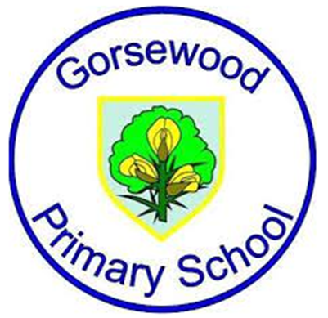
Year 3 Learning Overview

Term 1
English | Literacy Tree Writing Roots- Whole School Text - ‘Here we are - notes for living on planet earth’ , ‘Small in the City’ and ‘The First Drawing’.
Maths | Numbers to 1000, Addition and Subtraction, Multiplication and Division
Science | Scientific Enquiry  Rocks
History | Stone Age to Iron Age
Geography | Settlements - Local Area
PE | Gymnastics , Dodgeball, Hockey, Yoga  Forest School - x1 day a half term
Computing | Be Internet Legends: Online Safety  Connecting Computers
Art | Art:Painting and Mixed Media - Prehistoric Art.  Artist/Designer Focus Study: Andy Goldworthy
DT | DT: Structures - Constructing a Stone/Iron/Bronze Age home. Sculpt a Clay Quern.
Music | Singing rounds - incorporating DR PITTS (inter related dimensions of music);  Whole class Recorder tuition using MECLA resources;  Christmas production preparations.
Drama | Drama techniques and skills with a speech and language focus;  Harvest production;  Christmas production
RE | Christianity (God)  How (and why) have some people served God?  (Prophets, service to God, inspirational people)  Islam Why is the Prophet Muhammad (pbuh) an example for Muslims?  (The Prophet. Muhammed (pbuh), Zakah)
PSHE/RSE | My healthy self: How can I take care of my mind and body?  Connecting with others: What helps us feel safe and included?
French | France  Greetings and Name  Classroom Instructions  French Alphabet

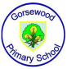

Year 3 Learning Overview

Term 2

English | Literacy Tree Writing Roots- Whole School Book focus ‘Winter Sleep - A Hibernation Story’, ‘Wilderness’, ‘How to live forever’.
Maths | Time, Length, Mass, Volume, Money
Science | Plants  Forces and Magnets;
History | Chronology - Time Box
Geography | Biomes
PE | Handball  Cricket  Athletics  Forest School - x1 day a half term
Computing | Stop Frame Animation & Sequencing Sounds  E-Safety ongoing throughout the year linked to PSHE and RSE.
Art | Art: Drawing - Growing Artists combined with Developing Drawing Skills  Artist/Designer Focus Study: Monet
D.T. | Pneumatic Toys - design and make a toy from past history
Music | Listening- ‘ Spring’ by Vivaldi. Introduction to structure and programme music plus consolidation of inter related dimensions of music through listening;  Composition based on programme music and design a basic graphic score.
Drama | Drama techniques and skills with a speech and language focus;  Range of activities linked to class texts and topics
RE | Christianity (Jesus)  What does it mean to be a disciple of Jesus?  (Discipleship, following the example of Jesus, helping others)  Christianity (Church):  What do Christians mean by the ‘Holy Spirit’?  (The Holy Spirit gifts of the spirit. Pentecost)
PSHE/RSE | The online world: How should we communicate online?  Citizenship: What rights and responsibilities do we have?
French | Numbers 0-50 and Age  The Date and Birthday  Colours

Year 3 Learning Overview

Term 3

English | Literacy Tree Writing Roots- ‘Escape from Pompeii’, ‘Cinderella of the Nile’
Maths | Pictograms and bar graphs, Fractions, Angles, Lines and Shapes, Perimeter
Science | Animals Including Humans  Light
History | Ancient Egyptians
Geography | Italy
PE | Swimming  Orienteering  Dance
Computing | Branching databases & Events and Actions in Programs  E-Safety ongoing throughout the year linked to PSHE and RSE.
Art | Art: Hieroglyphics/ Craft and design: Ancient Egyptian scrolls.( DT Egyptian Collars)  Artist/Designer Focus Study: Charles Rennie Mackintosh
D.T. | Cooking & Nutrition-Eating Seasonally - Food - pizza/pasta making. Meal design and budget.
Music | Continue with whole class recorder tuition using MECLA resources;  Finish recorder unit and perform for parents and school peers;  Summer showcase preparation.
Drama | Drama techniques and skills with a speech and language focus;  Range of activities linked to class texts and topics;  Summer Production
RE | Sikhism  Why are the Gurus important to Sikhs?  (Guru Nanak The 10 gurus, Baisakhi)  Hindu Dharma  Why is family an important part of Hindu life?  (religious duty Hindu scriptures - the Ramayana, Raksha Bandhan)
PSHE/RSE | Health protection: How can we prevent illness and injury and respond if they happen?  Citizenship: What careers do people choose and why?  Transition
French | Food - Hungry Caterpillar  My Family  Animals (at the farm)

