

**Term 1**

|  |  |
| --- | --- |
| **English** | Literacy Tree Writing Roots- Whole School Text - ‘Change Sings’ , ‘Small in the City’ and ‘The First Drawing’. |
| **Maths** | Numbers to 1000, Addition and Subtraction, Multiplication and Division, |
| **Science** | Scientific Enquiry Rocks |
| **History** | Stone Age to Iron Age |
| **Geography** | Settlements - Local Area |
| **PE** | Gymnastics , Dodgeball, Hockey, Yoga  Forest School - x1 day a half term |
| **Computing** | Be Internet Legends: Online Safety  Micro:Bit - animal tracker and species counter. |
| **Art** | Art:Painting and Mixed Media - Prehistoric Art. Artist/Designer Focus Study: Andy Goldworthy |
| **DT** | DT: Structures - Constructing a Stone/Iron/Bronze Age home. Sculpt a Clay Quern. |
| **Music** | Singing rounds - incorporating DR PITTS (inter related dimensions of music);  Whole class Recorder tuition using MECLA resources;  Christmas production preparations. |
| **Drama** | Drama techniques and skills with a speech and language focus;  Harvest production;  Christmas production |
| **RE** | Christianity (God)  How (and why) have some people served God?  (Prophets, service to God, inspirational people)   Islam Why is the Prophet Muhammad (pbuh) an example for Muslims?  (The Prophet. Muhammed (pbuh), Zakah) |
| **PSHE/RSE** | Family and relationships  Health and wellbeing |
| **French** | This is me and greetings, common phrases  Remembrance |

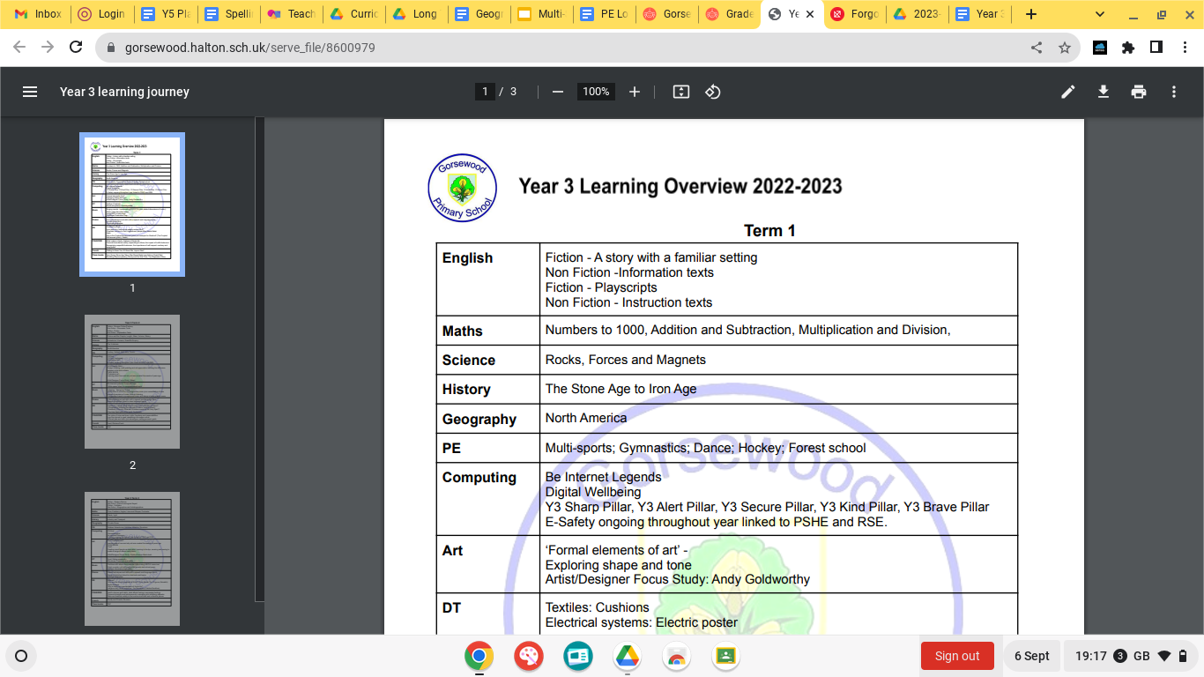

**Year 3 Learning Overview**

**Term 2**

|  |  |
| --- | --- |
| **English** | Literacy Tree Writing Roots- Whole School Book focus ‘Flooded’, ‘Wilderness’, ‘How to live forever’. |
| **Maths** | Time, Length, Mass, Volume, Money |
| **Science** | Forces and Magnets;  Plants |
| **History** | Chronology - Time Box |
| **Geography** | Biomes |
| **PE** | Handball  Cricket  Athletics  Forest School - x1 day a half term |
| **Computing** | Experience CS - Weather Watchers  Be Internet Legends: Online Safety |
| **Art** | Art: Drawing - Growing Artists combined with Developing Drawing Skills  Artist/Designer Focus Study: Monet |
| **D.T.** | Pneumatic Toys - design and make a toy from past history |
| **Music** | Listening- ‘ Spring’ by Vivaldi. Introduction to structure and programme music plus consolidation of inter related dimensions of music through listening;  Composition based on programme music and design a basic graphic score. |
| **Drama** | Drama techniques and skills with a speech and language focus;  Range of activities linked to class texts and topics |
| **RE** | Christianity (Jesus)  *What does it mean to be a disciple of Jesus?*  (Discipleship, following the example of Jesus, helping others)  Christianity (Church):  *What do Christians mean by the ‘Holy Spirit’?*  (The Holy Spirit gifts of the spirit. Pentecost) |
| **PSHE/RSE** | Safety and the changing body  Economic Well Being |
| **French** | Forest/woodland (describing terrain/colours) - Story -We’re going on a Bear Hunt  Numbers, calculations, shopping |

**Year 3 Learning Overview**

**Term 3**

|  |  |
| --- | --- |
| **English** | Literacy Tree Writing Roots- ‘Escape from Pompeii’, ‘Cinderella of the Nile’ |
| **Maths** | Pictograms and bar graphs, Fractions, Angles, Lines and Shapes, Perimeter |
| **Science** | Animals Including Humans  Light |
| **History** | Ancient Egyptians |
| **Geography** | Italy |
| **PE** | Swimming  Orienteering  Dance |
| **Computing** | Website Design - Visit Italy  Video production - Green screen videos, interview Tutankhamun  E-Safety ongoing throughout the year linked to PSHE and RSE. |
| **Art** | Art: Hieroglyphics/ Craft and design: Ancient Egyptian scrolls.( DT Egyptian Collars)  Artist/Designer Focus Study: Charles Rennie Mackintosh |
| **D.T.** | Cooking & Nutrition-Eating Seasonally - Food - pizza/pasta making. Meal design and budget. |
| **Music** | Continue with whole class recorder tuition using MECLA resources;  Finish recorder unit and perform for parents and school peers;  Summer showcase preparation. |
| **Drama** | Drama techniques and skills with a speech and language focus;  Range of activities linked to class texts and topics;  Summer Production |
| **RE** | Sikhism *Why are the Gurus important to Sikhs?*  *(*Guru Nanak The 10 gurus, Baisakhi)  Hindu Dharma *Why is family an important part of Hindu life?*  (religious duty Hindu scriptures - the Ramayana, Raksha Bandhan) |
| **PSHE/RSE** | Citizenship  Transition |
| **French** | Food and Menus  Beaches and Deserts |