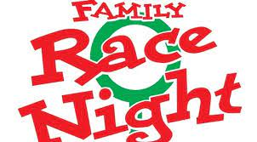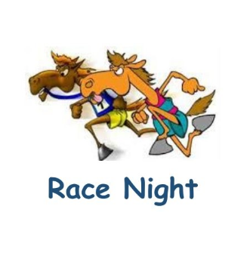

Saturday 4th May 6pm Parish Hall.
We are looking to raise funds for school PTA/trips etc. We need your support.
The race night is a lots of virtual horse races.
Please support us by either naming a Race (£20), naming a horse(£2) e.g. "Jammie Dodger", or name the Jockey (£1) e.g. "Bonnie" etc.
Complete the form with your chosen names, put the money (total cost) in the envelope, seal it, put it in your child's school bag or hand in to the school office. Get your envelopes in as soon as possible. You received them a couple of weeks ago.
Great family night out guaranteed, licensed bar, hot dogs, sweet shop, 8 races.
50p entrance

