

**Residential Autumn Menu**

Week 1.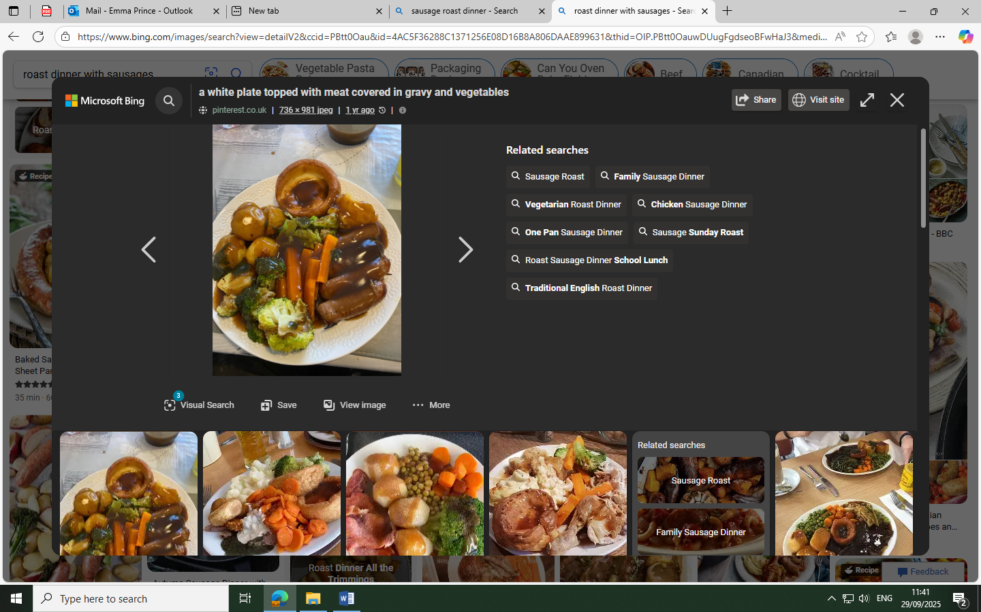

**Sausage roast dinner with Yorkshire pudding and vegetables**

**Strawberry Mousse / Fruit**

Week 2.  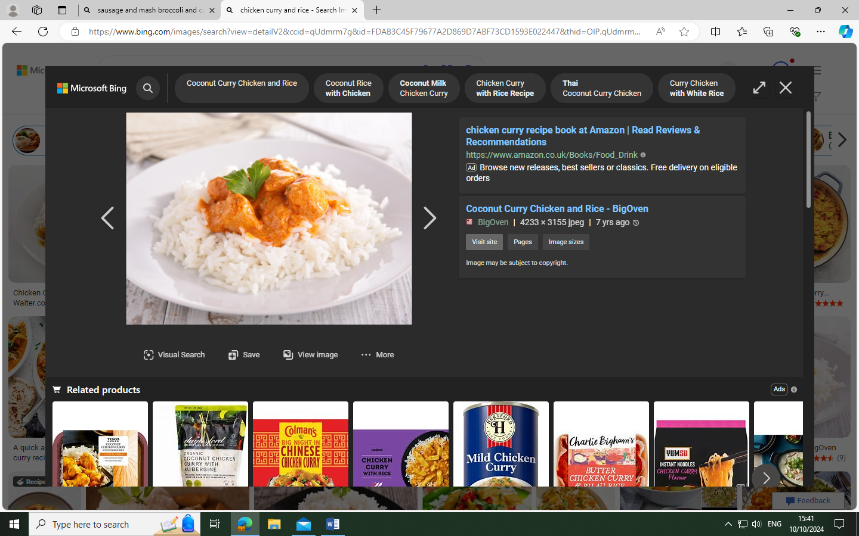 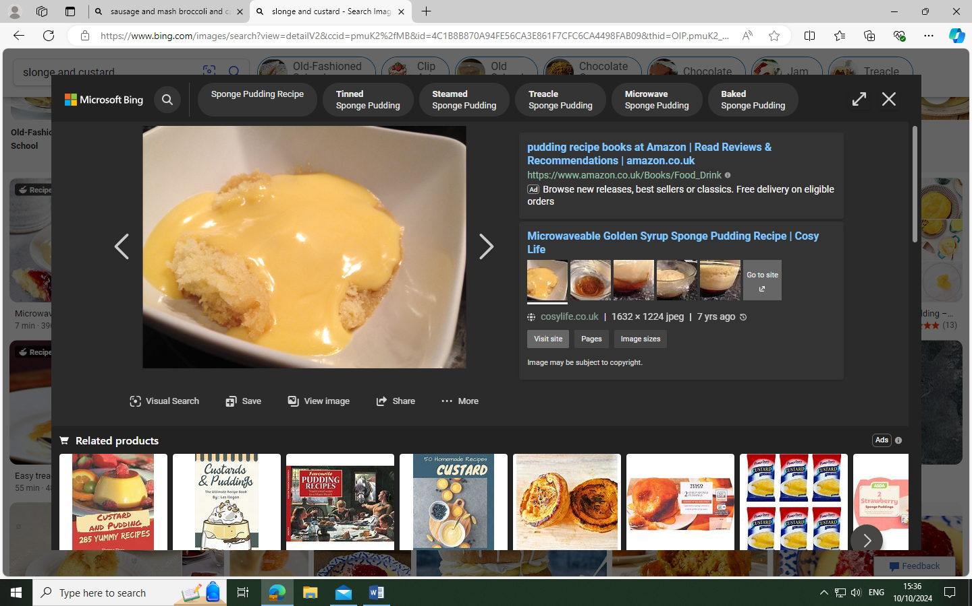

**Chicken curry, rice, poppadum’s & naan with vegetables**

**Sponge & custard**

Week 3.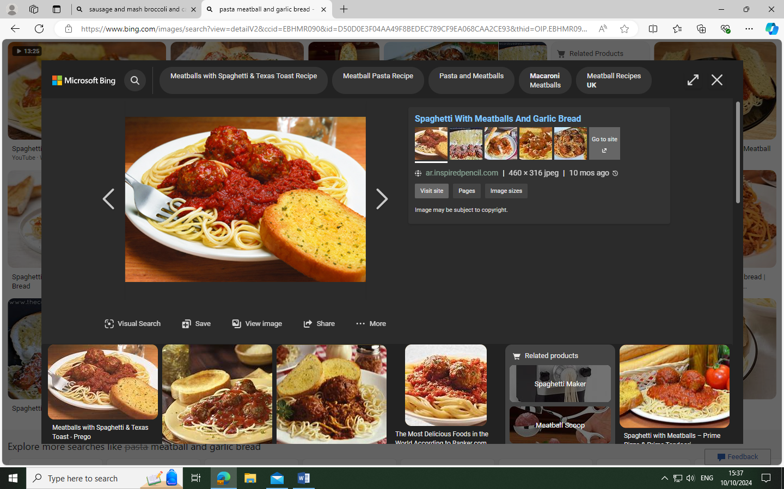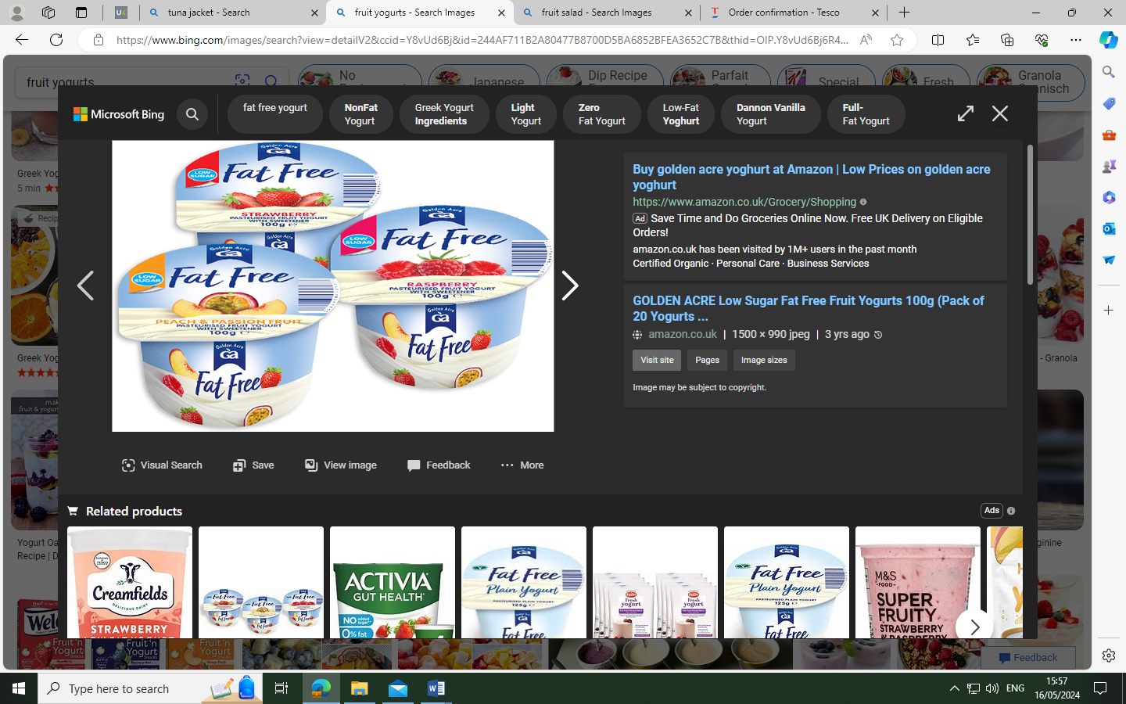

**Pasta, meatballs and garlic bread with vegetables**

**Fruit / Yogurt**

**Available every day, Sandwiches, Wraps, Jacket Potatoes and Salad Bar.**

