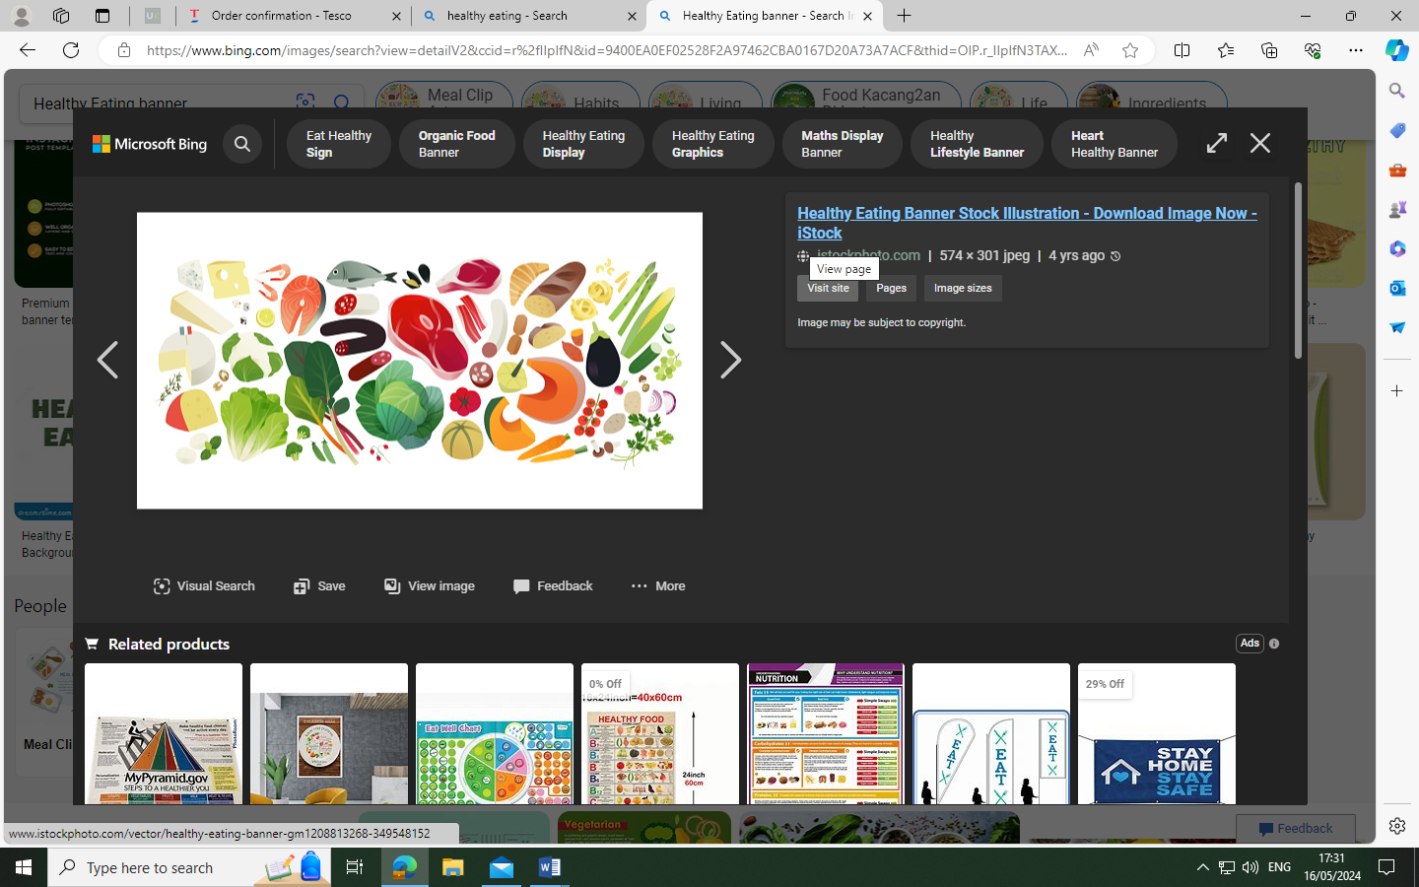
Residential Summer Menu

Week 1. 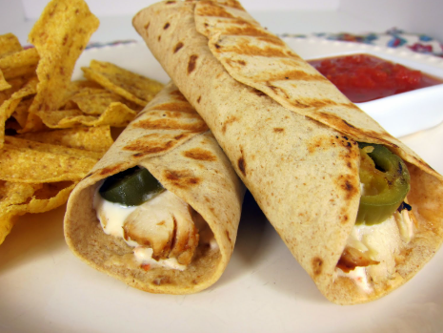 
Chicken fajita wrap with nachos and sweetcorn
Strawberry and vanilla mousse

Week 2. 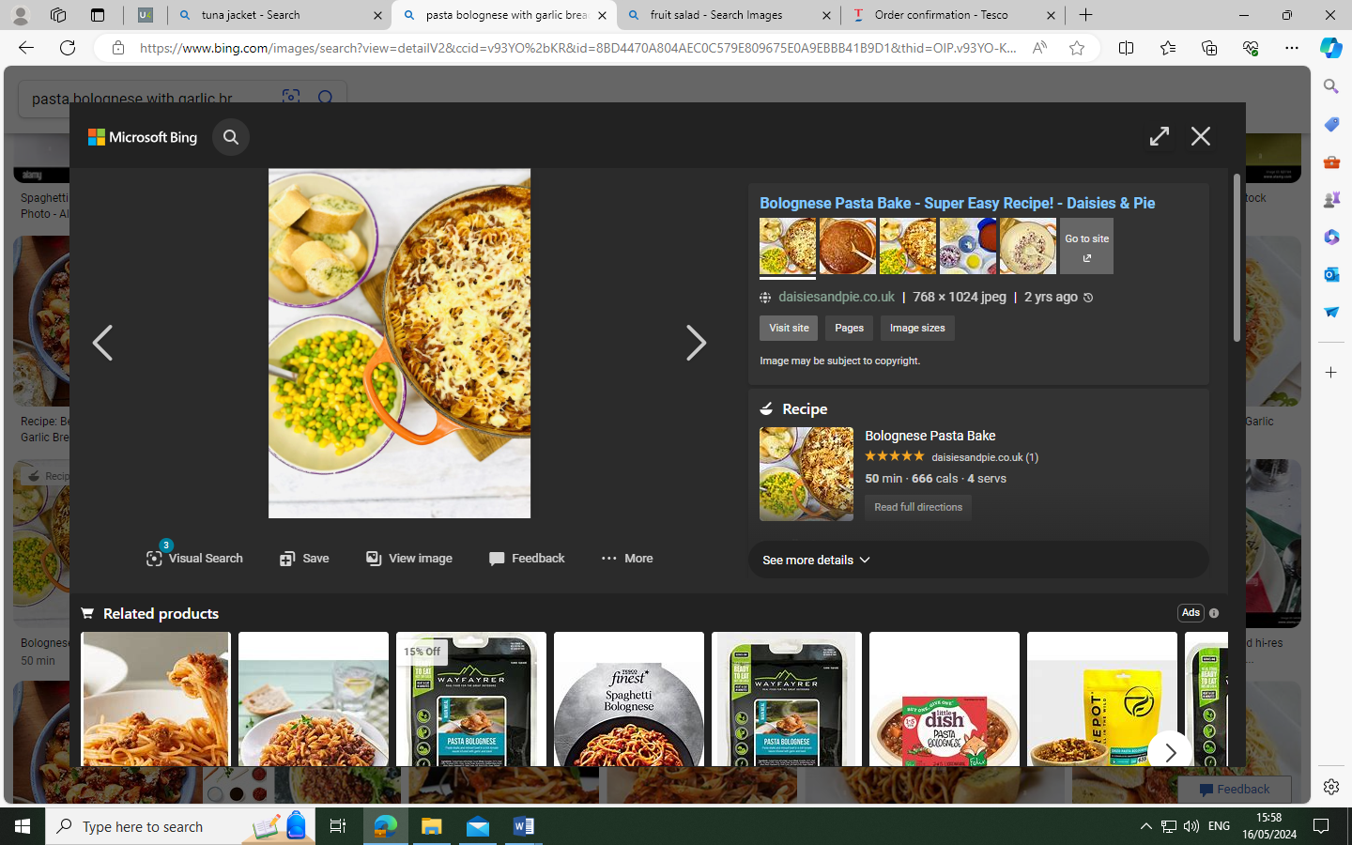 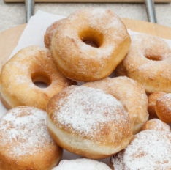
Bolognaise pasta bake, garlic bread with peas & sweetcorn
Doughnut

Week 3.  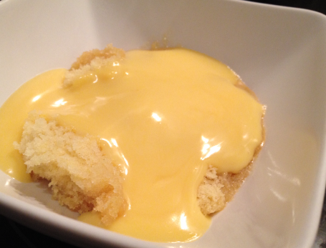
Chicken burger, homemade wedges and sweetcorn
Sponge and custard

Available daily, sandwiches, jacket potatoes, filled wraps, salad bar, fresh fruit and yogurts.
