Delving into Freedom | Vocabulary Dozen |  | BIG question  What does it mean to be ‘free’? |  |  | Persecution – Enslaved people faced daily persecution and cruelty.
The first slave voyage from the Americas to Africa is believed to have been in 1526. The trade of slaves continued until 1867 and it is reckoned that over 13 million slaves were forced to make the journey. | Enslaved – Henry was enslaved from birth and forced to work without pay. |  |  | Plantation – Life on the plantation was full of hard labour and sadness for Henry.
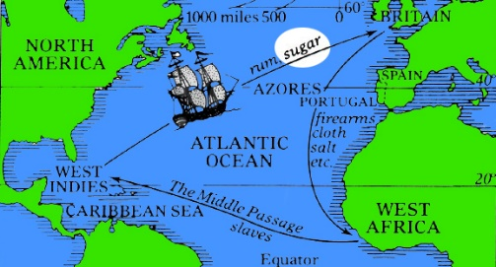  The Triangular Trade route for slavery between Africa, Europe and the Americas. | Emancipation – Henry dreamed of emancipation, wishing for the day he could live freely. |  |  | Captivity – Henry’s captivity meant he could not choose where to go or who to be with. |  | Peril – The journey in the box was full of peril, as Henry could have been discovered at any time.
Slaves had no say in where they worked, what they worked as or how long they worked for. They could work as: cotton pickers, sugar cane harvesters, rice planters, railroad builders or planting and growing coffee or tobacco. | Resistance – Thinking of a daring plan to mail himself showed Henry’s quiet resistance against slavery. |  |  | Oppression – The oppression of slavery made Henry determined to find another life. |  | Perseverance – Henry showed great perseverance by staying hidden in the box for days.
William Wilberforce, a Christian politician in Britain fought to abolish slavery. It took until 1807, when the Abolition of the Slave Trade Act finally abolished the transatlantic slave trade throughout the British Empire. The Act Prohibiting Importation of Slaves was also signed in America in the same year. | Auctioneer – Henry felt heartbroken when the auctioneer sold his wife and children to strangers. |  |  | Underground Railroad – Friends from the Underground Railroad helped Henry with his escape plan. |  | Liberation – When Henry climbed out of the box in Philadelphia, he felt the joy of liberation.
Map of North America’s Geographical features  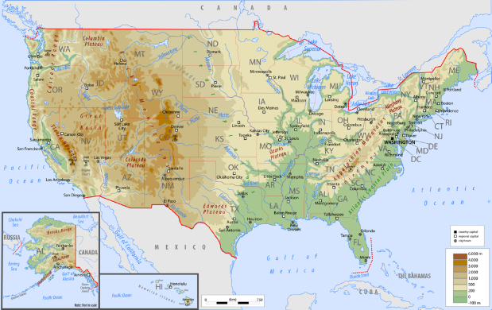  Forests Mountain ranges Hills  Rivers Lakes Vast plains Oceans |  | Biomes  A large region of Earth that has a certain climate and certain types of living things.  Tundra – a harsh climate where only certain plants and animals are able to survive.  Coniferous – a forest containing pine and fir trees and is inhabited by herbivores.  Prairie – wild grasses and plants span this biome which is inhabited by coyotes, bald eagles and prairie dogs.  Deciduous – a forest containing beech and oak trees and is the habitat of a range of insects, birds and mammals live.  Desert – little rain falls here and it is very hot and dry. Only a few specialised animals and plants can live here. |  |  | For to be free is not merely to cast off one’s chains, but to live in a way that respects and enhances the freedom of others.  One BIG thought from Nelson Mandela  