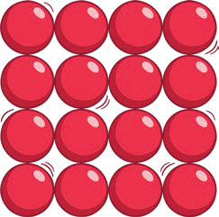
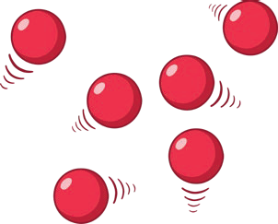
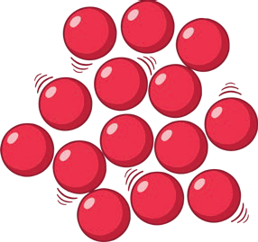
St Austin’s R.C. Primary School - Science
Topic: States of Matter | Year: 4 | Strand: Chemistry

Key Knowledge
All materials are made from particles so small that we can’t see them.
Solid | Liquid | Gas
Particles in a solid are close together and cannot move. They can only vibrate. | Particles in a liquid are close together but can move around each other easily. | Particles in a gas are spread out and can move around very quickly in all directions.
There are three states of matter.

Key Vocabulary
states of matter | Materials can be one of three states: solids, liquids or gases. Some materials can change from one state to another and back again.
solids | These are materials that keep their shape unless a force is applied to them. They can be hard, soft or even squashy. Solids take up the same amount of space no matter what has happened to them.
liquids | Liquids take the shape of their container. They can change shape but do not change the amount of space they take up. They can flow or be poured.
gases | Gases can spread out to completely fill the container or room they are in. They do not have any fixed shape but they do have a mass.
water vapour | This is water that takes the form of a gas. When water is boiled, it evaporates into a water vapour.

Year 4
States of Matter
When water and other liquids reach a certain temperature, they change state into a solid or a gas. The temperatures that these changes happen at are called the boiling, melting or freezing point.

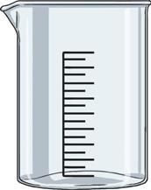
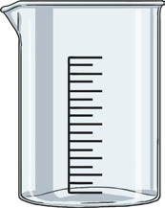
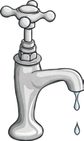
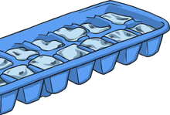

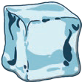
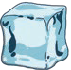
solid
liquid
liquid
solid
heat
cold
If a solid is heated to its melting point, it melts and changes to a liquid. This is because the particles start to move faster and faster until they are able to move over and around each other.
When freezing occurs, the particles in the liquid begin to slow down as they get colder and colder. They can then only move gently on the spot, giving them a solid structure.

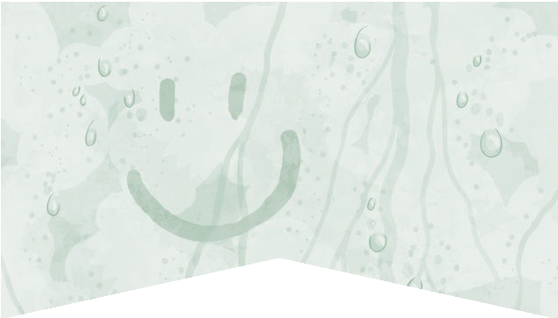
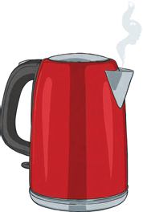
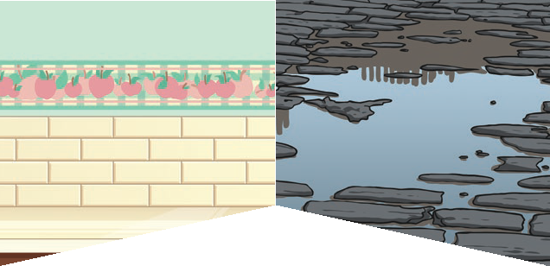
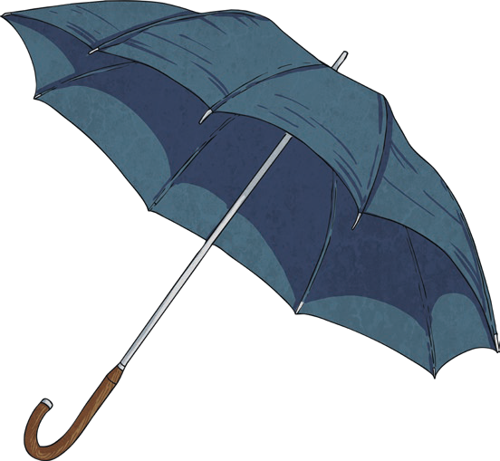
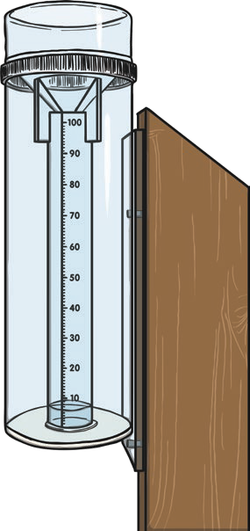
Condensation

Condensation is
when water vapour is cooled down and turns into water. You can see this when droplets of water form on a window. The water vapour in the air cools when it touches the cold surface.
Evaporation

Evaporation occurs
when water turns into water vapour. This happens very quickly when the water is hot, like in a kettle, but it can also happen slowly, like a puddle evaporating in the warm air.
Year 4
States of Matter
Key Vocabulary
melt | This is when a solid changes to a liquid.
freeze | Liquid turns to a solid during the freezing process.
evaporate | Turn a liquid into a gas.
condense | Turn a gas into a liquid.
precipitation | Liquid or solid particles that fall from a cloud as rain, sleet, hail or snow.

Condensation and evaporation occur within the water cycle.
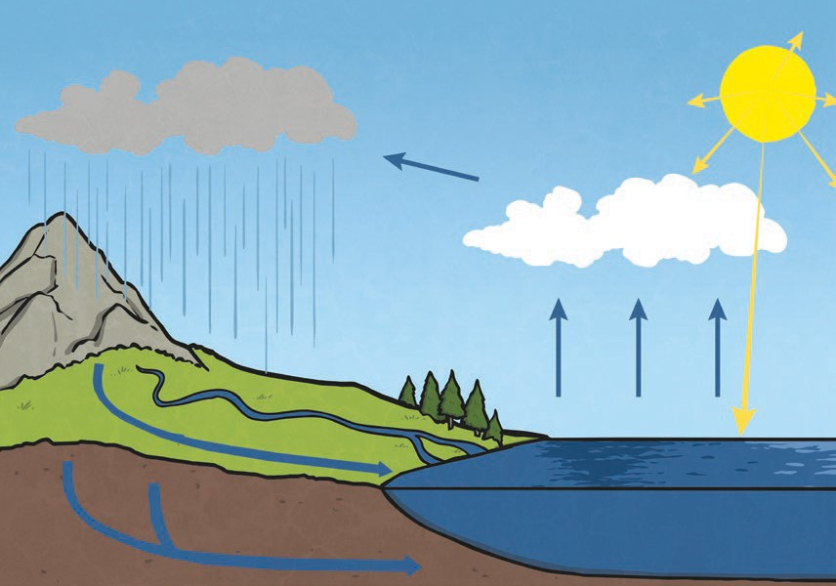 | - Water from lakes, puddles, rivers and seas is evaporated by the sun’s heat, turning it into water vapour.  - This water vapour rises, then cools down to form water droplets in clouds (condensation).  - When the droplets get too heavy, they fall back to the earth as rain, sleet, hail or snow (precipitation).

