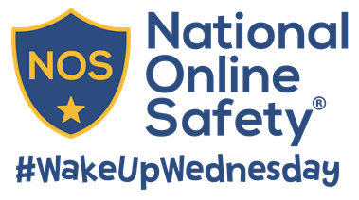
Free Online Safety Guide:
What Parents Need to Know About PS4
Since arriving on the market in 1994, PlayStation has become one of the most recognised names in the gaming industry. Its current model, the PlayStation 4, is an all-in-one entertainment hub, offering much more than just the ability to game with internet access, streaming services and online chat features. That’s why we’ve created this guide to help parents and carers understand exactly what the PlayStation 4 is all about.
Read on to get your free guide and to catch up on the latest online safety news.

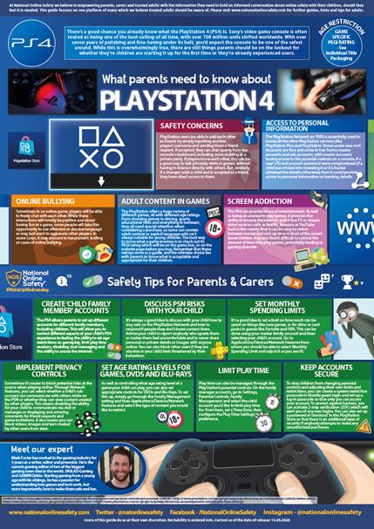
PlayStation is one of the most widely known games consoles in the world. It can offer hours of entertainment for children who can soon find themselves immersed in the latest gaming release. But how does it work? What features does it house? And should parents have any safety concerns? Find out with this guide.
Created by gaming expert, Mark Foster, this guide will aim to provide parents and carers with an understanding of what the PlayStation offers beyond just gaming. As always, the guide also provides a number of useful tips for parents and carers to consider around safe use of the platform. Click the button below to access your free guide now.

Download Your Guide
View on Facebook
View on Twitter
View on LinkedIn
Your Online Safety News
This week we’ve included news of a new lockdown walk inspired social distancing game, Twitter’s ploy to add warnings to misleading coronavirus tweets and a warning over children’s screen time.
Coronavirus: Lockdown walk inspired social distancing game

A new online game called ‘Can You Save the World’ that aims to help children see the importance of social distancing has racked up about 10,000 plays in its first two days.
READ MORE
Twitter will hide 'misleading' coronavirus tweets with warnings
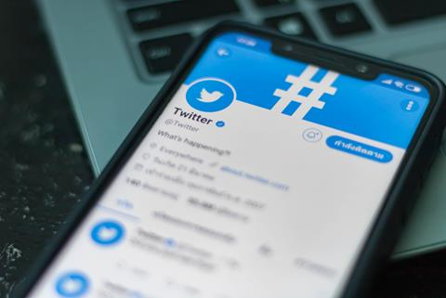
Twitter has said labels and warning messages will be added to “provide additional context and information” to tweets with “disputed or misleading information” about COVID-19.
READ MORE
UK coronavirus app could be 'ditched for different model' after trials
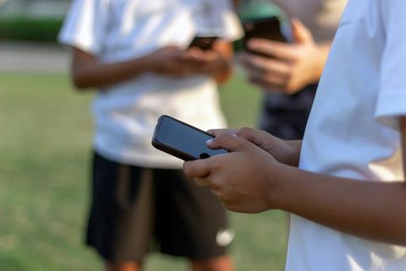
After piloting it in the Isle of Wight and learning lessons from other countries, the UK could adapt or ditch its coronavirus contact-tracing app and “move to a different model”.
READ MORE
Coronavirus: 'Plandemic' virus conspiracy video spreads across social media

Major social networks are rushing to take down a new so-called “Plandemic” coronavirus conspiracy theory video which has rapidly spread across the internet.
READ MORE
WhatsApp users warned over scam offering free Cadbury chocolate
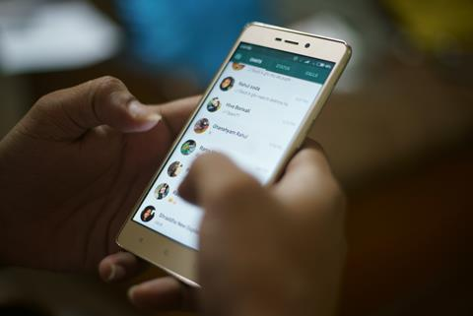
WhatsApp users have been warned over a scam that promises to give you free chocolate – but in fact just steals money and personal information.

READ MORE
Coronavirus: Opticians advise screen breaks for children in lockdown

Optometrists warn that parents need to be careful about how much time children are spending on screens during lockdown, with risks of developing myopia, or short-sightedness.
READ MORE

Get Involved in #WakeUpWednesday
We believe all parents, carers, teachers and trusted adults should be empowered with the all the information needed to have informed and age-appropriate conversations about online safety with children. That's why, every Wednesday, we produce practical, easy to follow guides which focus on specific risks we think you need to be aware of.
Is there a game, app or social network you would like us to cover? If so, please get in touch with us at hello@nationalonlinesafety.com any time.



