‘Religious Education allows pupils to enter into a rich discourse about the religious and non-religious traditions that have shaped Great Britain and the world. It enables pupils to take their place within a diverse multi-religious and multi-secular society and provides the opportunity to make sense of their own place in that world’
OFSTED



Intent - What we want for our children?
Our Religious Education (RE) curriculum develops children’s understanding and respect for diverse faiths and worldviews, while encouraging reflection on their own beliefs and values. We take a holistic approach that supports moral, spiritual, social and cultural growth through discussion, reflection, and the sharing of ideas.
Children learn about Christianity alongside a wide range of religions and non-religious traditions. The curriculum is progressive, beginning in Early Years and building year on year through revisiting and reinforcing key concepts. This ensures pupils develop both knowledge and essential skills, leading to a lasting appreciation and enthusiasm for RE.
In line with the locally-agreed syllabus, we aim to provide a broad, balanced, and inclusive curriculum. Pupils explore how people express beliefs, use artefacts, and follow rituals, while learning to question, interpret, and assess claims with accuracy. They are encouraged to reflect on how their own values connect with wider traditions, fostering curiosity, respect, and acceptance of different cultures.

Implementation - How is the curriculum delivered?
We use stories, songs, art, drama, and discussion to introduce religious ideas and practices. The curriculum is carefully sequenced, enabling children to compare faiths and reflect on their own views while listening to and valuing those of others.
Books, artefacts, and high-quality texts are used to deepen understanding. The Education Library Service provides resources, and class sets of Bibles are available for independent use. Where appropriate, RE is supported through reading lessons to strengthen vocabulary and comprehension.
Curriculum Enrichment
Children encounter a range of religions through:
- Themed days and whole-school events
- Visitors and links with local faith leaders
- Trips to places of worship (e.g. churches, a synagogue, Chester Cathedral)
- Regular assemblies led by the vicar
Special RE days (e.g. Hinduism Day, Islam Day, Judaism Day, Holi Festival) celebrate key traditions and festivals, raising awareness and pride in children’s own cultures while promoting interest and respect for others.

Impact - How do we know our RE curriculum is effective?
We know our curriculum is effective when pupils can express their understanding of religious, moral, and spiritual ideas with confidence. Pupil Voice is a key tool for assessing progress and ensuring learning is meaningful.
Children present their learning and understanding of essential skills in varied ways:
- Written outcomes, artwork, drama, discussions, debates, and presentations
- Sharing assemblies following themed days
- RE learning journeys that show progression
We also keep a whole-school SMSC book capturing snapshots of RE across the year. These outcomes provide opportunities for children to recall, celebrate, and demonstrate their growing knowledge and enthusiasm for Religious Education at Horn’s Mill.
Religious Education (RE) is a statutory part of the curriculum and is taught to all pupils at our school. We believe that RE provides valuable opportunities for children to develop their knowledge and understanding of different religions and worldviews, while promoting respect, tolerance and understanding of others.
Parents and carers have the legal right to withdraw their child from all or part of RE lessons. If you are considering withdrawing your child from RE, we encourage you to contact your child’s class teacher to discuss this in the first instance.
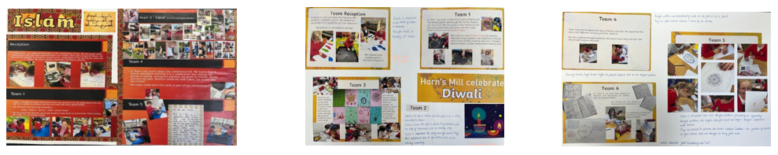
If you have any further enquiries relating to the RE curriculum, please email Mrs Hulse on ghulse@hornsmill.cheshire.sch.uk
