
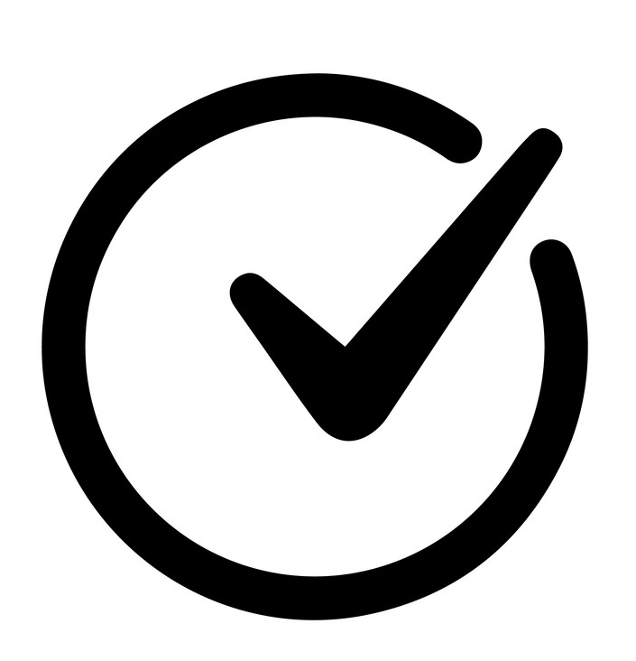

Starting School - Parent Checklist
Task | Completed
Online start paperwork completed by Friday 16th May

Uniform ordered

Uniform and coats labelled

Free School Meal online application

Starting school story book read

Holiday book completed

P.E Kit packed

School Spider App installed and logged in

Log into School Grid and become familiar with how to order your child’s lunch

Water bottle ordered and labelled

Staggered school timings checked

Long-term medication if needed, ready to be sent in with child e.g. inhalers (medical form to be completed during first week).
Book bag ready (already provided)

Wrap around care organised (if needed)

Wellies bought

Check your child can use the toilet independently and be familiar with how to fasten zips and button on their new school uniform
(practice over the summer if needed)
Best start in life website – be familar with the school readiness expectations and follow the ‘tips to try at home’
See link below:
https://beststartinlife.gov.uk/preparing-for-school/

