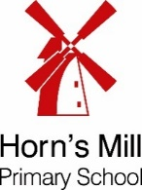
What will we be learning this week?

Week Beginning – 5.5.26
Our child-led learning this week will be focusing on…
UTW: People, Culture and Communities – Our World
We will be giving children opportunities to:
- Explore globes & maps and identify Antarctica
- Know what the weather is like in Antarctica
- Compare physical differences between Antarctica and our country

Don’t forget to send into school any WOW moments which happen at home! 
tion
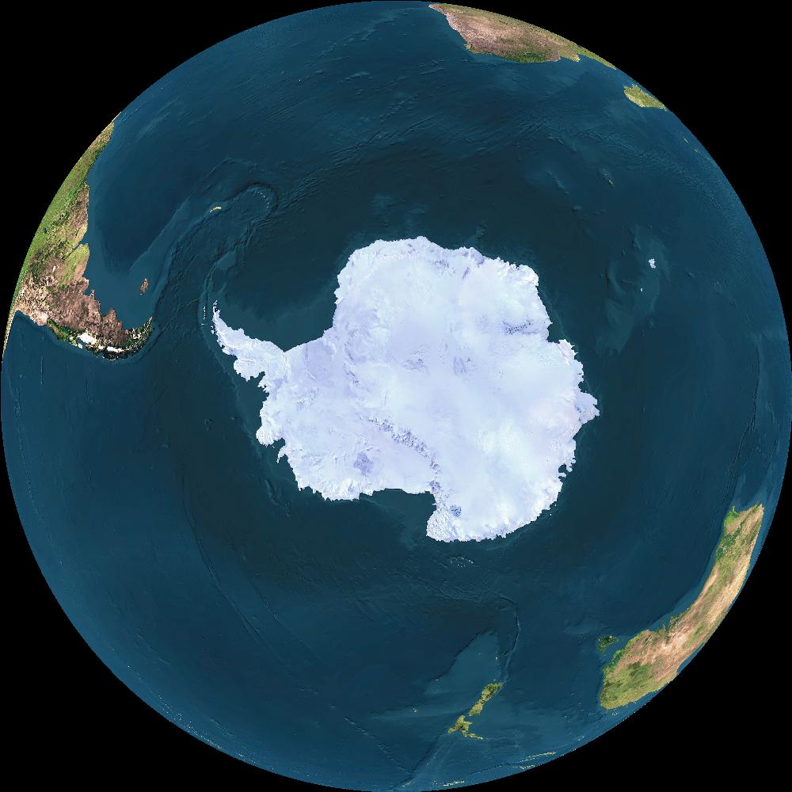

As part of our class phonics…
Children complete their daily phonics sessions in smaller reading groups, taught by different adults. In class, we will be reviewing all Set 1 special friends and set 2 sounds together. We are currently focusing on reading the tricky words are, your, she, all, baby. During shared writing we will be focusing applying the phonics we know to spell words.

In Literacy….
We will find out a little more about our mystery creature this week, as we are introduced to the story ‘Silly Doggy’. We will compare our wanted posters to the creature in the story and discuss if they are the same. We will read the first few pages and discuss who and what we can see. Children will write simple sentences independently e.g.
‘I can see a ……’

In Maths…
This week, the children will continue to engage with activities that draw attention to the purpose of counting – to find out ‘how many’ objects there are. The children will also revisit the concept of cardinality – the idea that the last number in the count tells us how many things there are altogether. They will be given further opportunities to hear, join in
and spot missing numbers in
the number sequence.


