

**What will we be learning this week?**

**Week Beginning – 13.10.25**

Our child-led learning this week will be focusing on…

**UTW: People, Culture and Communities - Diwali**

We will be giving children opportunities to:

* Learn what religion is, in particular Hinduism
* Know about the Diwali Festival and its celebrations
* Create Rangoli patterns and Diya lamps

Don’t forget to send into school any **WOW** moments which happen at home! 

tion



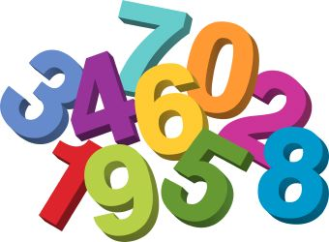

As part of our **class phonics**…

During Ready Steady Read this week as a class, we will be learning the sounds ‘**e, l, and r.** We will be learning how to say and write these sounds. We will also be continuing our oral blending practice with ‘FRED the frog’ and will be using the magnetic boards to help us begin to segment and blend together simple 2 or 3 letter words.

**In Literacy**….

We will be growing close to the ending of our class text **‘The Gingerbread Man’** this week. We will follow The Gingerbread Man, as he scurries along the path, meeting different animals on the way. We will make predictions about what happens next in the story and help The Gingerbread Man find a solution to how he can cross the river. All of our discussions will include element of our phonics learning and we will extend our ideas during Learning Time.

**In Maths**…

In maths this week, children will build on their subitising skills. They will continue to use instant recognition by saying the number of sounds that they can hear, such as claps or drum beats, without needing to count. They will be encouraged to look closely at small quantities and observe whether the quantity has changed or only the arrangement. For example, how Numberblock 4 could be arranged as a 2 on top of a top.

