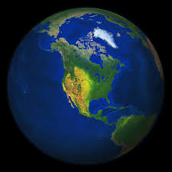

* **Music**

In Music, we will develop our singing, composing and performing skills in the Christmas Carol performance.

**PE**

We will be learning the skills needed for orienteering and gymnastics.

**Computing**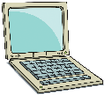

In computing we will be learning how to identify fake news and being safe online.

**Geography**

During this topic, we will locate North America on the map. We will explore the environmental regions and key physical and human characteristics of North Am erica.

**North America**

**PSHE**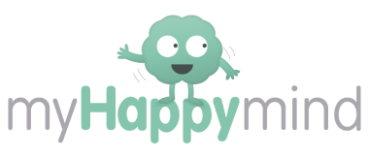

In myHappymind, we will be completing the Meet Your Brain and Celebrate units.

**Art/DT**

In art/DT, we will be learning about illustrations from Walt Disney. In DT we will learn about how to create our own healthy food.

**RE**

In RE, we will be learning about Islam. During this topic, we will be leaning about the pillars of Islam and how Muslims create a cohesive community.

.

**French**

We will develop pronunciation and intonation in conversational French.

**History**

We will learn about the Anglo-Saxons and why they settled in the United Kingdom. We will investigate if Alfred the Greats title is really fair and how the battle for the English throne was complex and filled with conflict.

**Horn’s Mill Primary School**

**Science**

In Science, we will be learning all about forces including the effect of air resistance, water resistance and friction.

We will also be learning al about light and how it travels. We will investigate how we see things.