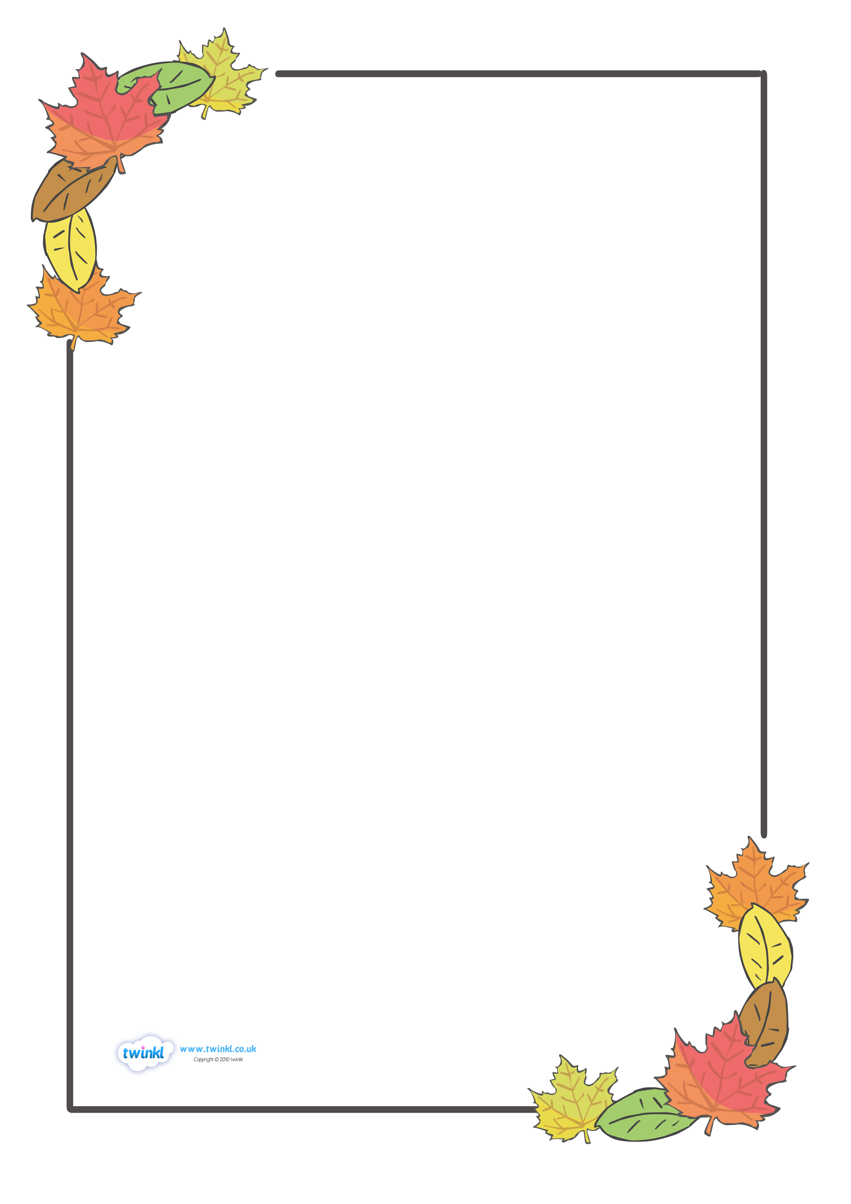
The Colours of Autumn

Golden wheat getting cut for food,
straw placed under burnt orange pumpkins,
corn being made into horse feed for the winter,
gold is a colour of autumn.

Tommy Joyner

Red as sunsets fading into the smoke of chimneys,
juicy apples falling onto the damp land,
crispy leaves with shades of scarlet,
red is a colour of autumn.

Zach Hard-Smith

Orange as a huge bumpy pumpkin lying on a prickly layer of golden hay,
an incredible sunset slowly fading into the horizon,
petals of flowers slowly dropping off creating a soft, orange land,
Orange is a colour of autumn.

Lucian Fitton

LABEL HERE
LABEL HERE

