Billinge Chapel End.
Feedback from pupil surveys 2025 – 2026
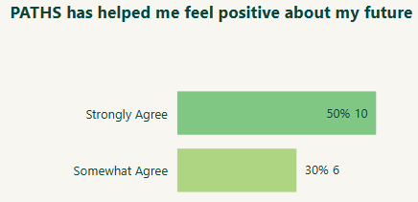

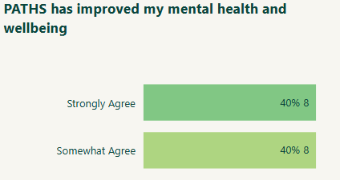

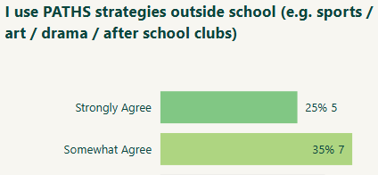

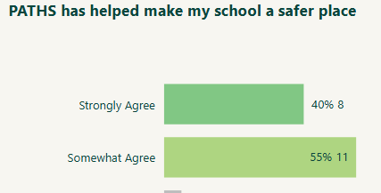

What is the most useful thing you have learnt from PATHS
About feelings
All feelings are ok
Box breathing
Coping with my big feelings especially when I’m angry or upset
Everything
Everything
Hot chocolate breathing
How to calm down when I need to
I’ve learnt calming down strategies
Lots
Safety
Steps for calming down
To be respectful to other people
To calm down and relax
To explain feelings and behaviours in and out of school.
To make more friends
to understand my feelings
Uhmmm… TAXES :D

Staff feedback
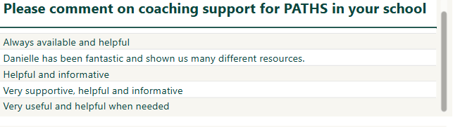
Surveys results from staff
