

Chapel End Primary School
Physical Education Policy

'Mission Statement.'

We aim to provide our children
with the highest possible standard
of education, through quality
teaching and learning, in a happy
caring environment.

We will do the best WE can to enable our children to do the best THEY can.

This policy was approved by: | Full Governors
Date | Autumn 2024-2025
Review Date | Autumn 2027-2028

Intent
Through the teaching and learning of PE at Chapel End Primary School we aim to stimulate our children’s curiosity by incorporating a range of physical activities into the curriculum. These activities will include dance, gymnastics and movement, invasion games, swimming and athletics. We endeavour for all of our children to experience first-hand what it is like to enjoy physical activity. It is our aim that progressive activities from EYFS through to Year 6 will foster an interest in a range of sports. By learning about different physical activities, it is hoped children will be able to recognise the importance of personal fitness and also the pleasure that can be gained from team and individual sporting activity. This supports our ultimate goal in supporting our children towards becoming responsible global citizens. Through completing our contextualised programme of study, we aim for our children to develop independence and resilience as they move out into secondary school and the wider world.
We will do the best WE can to enable our children to do the best THEY can.
Aims and objectives:
At Chapel End Primary we recognise the importance PE plays in the curriculum and are committed to providing all children with opportunities to engage fully in Physical Education. The aim of our PE programme is to develop children's basic physical competencies, build confidence in their ability and build the foundations for a lifelong love of sport, physical activity and a healthy lifestyle. PE lessons encourage children to compete against themselves and others whilst being challenged to improve their physical, social, emotional and thinking skills. These skills are embedded in the heart of our planning.
We aim to develop:
• The ability to acquire new knowledge and skills exceptionally well and develop an in-depth understanding of PE.
• The willingness to practise skills in a wide range of different activities and situations, alone, in small groups and in teams and to apply these skills in chosen activities to achieve exceptionally high levels of performance.
• High levels of physical fitness.
• A healthy lifestyle, achieved by eating sensibly, avoiding smoking, drugs and alcohol and exercising regularly.
• The ability to remain physically active for sustained periods of time and an understanding of the importance of this in promoting long-term health and well-being.
• The ability to take the initiative and become excellent young leaders, organising and officiating, and evaluating what needs to be done to improve, and motivating and instilling excellent sporting attitudes in others.
• Exceptional levels of originality, imagination and creativity in their techniques, tactics and choreography, knowledge of how to improve their own and others’ performance and the ability to work independently for extended periods of time without the need of guidance or support.
• A keen interest in PE. A willingness to participate eagerly in every lesson, highly positive attitudes and the ability to make informed choices about engaging fully in extra-curricular sport.
• The ability to swim at least 25 metres before leaving school at Year 6.

The Curriculum
Swimming and Water Safety
All children must have access to swimming instruction in key stage 2.

In particular, pupils should be taught to:
• Swim competently, confidently and proficiently over a distance of at least 25 metres
• Use a range of strokes effectively such as front crawl, backstroke and breast stroke
• Perform safe self-rescue in different water-based situations

At Chapel End Primary School, the children have access to swimming instruction provided by the local authority. Swimming is coached by pool staff who are assisted by teaching staff. Organisation of swimming instruction can vary year on year based on availability within St Helens Local Authority.
All children will be given the opportunity to participate in a range of physical activity – please refer to PE overview for details of each year group’s focus activities.
In Key stage 1, focus is on developing agility, balance and control using the vehicle of established sports and fun physical activities. We aim for children to also develop a knowledge and understanding of simple tactics.
In Key Stage 2, skills are developed and identified sports are used to develop children’s knowledge and understanding of sporting rules along with more advanced tactics.
At Chapel End Primary School, we are fortunate to have expansive outdoor grounds. To take advantage of this we have an orienteering course in place which is utilised by Upper Key Stage 2 pupils.
We fulfil the national curriculum requirement and teach PE for 2 hours each week.
Equal Opportunities and SEND
A range of PE activities are offered to boys and girls and children with any registered disabilities; enriching experiences and high expectations are set regardless of gender or ability. Selection for school sport teams is based upon both ability and opportunity. The PE Leader aims to have a high percentage of children from the school represent the school in some capacity. PE lessons and extra-curricular sport clubs offer all children the opportunity to improve their knowledge and techniques so everyone has the opportunity to be the best they can be.
For children who have physical or learning disabilities, some modification may have to be made to the way in which an activity or sport is taught, learnt and played. Any such modifications will be made in consultation with the relevant staff and specialists and noted on teachers’ plans. Children who are identified as gifted and talented with PE are provided with a range of enhancement opportunities, designed to challenge and develop their skills and understanding. Chapel End offers bespoke extra curricular teaching and activities to those children who are on the SEND register or who are Pupil Premium.

Planning
- Teachers use the Edstart PE programme – this is a published scheme which PE co-ordinator in school has worked on collaboratively with Edstart.
- Basic skills relating to English Maths and speaking and listening are incorporated into lessons but do not override the PE focus of any session.
- Resources are purchased annually so that each unit of work can be completed in line with the curriculum overview.
- Staff choose which activities best suit the needs of their class. They also choose the level of support individuals may need.
Below is the curriculum overview, outlining planning units for EYFS through to Year 6.
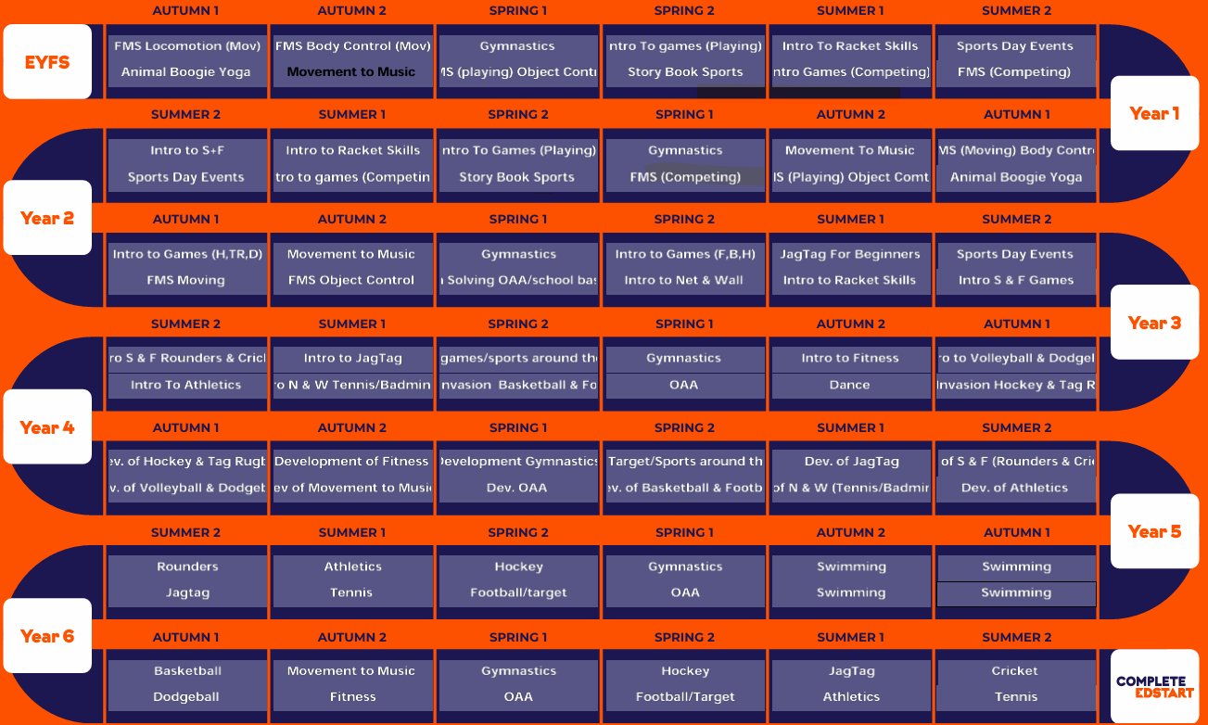

Teaching and Learning
Our PE lessons are planned using the Edstart scheme. Teachers ensure resources are used to align with our core values, our whole child approach to PE and the objectives laid out in the National Curriculum. Progression is built into teaching which ensures our children are increasingly challenged as they move up through the school.
In all classes, children have a wide range of physical ability. Whilst recognising this fact, we provide suitable learning opportunities for all children by matching the challenge of the task to the ability of the child. We achieve this through a range of strategies:
1. Setting common tasks that are open-ended and can have a variety of results (e.g. timed events, such as balancing on one leg);
2. Setting tasks of increasing difficulty, where not all children complete all tasks (e.g. the high jump);
3. Grouping children by ability, and setting different tasks for each group (e.g. different games);
4. Providing a range of challenge

Assessment and feedback
Monitoring
- Progress and achievement in PE will be monitored in the following ways:
- Autumn: Key Stage 2 teaching and learning observations and whole school data analysis
- Spring: Key Stage 1 teaching and learning observations, whole school Dojo evaluation and whole school data analysis
- Summer: EYFS teaching and learning observations, whole school Dojo evaluation and whole school data analysis
Teaching staff will complete Assessment tracker for each child for every lesson.

PE Kits
Children should wear appropriate clothing. Jewellery (except stud earrings) must be removed. Teachers will not take responsibility for looking after jewellery. Parents should use Dojo or inform the school office, if they are unable to participate through illness or injury. Staff should be vigilant if a pattern of non-participation is established for a variety of reasons (including child protection issues). Patterns of non-PE participation are recorded on the schools CPOMS system.
Children not going swimming through illness or injury are still required to go swimming for the theoretical aspect. In all other PE lessons children not participating should remain with their class: helping in the lesson or doing PE related work.

Children without Kit
The PE Kit is detailed in the Chapel End Primary School Uniform policy.
At the beginning of each year, parents will be informed by class newsletter of PE kit requirements, and they will have the opportunity to discuss any serious reservations with the Headteacher.
The Uniform requirements are:
Plain white round-neck T-shirt
Plain red shorts
Plain red sweatshirt/hoodie
Plain black jogging bottoms
Trainers suitable for indoor and outdoor activity.
Children attend school in their PE kit all day when they have a PE lesson. If children do not wear the correct PE kit, the class teacher will contact parents and carers to offer support in order for them to do so.

Health and Safety

We recognise that participation in PE and physical activities contains an element of risk. Staff are responsible for ensuring that they are familiar with safe practice to reduce the element of risk to the absolute minimum within their control.
Staff are aware of pupils who have special needs with regards to physical activity and make special provision for needs where appropriate e.g. physical disability, asthma.
Staff know about the safe practices involved in moving and using apparatus.
- Pupils may be asked to remove shoes when participating in indoor activities such as gymnastics, dance and yoga.
- Correct use of equipment is taught along with any potential hazards, including completing a risk assessment for each area/ space that PE and school sport takes place in.
- Equipment and apparatus are stored safely at the end of each lesson.
- Pupils are taught to consider their own safety and that of others at all times.

St Helens Authority undertake an annual Risk Assessment of the school premises and areas where PE is taught and equipment including PE equipment as necessary. Risk Assessments are in place for all school sporting trips.

Roles and responsibilities
Pupils
- It is the role of every pupil to engage with every lesson and ‘DO THE BEST THEY CAN’
- Children are responsible for presenting work to the highest standards possible.
- Children are responsible for responding to teacher feedback.

Teachers
- Use the wealth or resources, including those online to challenge their current class.
- Continue develop and broaden their own subject knowledge.
- Deliver lessons that are fun and offer a wide range of teaching and learning approaches.
- Provide children with opportunities to develop their speaking and listening skills within an active environment.
- Assess work/performance and provide feedback that supports the development of learning.
- Seek out CPD opportunities to improve their own subject knowledge.
- Report back to the co-ordinator, particularly regarding the need for additional resources.
- Use display opportunities to celebrate the children’s PE work (notably at inter school or intra school competitions).

- Subject Leader
- Create a subject intent statement with the staff.
- Write the PE policy and update it every 2 years.
- Ensure that knowledge, skills and vocabulary are progressive across the Key Stages.
- Ensure that links are made with other curriculum areas.
- Monitor the progress and attainment of children in PE.
- Support teaching staff in accelerating the learning of children identified in the monitoring process.
- Organise enrichment activities linked to PE.
- Report to Governors regarding the teaching and learning of PE at Chapel End Primary School.
- Use a yearly budget (including Sports Premium) for PE to ensure that resources are in place to allow for the effective delivery of the curriculum.
- Research new developments in geography and adapt the curriculum accordingly.

Head teacher
- To ensure that the subject leader in undertaking their duties.
- To monitor attainment and progress and use this to plan the overall direction of the subject with the subject leader.
- To provide the subject leader with CPD to ensure that they are capable in their role.
- To ensure that the Sports premium plan is accurate and published on the school website.

Governors
- Receive annual reviews relating to the subject from the subject leader.
- Monitor that the Head teacher and subject leader are carrying out their duties effectively.

Impact
By completing the PE curriculum at Chapel End Primary School children will have developed:
- The fundamental skills needed to maintain a healthy lifestyle.
- Confidence when developing new and unfamiliar skills.
- Independence and resilience.
- An inherent interest in being healthy and enjoying a range of sporting activity
- The ability to ask questions on how to improve performance.
- Respect and tolerance for people around the world who have different sporting ability.
- A love of the outdoors.
Dissemination
This policy is available on our school website where it can be accessed by the community. Training is regularly delivered to staff on the policy content. Copies are available from the school office on request from parents/carers.

